Mi tin tli^/iiudviiest '

\A a\\XV\K?N VV

dl Uieytfdrsi luitural disasters .

in li'tsturv* these atieeied wereu

\

just utmygless,'iaeeless iidti|dei Liet^is tUiAslurv ui several A.LQ



nm

»

**To order contact:**

g Corp. • 850 Busse Highway • Parti (847] 602-5940

F#e Information Reader Service Card #24



7W?"

**AUGUST 2,1997 CONVENTION CENTER HOTEL**

**RENO, NEVADA**

WITH QUESTIONS OR COMMENTS CONTACT:

ASSOCIATED LOCKSMITHS OF AMERICA, INC 3003 LIVE OAK ST.

DALLAS, TEXAS 75204

214-827-1701

800-532-2562

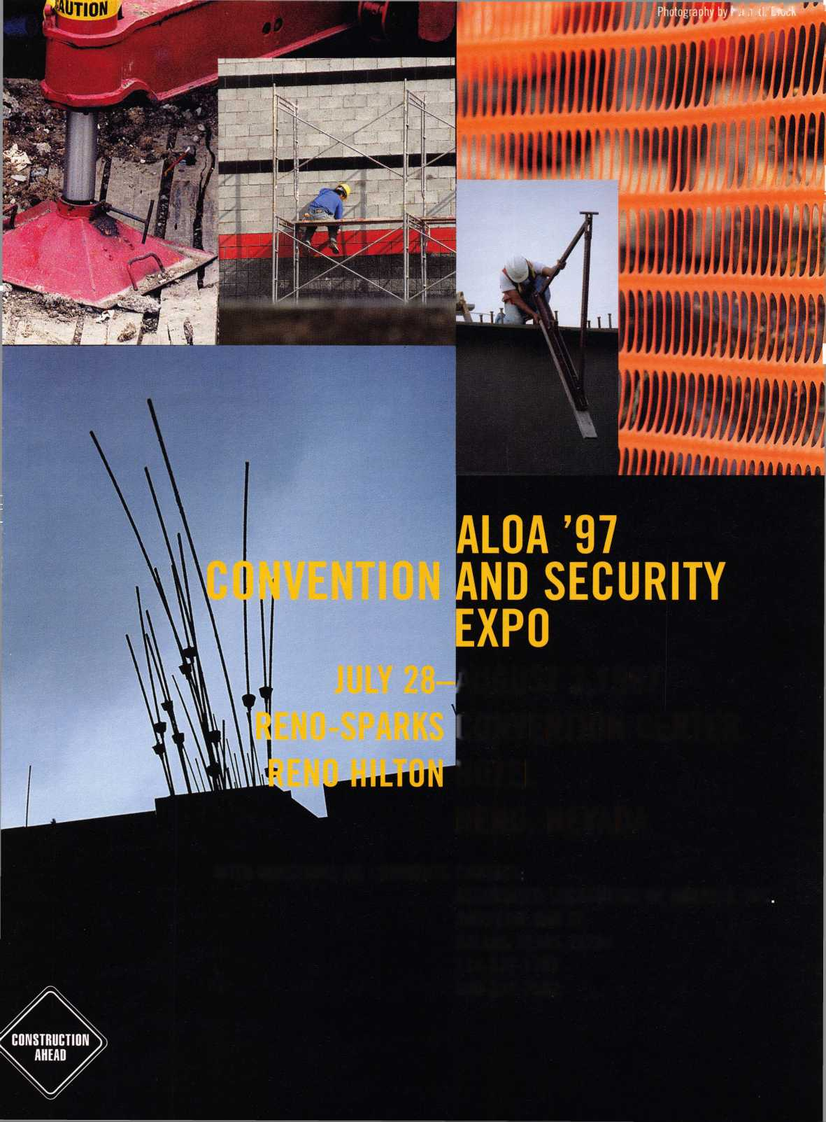

avid 1 owell

We hope to represent everyone in how tomorrow’s decisions are reached.

It has often been said that most confusion is caused by a lack of communication.  
Accordingly, I hope you all took a little time to fill out the ALOA membership survey you  
received during May. Only by hearing your opinions and needs can ALOA shape the associ-  
ation’s future in a manner that will serve all members fairly and accurately. For too long  
many of our leaders have had to rely on educated guesswork and feedback from a vocal few  
to guide policies and expenditures for an organization that is 10,000 large—and composed  
of individuals with widely differing needs and concerns. With this new and valuable infor-  
mation, we hope to represent everyone in how tomorrow’s decisions are reached. (Don’t for-  
get—the membership survey was funded by the December magazine production funds, so  
you will be receiving a combined November/December 1997 Keynotes.)

Speaking of our many members, I know you will be pleased to hear that ALOA’s ongoing  
member recruitment campaign has begun to pay off—as you will see by the long list of  
applicants on p. 12. As our numbers grow, we will be able to expand our services to each of  
you and to advance toward our goal of operating as a true international association. With  
this in mind, we will be printing the ALOA membership application on the lip of the read-  
er service card several issues each year. Give some thought to tearing out an application the  
next time you flip through Keynotes and find someone to recruit. Whether or not you want  
to join the ranks of our President’s Club recruiting veterans, if every member signed on only  
one other member, think about it—our membership base would double! And, be assured, if  
you want more than one application and don’t wish to photocopy—we’ll be glad to send  
you as many applications as you need. (Hint to chapter leaders: Are you passing out ALOA  
applications at meetings occasionally?)

Even as this issue reaches you, your board and staff are busily placing the finishing touch­es on what we hope will be a new and exciting ALOA convention. If you are still trying to decide whether or not to attend the ALOA ’97 Security Expo, let me assure you—every effort has been made to ensure that this year’s trade show, classes and fellowship experience will be the best you’ve had in a very long time. I can’t believe two years have passed and I’m about to step down as your president, but I feel inspired and confident about passing the gavel to the Nominating Committee’s chosen candidate, Dallas Brooks. Dallas is fully com­mitted to continuing the association’s positive direction and every success.

So I hope to see you at the show, and to share your ideas about ALOA and locksmithing in person soon.

-David Lowell, CML, CMS

ALOA President

i

Keynotes

June 1997

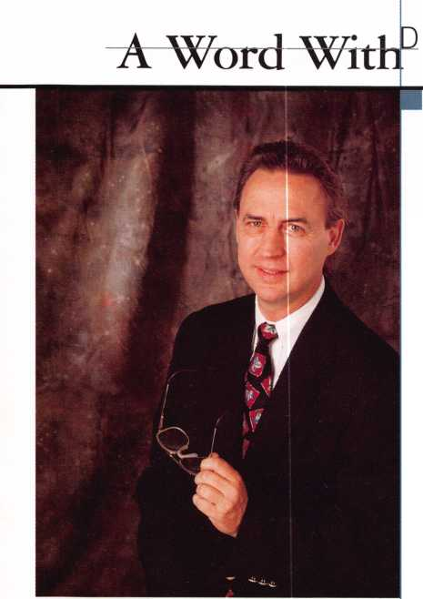

[Staff)

Executive

3oarri

Editor Associate Editor Art Director/Designer Advertising Sales

Contributing Authors

Publications Committee

ALOA Professional Staff

Staff Administrator Office Manager Receptionist Comptroller Financial Assistant Associate Executive Director Meetings & Education Coordinator Administrative Assistant Membership Coordinator Mailroom Assistant

Anne McDonald Davis, ABC

Laurie Kline

Derek Holiman

Mary Sadler

Anelia M. Banda

Jerome V. Andrews, CML

Charles Cameron,CML

Paul Chandler, CRL

Claire Cohen, CML

Bob De Weese, CPL

Ray DAdamo, CML

Sal Dulcamara, CML

James Glazier, CML

Jon Griswold, CML

A.J. Hoffman, CML

Ken Holmlund, CRL

Tom Hood, CML

Richard A. Lacy, CPL

Barry Leas, CRL

Ray Lusk, CML

Mark Ohno

David Parrott

Randy Simpson, CML

Robert Stafford, CPL

Dave Thielen

John D. Cannon, CML, Chairman

Jerome Andrews, CML

AJ. Hoffman, CML

Ricardo Ohmit, CML

Donald E. Rule', CML

John I. Shandy, CML

James Watt, CML, CPS

Charles W. Gibson, Jr.

Mary May

Margo E. Vela

Kathy J. Romo

Debra Bradshaw

Carmen D. Murphey, CMP

Jessica Vasquez

Janelle Vergara

Brandon Durrett

Jesse Morales Jr.

Complete address and phone number listings for the ALOA Board and Keynotes authors are available in your membership directory or by contacting the ALOA office at (214)827-1701.



•ion Statement: The Associated Locksmiths of America, Inc. is dedicated to enhancing the professionalism, education and ethics among locksmiths and ; in related sectors of the physical security industry. With approximately 10,000 members in the United States, Canada and the freeworld, ALOA is poised to members obtain the knowledge, the strength, and the confidence to perform their role in the physical security field with pride and dignity. But it is only gh active involvement and participation that ALOA can fully achieve its potential-and can help members to achieve theirs.

cies: Keynotes® is the official publication of the Associated Locksmiths of America, Inc. (ALOA). Keynotes® acts as a moderator without approving, disap- ng, or guaranteeing the validity or accuracy of any data, claim, or opinion appearing under a byline or obtained or quoted from an acknowledged source, jpinions expressed by the authors do not necessarily reflect the official views of ALOA. Also, appearance of advertisements and new products or service nation does not constitute an endorsement of products or services featured by the Association. The Association does not accept responsibility for the inac- :y of any data, claim, or opinion appearing in this publication, due to typographical errors on the part of the authors, Association staff or its agents, or’s Note: This publication is designed to provide accurate and authoritative information in regard to the subject matter covered. It is provided and do­nated with the understanding that the publisher is not engaged in rendering legal or other professional services. If legal advice and other expert assistance pred, the services of a competent professional should be sought.

hors’ Payment: Effective Nov. 1, 1995, payment will be made for original articles submitted exclusively to Keynotes® magazine at a rate of: technical arti- -$75 per page, double-spaced with standard one-inch margins: and business/human interest articles-$50 per page, double-spaced with standard one- margins. (If only a portion of an eligible article is published, payment will be made for that portion only.] Authors will be paid $10 for each photograph,

:, exhibit or illustration that is utilized for their article. Maximum payment for both copy and photos is $350 for technical articles and $150 for less/human interest articles.

lent will not be offered for articles submitted by ALOA employees or members of the ALOA Board of Directors (unless material is of a technical nature), nor tides submitted by a company that promote that company's products or services. ALOA reserves the right not to pay for articles submitted by an individ- ) that promote a particular company’s products or services.

:laimer: The Associated Locksmiths of America, Inc., (ALOA), reserves the right to refuse any article for any reason. Additionally, ALOA reserves the right lit, amend or modify any article submitted for publication in order to preserve technical accuracy, clarity, fairness or grammatical correctness. ALOA will ; the best efforts to notify the author of any changes. The extent of ALOA’s liability for any article or information contained therein will be a notice of correc- Dr retraction in the next possible issue.

otes® (ISSN 0277 0792) is published monthly except for the combined July/August issue by The Associated Locksmiths of America, Inc., 3003 Live Oak St„ s, TX 75204-6186. Telephone: (214) 827-1701; FAX (214) 827-1810; e-mail [aloa@anet-dfw.com](mailto:aloa@anet-dfw.com). Subscription rates for members-$15.00 per year. Second postage paid at Dallas, Texas. POSTMASTER: Send address changes to: Keynotes, 3003 Live Oak St., Dallas, TX 75204-6186. © Copyright 1997, All rights ved. No part of the contents may be reproduced or reprinted in any form without prior written permission of the publisher.

President

David M. Lowell. CML, CMS

(602) 263-7716

Regional Vice Presidents

Southeast

Dallas C. Brooks

Chairman: Finance Committee

(334) 826-8990

North Central

David A. Paulsrud, Sr., CML

Chairman: ALOA Scholarship Foundation, Inc.

(612) 533-6164

South Central

Carl King, CML

Chairman: Bylaws Committee

Curator: ALOA Museum

(713) 465-2500

Southwest

John I. Shandy, CML

Chairman: Membership Committee

(303) 443-9740

Northeast

John D. Cannon, CML

Chairman: Publications Committee

(703) 960-6413

Northwest

James M. Watt, CML, CPS Chairman: PRP Committee (406) 549-7667

Secretary

Ricardo Ohmit, CML (217) 384-6006

Trustees:

Breck H. Camp, CML, Chairman (770) 455-6244 Henry H. Printz, CML (201) 538-2737

Evelyn V. Wersonick, CML, CPS

(505) 247-9413

Leonard J. Passarello, CPL

(416) 752-7210

Edwin Toepfer, RL

(416) 225-5589

Directors

Dana L. Barnum, CML Chairman: Chapters Committee (610) 565-9900 Mark E. Blum, CML, CPS (517) 482-5809 James H. Glazier, CML Chairman: Education Committee (301) 831-5454 John J. Greenan

Chairman: Legislative Committee (773) 486-2030 Barry K. Leas, CRL (610) 272-9292 Raymond C. Lusk, CML Chairman: Convention Committee (509) 624-3152 Jeffrey S. Nunberg, CML (305) 324-8800

Anthony J. Ramunno, CML, CPS Chairman: Library/Museum Committee (330) 782-6204 Randy L. Simpson, CML Chairman: Public Relations Committee

1. 780-7026 Robert H. Stafford, CPL Chairman: Grievance Committee (860) 768-7917

William T. Straub, CML

1. 779-0383 Bruce J. Tarbet, CML (601) 924-4184

Chairmen of International Affairs

Laurence P. Mills Australia (129) 958-0445 Hans Mejlshede, CML Europe

Members-at-Large

Jerome V. Andrews, CML

(860) 621-3601

Steven G. Engel, CML, CPP

Chairman: Strategic Planning Committee

(414) 731-5400

Thomas Freehling, CML

(320) 629-6538

AJ. Hoffman, CML

(714) 474-8877

J. Thomas Hood, CML

(610) 539-9555

Donald E. Rule', CML

(601) 324-2658

June 1997

Keynotes

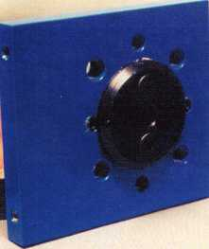

2a

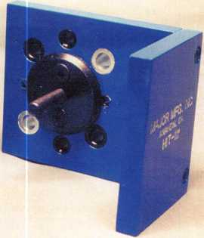

2

A Word With David Lowell

On Our Way To Serving You Better

o

o

c

9

Focus On Education

Planning For the Future By James Glazier, CML

3

**3**

***V)***

11

Legislative Comment

Testifying Before A Legislative Committee Hearing By John

Greenan

56

PRP Report

Just Getting Started By James Watt

57

Trade Tips

Atrium Door Locks and VATS By Tony Ramunno, CML, CPS

58

Chapter News

Positive Outlook By Dana Barnum

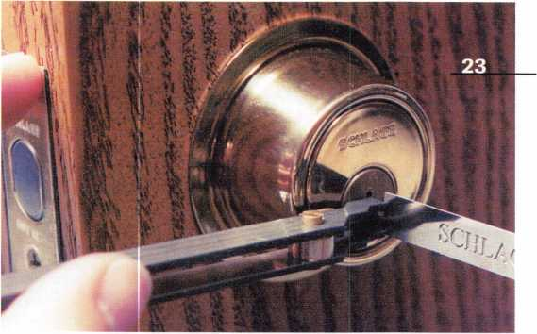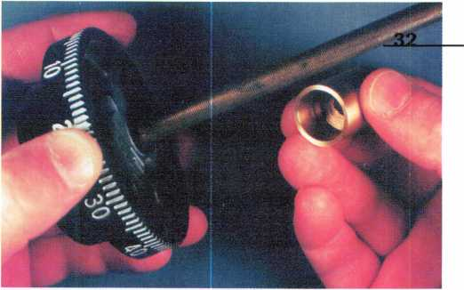

6Q

Mailbox ®

Fighting for change O

u

a

Upcoming Events

Important dates

12

Applicants For Membership

Scheduled for clearance for July 1

3

**CD**

**3**

**C/>**

14

Security Marketplace

New stuff

15

Industry News

Winners

59

ALOA Extra

The latest happenings in your association

60

Backpage

Straight from the horse’s mouth.

47

Buyers’ Guide

48

Associate Members

53

Classifieds

59

Ad Index

Keynotes

June 1997

**Advertising**

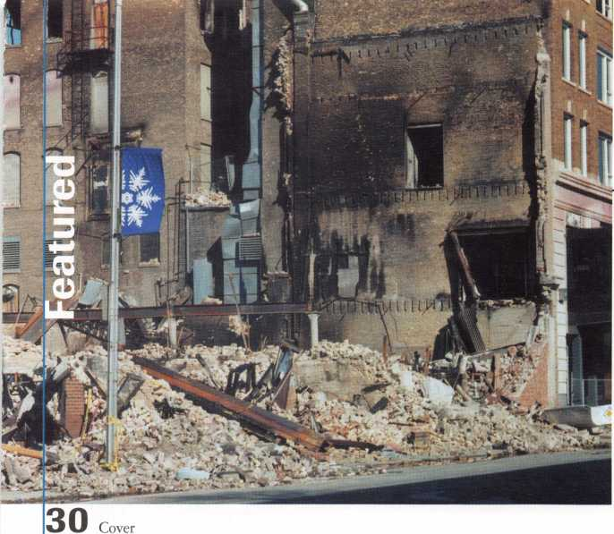

**Disaster in the Upper Midwest**

In the wee hours of the morning of April 18, the people of Grand Forks were startled by sirens blaring. Several ALOA members were among those forced to flee their homes and businesses in the face of the worst disaster ever in this part of the United States. Keynotes would like you to know more about it, and to help if you can.

Featured:also

10

**Bylaws Changes**

Familiarize yourself with these proposed changes, scheduled to be voted on at the August 2 membership meeting in Reno.

20

**Yale Collectors’ Edition**

If you got Yale locks that are over 20 years old, this guide will come in handy.

By AJ. Hoffman, CML

36

**ALOA ’97 Parade of Stars**

Check out the latest products to be found on this year’s trade show floor, and save the map so you can start planning your ALOA ‘97 Security Expo exploration now.

Image of flood used on cover © Star Tribune/Minneapolis-St. Paul

X

**o**

l2

■ I

X

□

H

O

LL

0

CU

0

0

o

o

,0

16

**Lori Lock’s Captive Thumb Turn**

Gain a reputation for being concerned about occupants’ safe-  
ty, as well as the security of your customer’s property.

By Wayne Gurnee, CRL

18

**Preparing For The Future With Value-  
Added Tools**

You can’t buy them, but you can use them to sell. Find out  
how these tools can increase your bottom line.

By Claire L. Cohen, CML

23

**Thank You, Santa**

This impressive lock opening/decoding tool might make  
some start their holiday wish list a little early.

By Sal Dulcamara, CML

26

**Opening Cars For A Living**

Goodbye to Slim Jims and hello to car opening tools from Sully.

By Steve Engel, CML, CPP

28

**A Major Hit For Installation**

Get the inside scoop on a versatile drill guide.

By Sal Dulcamara, CML

32

**Tools, Tools, Tools**

Everything you wanted and needed to know about Lockmaster’s spindle cut-off tool.

By Brian Costley, CML, CMS ■

June 1997***Keynotes*** | 5

**Keynotes**

Mail Box



(Dept)

**If you have an opinion to offer on the letter(s) printed in** Keynotes **each month, let us know! Submissions to the “Keynotes Mail Box” department are printed on a space-available basis.**

**Write to: Keynotes Mail Box;**

**Associated Locksmiths of America, Inc.; 3003 Live Oak Street; Dallas TX 75204; or FAX (214) 827-1810.**

Get Your Pen Out

Dear Fellow Locksmiths:

Recently, I wrote a letter to Chrysler’s Customer Assistance addressing locksmiths’ inability to get key codes for customers.

In my letter, I addressed the extra cost our customers had to pay to get lost keys originated because of that inability.

I was contacted within 10 days by Chrysler’s representative, Nicole Thorton. Ms. Thorton addressed their concern for consumer safety as being the reason they do not give out key codes to anyone other than a Chrysler dealer. I explained how other roadside programs protected their con­sumers by having only locksmiths regis­tered with their company able to get the codes from them. Ms. Thorton then explained that my letter was to be turned over to the team who handles this decision and that it would be considered because, after all, it is in their best interest to do what they can for their customers. She also went on to explain that my letter addressing this problem was one of only a few letters. She suggested that locksmiths start writing letters to customer service in order to sway those powers that be.

That is my purpose in writing this let­ter—to get as many locksmiths as possible to write and help institute change. The address follows:

Chrysler Customer Center

P. 0. Box 21-8004

Auburn Hills, Ml 48321-8004

If you are interested in being involved in Chrysler, please write them. Just for thought—right now they only have roadside assistance through tow truck companies.

I thank you for your time.

Mary Jenkins

Telephone Machine Gripes

Dear Editor:

How many times have you called a com­pany for information and ended up talking with, or punching numbers into, a machine?

I realize that it is less expensive to have a machine answer the telephone and route the

calls, and sometimes you can get the needed information from the machine, but there are times when a person is needed to answer a specific question.

During the past month, we tried to get specific information on interior parts of a lateral fire file that an “in house” mainte­nance man had “repaired,” and now one drawer will not close. Our supplier tried to get the information, and after talking to the machine many times, told us that they would not try again.

I tried the machine route, and after the machine told me twice that the information would be sent—and then after not receiving anything from the company—I made a call to the vice president. Again, a machine told me “he was out of town,” but I did get a return call and he advised me he would send the needed information, which he did.

I have since had to call again, and after the machine gave me the runaround, I talked to a human and was advised that they did not actually manufacture the prod­uct, but would try to get me the informa­tion. It has been over a week and I’m still waiting.

How can a company expect to stay in business if they rely on total telephone machines that do not do what they say they will? I have sat in many offices when the phone would ring, and the person would say “Let it ring—I do not want to talk with them. The machine will take the message.” George A. Sharpley, CML

Frustrated With Service

Dear Editor:

I am writing this letter in frustration about the recent developments in service that I have been having with three of the roadside service networks. It seems that they now have all decided that the rates that we have quoted and that they have authorized payment on in the past are not now acceptable.

AAA has agreed to give us all of the lockouts in our region of service, which we have been servicing for the last 25 years. When we agreed to give them a discounted

rate for the initial service and night rate, we got some calls, but they soon went back to the wrecker services. We aren’t able to get our reduced rate back through overpriced repairs like they do to make up for the lower tow rates. If the customer was not there (GOA) when we arrived, then we would only get half of our service charge, but we still had to take our service vehicle to the service site. I feel that this is unfair and we were forced to drop their service because of lost revenue, but we still had the same expenses.

CCMC just recently changed their rates that they are willing to pay the locksmith for performing the duties that we have done since they have started business. Just recent­ly, we performed various automobile open­ings, quoting the dispatcher the rates before leaving to the customer’s location, as we normally do. The dispatcher approved the rates. When the check arrived, three of the jobs were paid at a rate that they established in March of 1994 with no annual review. Their rate was $35 for days and an addition­al five dollars for nights plus an additional one dollar per mile after 10 miles. We never signed an agreement for these rates without the possibility to review annually. I am sorry, but I can’t go out for the rates that they want to pay and still pay my employ­ees, make a profit and stay in business. Since we would not agree to their terms, they said that they would not use us anymore as their primary locksmith in this area. Since other locksmiths in our area don’t go out at night, I guess all of their customers will have to wait until the morning hours for service.

RCN or General Motors has a problem paying the rate for the service call plus sales taxes if you quote them as separate items. I was told today that I don’t pay sales tax and I asked for a sales tax redemption form for our state. I was told it wouldn’t happen since I need this form or I would be fined if I didn’t charge the sales tax. I was told just to add on the approximate amount of sales tax to the estimated cost of the trip charge. This is fine, but it seems that this type of overestimating will cost them more money

Keynotes

June 1997

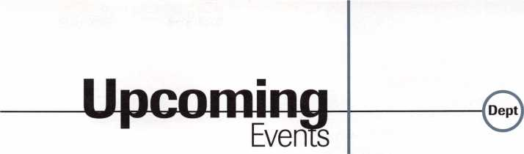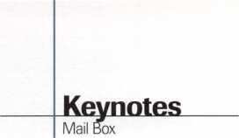

|  |  |  |  |
| --- | --- | --- | --- |
| than if they paid the right amount quoted | June ’97 | ADI Expo Series | / Future |
| over the phone. | 1 | New Orleans, LA | Conventions |
| In my opinion, it seems that since we | California Locksmiths’ Assoc. | (504) 581-1000 |  |
| locksmiths as a group made these compa- | Sacramento Valley Chapter |  | 1998 |
| nies successful businesses, now we have to | SWAP Meet, Trade Show, Lock- | 28-Aug. 2 | ALOA ’98 |
| renegotiate rates for our services. What they | smith classes | ALOA ’97 Security Expo and | June 15-20 |
| are doing is amounting to price fixing for | Elk Grove, CA | Trade Show | Nashville, TN |
| their industry, and if we discussed prices, we | Contact: Joe Longoria | Reno, NV | SAFETECH ’98 |
| could be in trouble for price fixing. I think | (916) 391-1744 | Contact: ALOA Meetings |
| that we have to act in an united front with |  | (214) 827-1701 | May 4—9 |
| these companies so that we can all survive | 1 | FAX (214) 827-1810 | Valley Forge, PA |
| and make a living in the profession we have chosen in life—we are aware of the rates | 3rd Annual Locksmith Swap  Meet and Olympics | August ’97 | 1999 |
| that we need to charge. We are all profes- | Lyndhurst, NJ | 2 | ALOA ’99 |
| sional locksmiths, and our services and our | Contact: Jeff Si tar | ALOA Annual Membership | July 25-31 |
| rates reflect the professionalism that we | (201) 777-0620 | Meeting | Cincinnati, OH |
| show in our businesses. I realize that there are price cutters out there and this is why | June 29-July 6 | Reno, NV  Contact: ALOA Meetings | SAFETECH ’99 |
| we are not considered professionals. Look | European Locksmith Federation | (214) 827-1701 | May 3—8 |
| what the discount stores (Home Depot, | Locksmiths Convention | FAX (214) 827-1810 | Las Vegas, NV |
| Walmart) have done to our industry and others in your neighborhood. If these service | Contact: Keynotes staff (214) 827-1701 | 25-29 | 2000 |
| companies can set the rates that they are |  | mark bates Associates | ALOA 2000 |
| willing to pay for your area, you may not be | July ’97 | 5 Day D.O.D./D.O.E. | Date TBA |
| able to make a living as a locksmith doing | 10 | Combination Lock Training | Las Vegas, NV |
| emergency service lockouts. | ADI | (888) 622-5495 |  |
| William Timmann, CML | ADI Expo Series |  | SAFETECH 2000 |
|  | Cincinnati, OH | September ’97 | May 8-13 |
|  | (513) 771-7744 | 24-28 | Lexington, KY |
|  | 15 | SERLAC  Grenelefe, FL | 2001 |
|  | ADI | Contact: Kennith Moore | ALOA 2001 |
|  | ADI Expo Series | (904) 526-5397 | July 15-21 |
|  | Houston, TX (713) 688-0100  14-18  mark bates Associates | 18-21  TAOL 24th Annual Convention Toronto, Canada  Contact: (416) 321-2219 | Baltimore, MD  For PRP dates, see p. 52. For ACE dates, see p. 5 7. Send in the |
|  | 5 Day D.O.D./D.O.E. | FAX (416) 321-5115 |
|  | Combination Lock Training (888) 622-5495 | October ’97 | dates of your organi­zation’s activities |
|  | 17  ADI  ADI Expo Series  Townson, MD (410) 321-7400  22  ADI | 21-26  24th Annual Tri-Regional  Security Conference  Bellevue, WA  Contact: Harold Hasfjord (206) 846-1570}  FAX (206) 846-2291 | today!  J |

June 1997

Keynotes

**New Standard Traditional**

***designed by Robert A. Labbe CEO***

**UNIVERSAL AND ORIGINAL TUMBLER PINS AND PROFESSIONAL PINNING KITS ARE THE ONLY CHOICE OF SECURITY PROFESSIONALS, THE FINEST LOCK MANUFACTURERS, ALL THE LEADING LOCK WHOLESALE DISTRIBUTORS AND CONTRACT HARDWARE SUPPLIERS WORLDWIDE.**

**700 EMMETT STREET. BRISTOL, CT 06010 • 1-860-589-6037 • 1-800-243-8242 • FAX 1-860-583-7838**

**Frpp Infnrmptinn - RpaHpr Rprvirp Hard HO**

**Premium Tumbler Pins**

**The Most Advanced  
Universal Pinning Systems**



|  |  |
| --- | --- |
| "E* | On Education |
| rocus |  |
| 1 | IB James Glazier, CML  Education Chairman |

Please do not kiss goodbye this opportunity to better prepare yourself for the future.

/upcoming ACE Classes

New Mexico Convention

June 6-7 1997 Ruidoso, NM

Contact: Steve E.Highland, CML (505] 884-0046 Five ACE Classes

North Dakota Chapter

June 21, 1997 Fargo, ND

Contact: Todd Ladwig, CML (701] 232-9440

Professional Bypass Techniques Instructor: C. Allen Halverson

ALOA ’97

July 28-Aug. 1, 1997 Reno, NV

Contact: ALOA Meetings Department (214] 827-1810 FAX; (800] 532-2562 Approx. 45 full-day classes, 30 half-day classes and six evening seminars See brochure for details

Gateway Locksmith Association

September 6-7, 1997 St. Louis, MO

Contact: Steven Meinhardt (314] 638-6440

Master Key Methods & Formats Instructor: Jerome Andrews, CML

Central Pennsylvania Locksmith Assoc.

October 5, 1997 Contact: Frank Busch, CRL (717] 848-1754 PRP Preparation Class Instructor: William Neff, CML

Grand Canyon Chapter

October 18-19, 1997 Phoenix, AZ Contact: John Ilk (520] 474-8879 Domestic Auto Service Instructor: Ray DAdamo, CML

Central Pennsylvania Locksmith Assoc.

November 1, 1997 Contact: Frank Busch, CRL (717] 848-1754 Hands-On Access Control Instructor: William Neff, CML

Here is some great news! The Grand Canyon Chapter of ALOA just recently awarded $300 as a door prize at their Educational Weekend, April 5 and 6, where Ken Lee instructed a two-day ACE Safe Manipulation class. This was for assistance in attending ALOA’s Security Expo in Reno, NV, and the winner was John Ilk, CRL, the chapter vice chairman. Congratulations, John! Not only did they do this, but now they are matching dollar-for-dollar any ALOA scholarship awarded to a member of their chapter. This is really a great idea. How about some of the other chapters or associations considering this type of assistance for their members? They have already scheduled another two- day ACE class for October. Hey, chapters— are you going to let Grand Canyon chapter get ahead of you?

Here is some more great news! Sargent & Greenleaf has awarded the ACE program with a very high honor. ACE/ALOA will now be doing S&G certification classes, which will soon be scheduled by ACE and upon the request of various distributors. I am presently working with Brian Costley, CML, CMS, to work out all of the details on this certification program for S&G. At the ALOA Security Expo in 1998 in Nashville, ACE will present the first National Cabinet Lock certification class and will be doing certification for National throughout the coming year. I am presently working with Mr. Larry Roddy, National Cabinet Lock, to work out all the details as we prepare the outline and lesson plans for this class. ACE is on the move for the members’ benefit by bringing new and innovative classes to help you make more money in the future.

Well, you have now received you ALOA ’97 Security Expo brochure and have seen the great—and some new—classes that are being offered this year. Please do not kiss goodbye this opportunity to better prepare yourself for the future. I know that educa­tion is not very cheap, but ignorance is really expensive. Come and join your fellow lock­smiths, manufacturers and exhibitors, and gain the knowledge of a lifetime through interaction with all of these fine people.

Please—do not forget the membership meeting on Saturday morning, Aug. 2, from 9:00 to 11:30 am in the Convention Center. There will be a continental breakfast. This will be your opportunity to elect two-thirds of the officers and directors of your associa­tion. All awards will be given out at the banquet on Friday night, Aug. 1, from 7:00 to 10:00 pm in the hotel. Come see who gets the prestigious A.L.O.A. award, the ACE award and the Don Davis award. You really can’t afford to miss any of this great event, not to mention the fun one can have in Reno this time of year.

I am presently working with the Alabama Locksmith Association on a busi­ness class for September 1997, and with the Central and Southern Colorado Association for a Simplex/Unican manipulation and a lock picking/impressioning class for September 1997. ACE now owns the Simplex/Unican manipulation class and the copyright to the manuals, which are avail­able from Dallas for $35 plus postage and handling. ALOA also has a very nice Basic Locksmithing Manual by Joseph E. Rathjen, available from Dallas for $25 plus postage and handling.

Hope to see you all in Reno, and please let me or Jessica Vasquez in Dallas know if there are other classes that you would like to see ACE offer. This is your association and I, and the education committee, need your input. If we are doing something wrong, let us know, and if we are doing something right, it would be really nice to know this also.

The committee works hard to improve our educational offerings, so let us know your thoughts. You can fax me at (301) 831-5368, or call at (301) 831-5454.

Until next month.

1

1 About the Chairman: James

Glazier, CML, #14240, is a retired police officer  
and operates Security Plus in Mount Airy, MD.  
He also serves on the Finance, Convention and  
Personnel Committees of the ALOA Board.

June 1997

Keynotes



Bylaws Changes

The Membership meeting at this year’s convention will be very important. Because there was no quorum for last year’s meeting, business could not be con­ducted. This means that a lot of the business will be carried over to this year. In order to conduct the meeting efficiently, it will be best if those in attendance are familiar with the proposals to be presented to the membership. The bylaws require that proposed bylaws changes be published for just this purpose. The proposed bylaws changes and a resolution are printed below, along with some explanation of the board’s reasoning for proposing the changes.

Article III—Membership, Section 1. CLASSES: A. ACTIVE:

Currently reads: “Persons actively engaged in servicing or installing security hardware who have worked in the security industry for at least two years and can provide at least two of the following items:”

To read: “Persons actively engaged in the locksmith/access control industry for a minimum of two years and can provide at least two of the following items:”

The change is designed to better define eligibility for mem­bership. “Access Control” is an expression that encompasses more of what locksmiths do. Identifying locksmiths with access con­trol may be beneficial as the industry encounters more competi­tion from relatedfields.

Article Ill-Membership, Section 1. CLASSES: C. RETIRED:

Currently reads: “Persons who have been:

1. Active members for at least 20 years, have reached the age of 62 and have withdrawn from active engage­ment in the industry; or”

To read: “Persons who have been:

1. Active members for at least 15 years, have reached the age of 62 and have withdrawn from active engage­ment in the industry; or”

As many of our members enter the locksmithing profession following other work, they do not have time to work 20 years prior to their sixty-second birthday. Lowering the requirement for time as a member will allow more people to enjoy a relation­ship with their profession when they withdraw from full time employment.

Article III—Membership, Section 1. CLASSES: Added:

1. COMPANY SPONSORED: Employers of at least one person qualified for active or apprentice member­ship. Sponsored individual members shall demonstrate eligibility for Active or Apprentice membership as set forth above and submit an application to the association headquarters. Dues shall be paid and memberships) owned by the company and shall be transferable in the case of changes of employees. Said individual members shall have all member privileges, including voting.

In some lock shops, the owner pays for the membership of all employees. This change is designed to allow the employer to own the membership of his employees, if he pays for it. The employee’s membership would terminate when the employee leaves the employer, unless the employee transfers to individual membership by paying his own dues. The employer would be entitled to use the company membership, for which he has paid, for another employee. This would allow for an increased membership of employee locksmiths. Each employee would still have to demon­strate eligibility for membership.

Article III—Membership, Section 1. CLASSES: Added:

1. INSTITUTION SPONSORED: Persons qualified for

Active or Apprentice membership as set forth above and who submit an application to the association headquar­ters. Dues shall be paid and shall be transferable in the case of changes in employees. Institution sponsored members shall have all member privileges, including voting.

Institutions employing locksmiths are frequently reluctant to pay ALOA dues for these employees because the membership belongs to the locksmith. This change is similar to the “compa­ny sponsored” change in that the membership belongs to the institution. If the locksmith leaves the employment of the insti­tution, the institution can transfer the membership to another, or a new, employee who qualifies for membership.

Article III, Section 4. TRANSFER:

To amend:

Membership shall not be transferable except as specified above.

Article Vll-Officers and Directors Section 1.

Officers

A. PRESIDENT

Currendy reads: The president shall serve one term of two years or until his successor is elected and qualified. To read: The president shall serve one term of two years or until his successor is elected and qualified. Upon elec­tion of his successor, the president shall no longer be eli­gible to serve as an officer of the ALOA.

This change clarifies various provisions of the bylaws. Article III, Section 3, QUALIFICATIONS requires that to be elected an officer, persons must be qualified to be president. As the president can serve but one term, he could not meet this requirement. As only the serving officers are eligible to become president, the membership is limited to no more than seven can­didates for each presidential election. Having someone serve as an officer who is not eligible to be president would more severely restrict the membership’s options.

Article Vll-Officers and Directors Section 3. QUALIFICATIONS

Currently reads: “...The president shall be the owner, partner, corporate officer or employee of a retail lock­smith establishment and shall be serving a term as an officer of the association when nominated...”

To read: “...The president shall be an active member in the ALOA and be serving a term as an officer of the association when nominated...”

This change is intended to make any active member eligible to serve as an officer or as president of the association.

Currently, those locksmiths who may be working for institu­tions, or other non-retail companies, are not eligible.

Article XI—Committees, Section 1. STANDING: Add:

Section (Number TBD). STRATEGIC PLANNING: The Strategic Planning committee shall formulate and recommend to the board a plan to support the mission and objects of the association. The committee shall con­

tinuously review this plan and recommend changes to the board.

The Board of Directors believes that a plan to bring ALOA and its members into the next century is needed. The Strategic Planning committee has been meeting as a special committee. The board believes that the planning process should be continuous and permanent.

Article Xl-Committees, Section 1. STANDING: Add:

Section (Number TBD). LEGISLATIVE: The Legislative committee shall be responsible for legislative affairs. Its duties shall include, be not be limited to, developing policies and legislation.

The board recognizes the need for the association and its members to be aware of legislation and its potential impact on the members. The board also recognizes that ALOA may, from time to time, need to develop legislation which is in the best interest of the membership. In order to ensure that these things can be done, the legislative committee is required.

Article XII—Chapters, Section 4. MEMBERSHIP:

Currently reads: “A chapter shall limit its membership to ALOA members and no ALOA member may be a voting member of more than one chapter at the same time.”

To read: “A chapter shall limit its active membership to ALOA members.”

This change is intended to allow chapters to establish classes of membership which allow non-ALOA members to participate in chapter activities. This participation would allow non-mem­bers to become familiar with the advantages of chapter and ALOA activities and thereby encourage membership in the two organizations. It is expected that a new class of membership would not include voting privileges, the right to be an officer of the chapter and would be restricted to a limited period of time. This would also allow membership in more than one chapter. Since an important purpose of chapters is to promote educational and social activities among locksmiths, this seems an appropri­ate change.

Resolution

While not a bylaws change, a resolution concerning elections will be presented to the membership for vote. The resolution is:

“The ALOA Board of Directors will reduce the number of directors from twelve (12) to nine (9) by not filling the next three (3) vacant directorships in an effort to reduce the cost of governance.”

The ALOA is making a concerted effort to provide services in a cost effective way. There is increased need to provide funds for programs such as education and legislation. This effort requires an increase in revenue, as well as a reduction in other types of costs. This proposal will save the association an esti­mated $10,000 each year.

Keynotes

June 1997

ALOA Board of Directors Applicant Data Sheet

(For Review by Nominating Committee Only)

PERSONAL INFORMATION

Date of Application: Date of Birth:

ALOA Member #: Member since:

Name: PRP Level:

Home Address:

City, State, ZIP: Home Phone: ()

EMPLOYMENT INFORMATION

Name of Business:

Business Address: FAX number: ()

City, State, ZIP: Business Phone: () _

□ Owner □ Employee Number of full time employees, including yourself Types of services provided by your Arm. (please check all applicable categories)

|  |  |  |  |  |
| --- | --- | --- | --- | --- |
| LOCKSMITHING | SAFES | | OTHER SERVICES | |
| □ Residential | □ | Service & Combination Changing | □ | Alarms |
| □ Commercial/Industrial | □ | Safe Repair | □ | Access Control |
| □ Automotive | □ | Safe Opening | □ | CCTV |
| □ Master Key Systems | □ | Time Locks & Vault | □ | Other (please explain) |

Your personal specialties are:

ASSOCIATION EXPERIENCE

Chapters and Local Associations you are a member of:

Officer positions held and dates:

PERSONAL REFERENCE

Name: ALOA Member ft

Address:

City, State, ZIP: Phone:

Please complete reverse side

Revised 9/93

ALOA Board of Directors Applicant Data Sheet

(Continued)

Please attach a resume and a recent photograph of yourself. The resume should include:

* Your personal history as well as your previous involvement with ALOA, ALOA chapters, and other locksmith associations.
* Any other information you feel would be helpful to the Nominating Committee in its selection of officers and directors.
* A brief statement about what long-range goals you feel ALOA should pursue and how you can help to achieve those goals.

All information provided on this questionnaire will be held in the strictest confidence, and is for the sole use of the ALOA Nominating Committee. However, please retain a copy for your own files.

Your Commitment to ALOA Board Service

(Please read carefully and sign where indicated.)

The responsibilities of an ALOA Board member include contributing a significant amount of personal time to the organization. New members are usually appointed to three or four committees and are obligated to prepare for and participate in five to six days of meetings during the week of the Spring and Fall Board of Directors meetings. These meetings usually start early in the day and may last well into the evening. Board members are also expected to perform work assignments which may require time and sometimes travel in addition to the Board meetings. Board members must attend the annual membership meeting and all required functions at the convention, requiring up to nine days. Board members may also be assigned to represent ALOA at related local, state, or regional functions, including serving in the ALOA Booth, and otherwise promoting ALOA.

Expenses are the responsibility of the individual Board member except for lodging, travel expenses and a small food allowance. The Board has stipulated that assigned travel will be reimbursed at the lesser of the 30-day advance tourist class airfare in effect at the time of travel or the current per-mile rate for travel by personal automobile. Spouse expenses, including extra room charges, etc., are the individual’s responsibility. Board members purchase their own Board jackets required for all desig­nated functions. In summary, approximately on month or more of personal time and the expenditure of $2,000.00 to $4,000.00 of your own funds may be required to serve as a member of the ALOA Board of Directors.

I have read and understand the above responsibilities of an ALOA Board member, and agree to commit my time and energies as needed. I certify all of the information contained on this ALOA Applicant Data Form and supporting documentation to be true and complete.

Signed: Date:

This application and all supporting documentation should be submitted no later than one month prior to the ALOA Board Meeting.

Mail to: CONFIDENTIAL

Chairman, ALOA Nominating Committee  
3003 Live Oak Street  
Dallas, TX 75204-8186

|  |  |
| --- | --- |
|  | Comment |
| Legislative |  |
|  | ^ponr^Ujree n a n  Committee Chairman |

Legislative Comment is written by  
John Greenan on behalf of ALOA’s  
Legislative Committee. Comments or  
questions can be directed to him at:  
Fink Safe & Lock; 2307 N. Western  
Ave.; Chicago, IL 60647; (773) 486-  
2030; FAX (773) 486-4268.

There are certain rules or norms of behavior we must make sure to follow so that our professionalism comes through.

A very positive phenomena is occurring within ALOA: membership is becoming more and more involved in legislative proto­col. This action not only strengthens ALOA as an association, but by becoming active, locksmiths worldwide will have a stronger voice. The stronger the voice, the stronger the profession, and that effects each and every one of us. Hats off to everyone who is taking time out of his or her busy schedule to fight for the legislative rights of lock­smiths.

When dealing with the legislature, there are certain rules or norms of behavior we must make sure to follow so that our profes­sionalism comes through. If locksmiths are perceived as professionals, our level of credi­bility will increase. The more credible the source, the more influential and persuasive that source will be. If you plan to testify before a legislative committee, there are a few things you should remember: you’ve got to look good, sound good and act good. By doing these three things, you’ll come across great.

Professionalism begins with appearance. While it’s not necessarily true that “the clothes make the man/woman,” a nice suit sure does help! Approaching a legislative committee in a clean, well tailored, freshly pressed suit acts like a firm handshake: it sends the message that you are a sophisticat­ed, put-together kind of person. Like it or not, the way you look influences the way

people respond to you, and it can make the difference between being taken seriously and taken for a ride. If you plan on testifying at a legislative committee hearing or simply attending one to show support, make sure you look crisp, clean and professional.

The next thing to remember is that you are attending a legislative meeting to make a difference and you want people to respond to the things you say. If you want people to lis­ten to you, you must use language that com­municates your point in a professional man­ner. Avoid using slang or industry jargon— stick to a formal style of speaking that is professional yet friendly. If you speak clearly, directly and professionally, you will captivate your audience and have the best opportunity to influence people. Have you ever watched someone make a presentation that was filled with “urns,” “oks,” and long, unmotivated pauses? If you have, then you know how that speaker came across: like they didn’t know what they were talking about! If your audi­ence thinks you are uninformed about your topic, they will not be open to your opin­ions. In other words, if you do not come across as professional, credible and confident, then your audience will be less likely to pay attention to what you are saying. Be sure you stand or sit tall and make eye contact with the people in the room. This sends the message that you are speaking to everyone and no one will feel excluded or alienated. If you have devoted valuable time to speak at a

senate committee on behalf of locksmiths in your area, make sure your message comes through like a well-tuned airplane, not an exploding hand grenade.

Finally, it is imperative that you behave professionally. This means giving focus to people when they are speaking, raising your hand if you want to comment and keeping opposing opinions to yourself when you do not have the floor. By showing others respect, you will receive respect—even if there are people who are not supportive of your legislation. The Golden Rule will always apply: if you want to be treated like a professional, you must treat others the same.

Testifying before a senate committee can be a nerve-racking experience, but by look­ing, speaking and behaving like a profession­al, you will leave the room feeling proud that you spent the time and energy to help your profession. I hope all of you will keep up the good work—the industry can only benefit from your dedication.



Greenan represents the fifth generation of lock­smiths and is vice president of Fink Safe & Lock in Chicago, IL. A locksmith since 1985, John also serves on ALOA’s Convention and Strategic Planning committees. He is also chairman of the Allied Locksmiths of Illinois

**Legislative Action Contact Network**

Date

Name

Company Address

I am interested in:

* Working on Legislative Issues
* Fundraising
* Gathering/Giving Information

Home Address

Telephone

FAX

e-mail

June 1997

Keynotes

Applicants

For Membership

ALABAMA

Bessemer

026871, Michael L McCluskey, A

Pell City

026817, Robert A McGowin, A

ARKANSAS Fort Smith

026807, Glenn R Patterson, AP SPONSOR:Marie Mikus

ARIZONA

Eloy

026750, William R Miller, A

Mesa

026824, Jerry M Davner, A SPONSORS Rheam

Phoenix

026823, John H Anderson, A SPONSORS Rheam 026805, Michael W Meehl, A

CALIFORNIA

Alhambra

026872, Van Chau, A

Canoga Park

026873, Archie S Himidian, A SPONSOR:Dallas Brooks

Corona

026877, Kyle R Klingler, A SPONSOR Jim Williams

Costa Mesa

026881, David E Dunn, A SPONSOR John Shandy

Hollister

026869, Mike E Bidegary, AP SPONSORiCharles Robertson 026777, Casey J Long, A SPONSOR Jerry Muenzer

Huntington Beach

026875, Dave A Brand, A SPONSOR:George Hill

Lemon Grove

026778, Angelo A Williams, A SPONSOR:Burt Fieser

Long Beach

026882, Aaron R Tuff, A SPONSOR:Thomas Bell

Los Angeles

026876, David R Huling, A

Moreno Valley

026880, Dennis E France, AP SPONSOR:Frank Hartung

Orange

026773, Richard W Ferrell, A

Pleasant Hill

026874, Ray Brulez, AL SPONSOR:Dallas Brooks

San Diego

026878, Bruce L Akers, A SPONSOR:Gregory Parks

San Francisco

026810, Elston J Mallory, A SPONSOR:Elmo Jones

South Lake Tahoe

026780, Jarrell W White, A

Suison City

026814, Bryian Hill, A SPONSOR James Parrie

Whittier

026879, Bill L Smith, A

COLORADO Canon City

026767, Warren E Monett, A

Estes Park

026803, Ronald J Lasky, AP

CONNECTICUT

Waterford

026766, James P Radack, A SPONSOR:Marcus Muirhead

Woodstock

026813, Leo A Morissette, AP

FLORIDA

Gainesville

026811, Robert W McDowell, AP SPONSOR Jeffrey Kane

Jacksonville

026757, Sam K Landers, A SPONSOR:Stan Perkins

Miami

026820, Manuel Ferrer, A SPONSOR . Paul Renderer 026790, Steven D Ford, A SPONSOR:Paul Renderer

Naples

026756, William C Boughman, A SPONSOR:Ronald Amburgy

Palm Bay

026818, Gary W Whittaker, A SPONSOR Jay Wiener

Port Charlotte

026806, Keith LeRoy, AP SPONSOR:Larry Musall

Sarasota

026748, Christine M Hurst, A SPONSORJames Kruysman



12

Keynotes

June 1997

***The following applicants are scheduled for clearance***

***as members of ALOA The names are published for  
member review and comment prior to July I, 1997, to  
ensure applicants meet standards of ALOA’s Code of  
Ethics. Protests, if any, should be addressed to the Mem-  
bership Department and must be signed. Active Mem-  
bership applicants (A) have worked in the industry two  
or more years. Allied Membership (AL) applicants are  
not locksmiths, but work in a security-related field.***

GEORGIA

Atlanta

026763, Paul W Ouellette, AP SPONSOR Joseph Burger

Eatonton

026819, Dennis J Brown, AP

ILLINOIS

Springfield

026887, David LeVault, A

INDIANA

Plainfield

026749, John F Hall, A SPONSORiCharles Robertson

KANSAS

Lawrence

026761, Scott L Overfield, A

Russell

026789, Steven L Trueblood, AP SPONSOR:William Neff

LOUISIANA Bridge City

026852, Robert L Rippy Jr, AP SPONSORJedd Cox

MASSACHUSETTS Cherry Valley

026798, Darrell J Smith, AP SPONSOR:William Neff

MARYLAND

Baltimore

026753, John E Ferguson Jr, A SPONSOR:Earl Robinson 026884, Paul L McGrath, AP SPONSOR:Frank McGrath

MICHIGAN Bay City

026801, Mark A Gawrych, A

Linden

026776, Terry W Carsten, AP SPONSOR:Salvatore Dulcamaro

Taylor

026759, Sherman M Yarbrough, AP

SPONSOR:Dwayne Crenshaw

Waterford

026786, Kenneth H Chanley, AP SPONSOR:Salvatore Dulcamaro

MINNESOTA

Cedar

026768, Eugene H Trapp, AP SPONSOR John Heckman

Minnetonka

026774, Stephen C Regenold, A SPONSORiCharles Regenold

Virginia

026785, Peter M Shaken, A SPONSOR John Shaleen

MISSOURI Jefferson City

0267 51, John Taylor, A

MONTANA

Poison

026796, Daniel J Alexander, AP SPONSOR:Todd Rasmussen

NORTH CAROLINA Raleigh

026808, Laura J Busse, A SPONSOR:Adrian Busse 026809, Lawrence P Lafone, A SPONSORiAdrian Busse

NEW JERSEY Franklin Park

026754, Craig V Belunes, AP

Titusville

026782, Michael F Ferrio, A SPONSOR:Barbara Watt 026784, Frank Williams, A SPONSOR:Barbara Watt

NEW MEXICO Albuquerque

026760, Martin J Carr, A SPONSOR:Phillip Forbes 026797, Phil D Sandoval, A

Rio Rancho

026870, Art L Cruz, A SPONSOR Joseph Baca

Santa Fe

026825, John E Cunningham, AP SPONSOR John Brunello

NEW YORK Bronx

026799, Thomas J Foote, A

New York

026783, Angel Toro, A

OHIO

Cincinnati

026762, Bryan S Withers, A SPONSOR:Lawrence Smith

Fremont

026885, Joel T Smith, AP SPONSOR:Raymond Stefancin

Lorain

026827, John P Ganobcik, A

Mason

026752, Donald D Fueston, A SPONSOR:Lawrence Smith

Milford

026791, Michael C Goettsch, A SPONSORJames Brickler

New Lebanon

026792, Robert R Donnersbach, A SPONSORJames Hagan

OKLAHOMA

Mustang

026886, Sandi K Bradshaw, A SPONSOR Jean Shuford

OREGON

Astoria

026788, Clayton L Smith, A SPONSORiStanley Hauer

PENNSYLVANIA

Lebanon

026847, Raymond J Mahoski, A SPONSOR:Kenneth Steiner

SOUTH CAROLINA Beaufort

026793, Randy D Bradham, A

TENNESSEE

Collegedale

026848, Donald R Hart, A

Hendersonville

026826, Ron Hudgins, A SPONSOR:Tony Cagle

Knoxville

026828, Wallace D Mink, A SPONSORiGary Teams

TEXAS

Alvin

026781, Raymond Bromonsky, A SPONSOR:Walter Taylor

Amarillo

026775, Dee Stambaugh, A SPONSORiEugene Kostelaz

Dallas

026787, Randy L Almand, A 026804, Russ McClellan, A SPONSORrChuck East

Giddings

026822, M Terry, A

Longview

026770, Howard W Alexander, A SPONSOR:Ralph Warren

Rockport

026769, George R Hall, A

VIRGINIA

Norfolk

026755, Larry K Moore, A

A**pplicants**

ForlVIembership

Springfield

026758, Joe Grzeczka, A SPONSOR:Russell Waller Washington 026850, Craig Smoot, AP SPONSOR:Charles Robertson

VERMONT

Winooskie

026794, James J LaDeau, A

WASHINGTON

Cheney

026815, Marilynn H Brown, AP

Seattle

026865, Annsianne S Burdick, A 026864, Tim R Burdick, A 026868, Gary L Bykonen, A 026867, Glenn J Oikari, A 026866, Andrea M Stevenson, A Tacoma

026853, Harry A Boyd, AP SPONSOR:Lyle Boyd

WISCONSIN

Appleton

026800, Daniel P Krause, AP SPONSOR John Engel

Black River Falls

026812, Pat A Krause, A SPONSOR:Albert Mamath

Eau Claire

026779, Kevin A Bochman, AP SPONSOR: Richard Wilczynski

Ladysmith

026849, Fred R Love, AP SPONSOR John Dorsey

Omro

026772, Eric A Baier, A SPONSOR John Dorsey

AUSTRALIA

VICTORIA

Brunswick

026795, Kevin Chambers, AL

BAHAMAS

Nassau

026851, Errol F Haughton, A SPONSOR:David Glixman

BRITISH COLUMBIA Port Moody

026821, Stephen Wray, A SPONSOR:Robert Kent

CANADA

ONTARIO

Unionville

026845, Sanguine Chan, A SPONSOR:Kwok-kei Leung CHILE

Anshan Liaoning

026764, Yongqiang Huang, A SPONSOR:Hin-chor Mak

ENGLAND

Gloucestershire

Cheltenham

026816, Mike Wilby, A SPONSOR:Paul Souber HONG KONG 026835, Shu-Sun Ho, AP SPONSOR:Kwok-kei Leung 026841, Wong Yiu, AP Aberdeen

026840, Kwong-Sing Chan, AP SPONSOR:Kwok-kei Leung

Chai Wan

026842, Yee-Wai Wu, AP SPONSOR:Kwok-kei Leung

Hong Kong

026830, Petrus Kam-Hung, AP SPONSOR:Kwok-kei Leung

Kowloon

026837, Chun-Kwok Li, AP SPONSOR:Kwok-kei Leung 026839, Yung-Kwong Ng, AL SPONSOR:Kwok-kei Leung 026838, Koon-Wing Szeto, AP SPONSOR:Kwok-kei Leung Kowloon Bay 026833, Kit-Man Tam, AP SPONSOR:Kwok-kei Leung Stanley

026846, Kin-Lui Chung, A SPONSOR:Kwok-kei Leung

Yuen Long

026836, Yuen-Cheung Chow, AP SPONSOR:Kwok-kei Leung

KOWLOON Diamond Hill

026844, Wai-Wah Tang, AP SPONSOR:Kwok-kei Leung

NEW TERRITORIES

026834, Chi-Keung Yip, AP SPONSOR:Kwok-kei Leung Kwai Chung 026843, Wai-Yin Chui, A SPONSOR:Kwok-kei Leung

Shantin, Fotan

026831, Wan-Hung Lau, A SPONSOR:Kwok-kei Leung

Tai Waii

026832, Kam-Tim Wong, AP SPONSOR:Kwok-kei Leung ITALY

Canelli

026829, Marco Risso, A SPONSOR:Igor Anshevich

JAPAN

Tokyo

026854, Hideaki Tanaka, A 026857, Yoshihito Sakamoto, A SPONSOR:Toshihiro Asano

Fukuoka

026802, Nobuhisa Koishi, A 026862, Tomoo Yamazaki, A SPONSOR:Toshihiro Asano Kashima-Gun Ibaraki

Kawasaki City

026863, Hideomi Yoshizawa, A SPONSOR:Toshihiro Asano

Koshigaya City

026856, Mituo Inoue, A

Matsudo-City, Chiba

026860, Katsuyoshi Hayashi, A SPONSOR:Toshihiro Asano

Osaka

026771, Fumio Nakaue, A SPONSOR:Yuriko Yanai

Sagamihara City

026861, Temo Naruse, A SPONSOR:Toshihiro Asano

Saitama-Ken

026855, Masam Yanagi, A

Shimizu City

026765, Kazuo Nishino, A SPONSOR'.Toshihiro Asano

Urawa City

026859, Yoshitaka Yamamoto, A SPONSOR:Toshihiro Asano

Yachiyo City

026858, Shigeru Fujisaki, A SPONSOR:Toshihiro Asano

VIRGIN ISLANDS Gallows Bay,St Croix

026883, Jo D Tucker, AP SPONSOR:Liam O’Leary

June 1997

***Keynotes \*** 13

Security

Marketplace

**Light Weight Security**

The Abus Steel-O-Flex #1000 is a light weight option to maximum security for motorcycles. The unit is 68 inches long, weights 6.35 pounds and features a 7/8-inch in diameter, freely rotating, hardened steel alloy link that protects a 3/8-inch twisted aircraft-quality high strength steel cable.

The Steel-O-Flex includes the Abus Plus 7-Disc anti-pick, anti-Freon cylinder with 250,000 guaranteed key options.

All keys are customer registered and codes are kept in a secured file for factory guaranteed key control.

For more information and a complete catalog, contact:

ABUS Motorcycle Lock Co.

3555 Holly Lane North Plymouth, MN 55447 (800) 352-2287

Reader Service #3

**abiliKey**

abiliKey is an electronic access control device that is specially designed for use by people with severe disabilities. abiliKey eliminates the need for twisting, which is required by mechanical keys, and may be worn discreetly on a bracelet, wristwatch, neck chain, prosthesis, wheelchair, cane or walker, abilikey may be networked with sophisticated PC-based electronic access control systems.

The manufacturer is also looking for interested tradespeople to become autho­rized installers.

For more information, contact: magiCorp PO Box 627 Vernon, CL 06066

(888) 872-8708 or FAX (860) 870-6905 *Reader Service* #4

**Created From A Combination**

The Model 6140 Door Access Control Sys­tem was created by combining Sargent and Greenleafs UL listed, type 2, electronic combination lock, model 6123 and a modi­fied version of the US government latching extension for single door access. This unit



would be used for ATM rooms, telephone and computer equipment storage rooms or any other sensitive area.

The battery powered lock does not require special wiring, and all components are surface mounted for quick installation on new or existing doors.

The unit provides motor-driven lock bolt retraction with a six second hold back time and a spring bolt for smooth closing.

For more information, contact:

S&G Literature Line at (606) 885-9416, ext. 315 *Reader Service #5*

**Color Camera**

CCTV Corp. announces a new camera in their GBC “Smart Value” color series line— the Colorsentry SD-865C smoke detector color camera.

The camera is inconspicuous and is con­cealed in a non-working smoke detector that can be easily mounted on ceilings or walls. Once installed, the SD-865C provides surveillance with a resolution of 325 lines and a sensitivity of .4 lux.

The camera comes standard with a 4mm lens, mounting hardware and a 12VDC power supply. The user can own this color camera for the price of a black and white model.

For more information, contact:

CCTV Corp. at (800) 221-2240 *Reader Service* *#6*

**New Look**

The Domino Engineering Corp. has redesigned packaging for their Domino Keyless Entry System.

The keyless entry system is a security keypad that works with electric garage door openers. The company manufacturers key­pads and controllers for electric strikes and magnetic locks.

For more information, contact:

Larry Peterson at (800) 7-DOMINO *Reader Service* #7

**Smallest Sequencer**

Netmedia announces the V4X1, the world’s smallest sequencer. The unit contains a

microprocessor-controlled video switching system that can sequence up to four video cameras into a single video output.

The V4X1 comes with a 110V trans­former or operates on 12VDC power. Net- media also offers miniature cameras and video channel modulars that turn any video source into a TV channel or closed circuit T.V. broadcasting.

Manufacturer’s suggested retail price for the V4X1 is $199- For more information, contact:

NetMedia Sales at (888) RUN TABS *Reader Service #8*

**Under 10 Seconds**

The LeFebure 7700 Opening Tool will open LeFebure 7750 and 7737 flat renters safe deposit locks quickly with no damage. The tool is designed to work on locks having small or large diameter noses found on 3/8- inch and 1/2-inch thick doors that use a flat renters keyway. Ten blades are included.

To order, contact:

Lockmasters at (800) 654-0637 or FAX (606) 885-1731

Reader Service #9

**New Lock**

The Olympus DCN Cam Lock is supplied with reversible straight and offset cams that meet the requirements of 12 locking posi­tions.

A retaining stabilizer plate is also sup­plied. The DCN features a new one-inch face with the Olympus logo. It is available in KA, KD and MK in the National D4291 keyway with four cylinder lengths.

For more information, contact:

Tim Freeman at (206) 523-7665 *Reader Service #10*

Keynotes

June 199"7

Industry

News



(Dept)

**Southern Lock**

Southern Lock & Supply has a second Inter­net site: <http://www/securityl.com>. South­ern Lock has taken the development and maintenance in-house to provide for updates and product orientation as well as offering Web design services to customers and busi­ness partners.

Each department has its own page with e-mail links and pictures. There are infor­mation pages with new products, close-outs and discontinued items, as well as e-mail links and a form to receive notification of changes.

For questions or comments, contact:

Bill Haulmark (800) 237-2875

**Zero International**

Matt Welty has been named national sales  
manager for Zero International.

Welty is responsible  
for managing field  
sales and customer  
service organizations  
in support of all prod-  
uct lines.

Prior to joining  
Zero, Welty held vari-  
ous management posi-  
tions with Best Lock.  
He is a graduate of

Ball State University and holds a masters of  
business administration degree from Butler  
University.

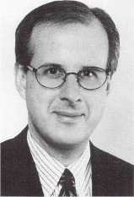

Matt Welty

**Selling**

Stanley Door Systems is selling its garage- related products business to Whistler Cor­poration.

Stanley has assisted Whistler personnel with the garage-related products to ensure transition support to customers and employees.

**Coming Together**

Computerized Security Systems and LaGard, Inc. have joined forces to form an operating unit of Mapsco Corporation. LaGard provides products for safe access

control and is primarily a supplier to mak­ers of bank equipment, ATMs and safes.

LaGuard will operate as a division of Computerized Security Systems.

**Home Show**

The Home Automation Association announced new dates for the ’98 Home Automation Show and Conference. The event will run Feb. 8—10, 1998, at the Orange County Convention Center in Orlando, FL.

For more information, contact: jKevin Hattori (203) 840-5542

**Chosen By Russia**

“OHRANA,” the state security ministry for Russia, has chosen Detection Systems, Inc.’s Safecom Wireless Security Network System. This ministry has the exclusive right to monitor alarm systems throughout Russia. They currently monitor approximately one million security systems from 2,000 central station locations. Only those security prod­ucts approved by “OHRANA” can be dis­tributed in Russia.

For additional information, contact: Detention Systems, Inc.

Frank J. Ryan (716) 223-4060

**Meeting**

Leaders from the American Society for Industrial Security (ASIS) met with the US President’s Commission on Critical Infra­structure Protection (PCCIP) and discussed the potential involvement of ASIS in the Commission’s research and final report.

The PCCIP was setup by President Clin­ton to make recommendations on protect­ing U.S. critical infrastructure, such as telecommunications, electrical power sys­tems, gas and oil storage and transportation, banking and finance, water supply, etc., from physical, computer-based, electronic and communications threats.

For more information, contact: asisonline.org

or John Ricci at (703) 312-6304

**Reader’s Choice Winner**

Cardkey’s PEGASYS 1000 security manage­ment system has been awarded the Reader’s Choice for security by the audience of Today’s Facility Manager.

The annual awards are voted on by the entire circulation of facility executives. Products competing are evaluated on their overall innovation, function and style. Cardkey Systems, Inc. supplies products and services for electronic access control and integrated security management applica­tions in domestic and international markets.

**Apprenticeship**

The Coalition of Ontario Locksmiths (COOL) has founded an apprenticeship pro­gram, however, locksmith assistance is need­ed in three areas: registering apprentices; communicating ideas and making dona­tions; and returning original, completed petitions.

COOL is working with various levels of government. COOL is also working towards a viable media package.

For more information, contact:

COOL Box 185

2356 Gerrard Street Fast Toronto, Ontario M4E 2E2 (416) 743-7595 (416)247-1071 (fax)

**ADI Pays Tribute**

ADI hosted its Eleventh Annual Vendor Appreciation Awards Dinner to extend thanks to its family of manufacturers.

1996 Team Vendor of the Year awards went to: Channel Plus, FireLite, Northern Com­puters, Sentrol, SONY and Vidavi.

June 1997

Keynotes

**Lori Lock’s Captive Thumb 'him**

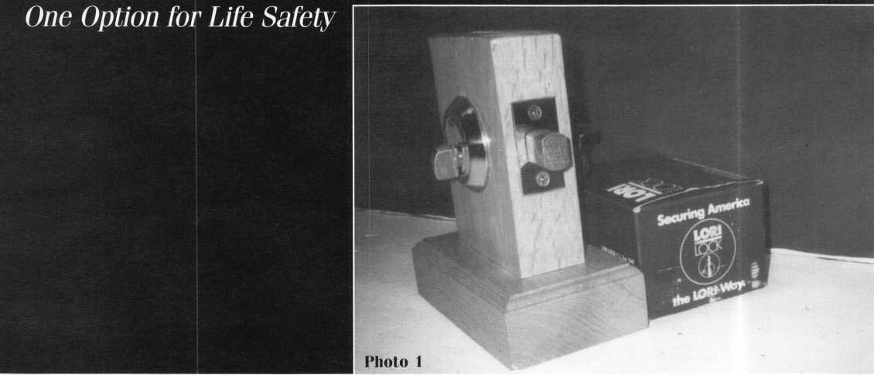

The National Life Safety Code, NFPA 101, published by the National Fire Protection Association in Quincy, MA, establishes guidelines and provisions that are deemed appropriate to protect lives while providing as much security as possible. The Life Safety Code is widely accepted in many parts of the country and is one aspect of locksmithing that is vitally important to our customers and reducing liability for the locksmith.

NFPA 101 establishes that doors shall be arranged to be readily opened from the egress side whenever a building is occupied. Locks, if provided, shall not require the use of a key, tool, special knowledge or effort for operation from inside of the building. Some occupancies allow exceptions—one of which is that key operation is allowed, pro­vided the key cannot be removed when the door is locked from the side from which egress is to be made. Lori Lock makes a captive thumb turn double cylinder deadbolt lock that caught my attention.

At my request, Ken Theriault, executive vice president at Lori Lock in Southington, CN, was gracious enough to send me a 4900 series double cylinder deadbolt on a counter mount, with a captive thumb turn cylinder for use in conducting Life Safety seminars (photo one). Nothing is better than having the real thing in your hand when explaining a concept. By the way, Lori Lock is an Associate member of ALOA.

First of all, I must admit I was impressed with the product over­all. According to their literature, “Lori Lock has long been recog­nized for precision and quality products that represent unsurpassed value.” I agree with all of their marketing claims except one—Lori Lock is little recognized for their products. You have probably installed a Lori cylinder without knowing it. That’s because Lori Lock will sell face caps (or scalps) with no imprint, or with a custom imprint. Many wholesalers marketing their own brand are actually selling Lori Lock replacement cylinders with a company name imprinted in the face cap. Lori Lock products are made in the United States, to exacting tolerances and of the finest materials.

Cylinders are produced in 27 keyways, therefore, integration and retrofitting are not a problem. Sorry, I have digressed from the topic of this article, but I’m glad to have this opportunity to introduce you to Lori Lock.

By the way, this lockset in the box weighted in at 900 grams— just under two pounds—and has a list price of $45 to $52, depend­ing on the finish, and the lock is attractive enough to dress up any door. Of course, I couldn’t wait to get my grubby little hands on this sucker and take it apart to see what makes it tick. All locks seem to have some integral weakness that I prefer to know about, rather than discover by accident.

Very noticeable was the lack of screws or screw hole covers on the face of the lock, and the armored collar around the cylinders. Big Bubba might break in through a window, but he won’t be walking out the front door, even if he has his trusty Super-Sampson screw­driver. The screws are only accessible after removing the bolt assem­bly cover from the narrow edge of the door, and even then you need a long Allen wrench to retract the mortise cylinder set screw enough to unscrew the mortise cylinder (photo two).

One last note on the deadbolt mechanism before we take a look at the captive thumb turn. The housing encapsulates the boltworks in such a manner that protects the bolt against an icepick being used to move the bolt activator to retract the bolt.

Okay, so I like the lock. The captive thumb turn is really what I wanted to talk about. The captive thumb turn unit is actually a mor­tise cylinder, available in polished brass and satin chrome. Although the keyway has no wards, it does have a full compliment of pins to prevent it from being easily picked. Theoretically, the cylinders can be set up so that one key can operate the outside cylinder and the captive thumb turn cylinder—when the thumb is removed.

These cylinders come in two lengths, 15/16-inch and 1 1/8- inch—to fit a variety of applications (photo three). Cylinders can be installed with an armored collar, wave washer and spacer, or standard

Keynotes

June 1997

Text and Photos by Wayne Gurnee, CRL

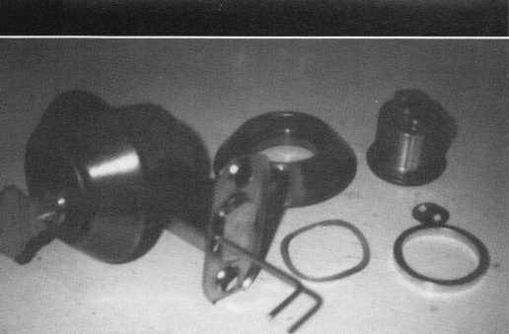

’hoto 2

LOCK

Captive Thumbturn-key Cylinders

4165-i5/i6"

4167 -V/a"

* Single cylinder fire exiting safety
* Double cylinder security
* Can be used in any mortise cylinder application
* 4165 - 15/i6*‘ designed for use in Lori 4900

series deadlocks

4167 - 1 **Vs"** designed for use in Lori 4500  
series deadlocks

* Available in US3 and US26D finishes Schlage C, C-K and Weiser keyways

hoto 3



collars. The cylinder has a list price of $24 and can be fitted with a wide vari-  
ety of cams to retrofit any lock using a mortise cylinder. Cylinders also come  
with an end plate on the plug to prevent snake pick opening (photo two).

The first cut in the blade of the captive thumb turn key is square cut to  
capture the first pin in the cylinder (photo four). This provides the key retain-  
ing status when the captive thumb turn is fully inserted into the cylinder. No  
tool is needed to insert the thumb turn key. The head of the thumb turn is  
typical size for mortise cylinders (an optional longer thumb piece would be  
nice to accommodate ADA needs) and is appropriate for narrow stile applica-  
tions where there’s not much room between the lock and the jamb. Ouch!  
That knuckle may be scarred for life.

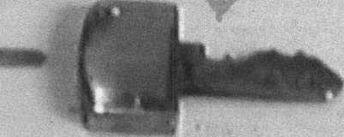

Photo 4



When nobody is home and removal of the thumb turn is desired to make the inner cylinder into a true double cylinder lock function, the extraction tool is inserted into a narrow slot in the end of the thumb turn. This lifts the first pin out of the square cut and up to the shear line, allowing the thumb turn key to be extracted. A lockpick could also be used to pick up the first pin. A hole drilled through the head of the thumb turn would be helpful so as not to lose the thumb turn key when it is not in the cylinder.

The Lori Lock 4500 and 4900 series modular deadbolts provide a lot of flexibility in terms of function and adaptability, with minimal parts inventory. It might be a good practice to maintain an inventory of a few units and some of these captive thumb turn cylinders on the van to answer the age old ques­tion of whether to double the deadbolt or not.

The convenience store manager can now secure after hours and still comply with the code. Many building officials require a double deadbolt where a win­dow is located near a door or if the door has glass panels. The customer can have the double they want and the peace of mind that egress can be made in an emergency. The locksmith can make the sale and gain a reputation for being concerned about the occupants’ safety, as well as the security of the property. Remember, the customer is counting on the locksmith for advice and recommendations. Knowing what products are available is part of our job.

Look for upcoming articles describing other products that will help the locksmith make the sale and comply with the Life Safety Code.

About the Author: Wayne Gurnee, CRL, has been the oumer of A Local Locksmith since 1987, and has been a member ofALOA snce 1990. He has instructed Life Safety Classes for SERLAC for the last seven years.

June 1997

Keynotes

k-

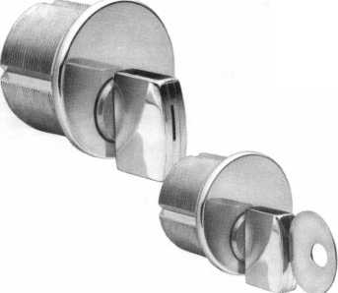

Preparing For The Future With Value-Added Tools

by Claire L. Cohen, CML

Much can be said for selecting the proper tools to do a job. Having good quality equipment is important to do a professional job. This goes hand-in-hand with selecting the proper hardware. But there are other tools necessary to survive at the end of the 20th century, and to put your company out in front in the 21st century. You can’t pur­chase these tools because this set of tools needs to be created for your business—these are value-added tools.

In today’s business environment, your cus­tomers are demanding more, yet they are looking for ways to pay less. You are facing new and hungrier competitors. You’re being challenged as never before to differentiate your company’s products and services. And as a locksmith, you’re not alone.

A great shakeup—a revolution—is alter­ing the relationship between buyers and sell­ers, and not just in the locksmith business. Many firms assume they must lower prices in order to survive, but such a knee jerk response is misguided. Instead, buyers are actually looking for better solutions to their locksmithing problems, rather than doing business with the lowest-cost locksmith. While your prices must be competitive, savvy locksmiths are focusing more on their value-added tools to keep old customers and win new ones.

You can create your value-added tools by using some of these strategies to differentiate your company—no matter if you are a part time, one-person company or a full service, multi-vehicle locksmith service.

Value-Added Tool #1: Be A Business Partner With Your Customer

Powerful things begin to happen when you go beyond merely trying to sell your prod­ucts and/or services and become a problem solver, coach, cheerleader and partner to your customers. As a small example, when a cus­tomer talks to you about having problems differentiating between keys, suggest the many options that are available, such as key labels, identifying rings, etc. When your customer talks about constant turnover of

employees, suggest alternative brands of hardware to his/her current locks that may offer the owner options to rekeying—per­haps high security or keyless mechanical locks or access control devices.

Value-Added Tool #2: Make The Customers’ Life Easier

Every individual customer or business has a convenience quotient that the customer cal­culates by dividing his or her desire for a product or service by the hassle and annoy­ance that must be endured to get it. Are you easy to do business with? Are your hours of operation convenient? Do you respond promptly to phone messages? What about customer-irritating policies, procedures or complicated forms? Offer an extra measure of user-friendliness and you have added value to today’s harried consumer.

Value-Added Tool #3: Empower The Customer With Knowledge

This is frequently the most cost-effective way to add value for customers. Often over­looked is the need for creativity rather than larger marketing expenditures. Consider ways to shift your sales efforts from pushing products to providing solutions. In what ways can educating your customers become a strategic advantage? Educating your cus­tomers about products that are available for the future may spark sales for today!

Value-Added Tool #4: Place Your Firm In Your Customers’ Life

Create uniqueness. Perhaps you can’t differ­entiate your products or services on the basis of unique products or better prices. One sug­gestion would be taking on an unpleasant or complex task for the customer. Investigate how to reduce your customer’s aggravation and costs at the same time. In the process, you’ll become indispensable!

Value-Added Tool #5: Provide Greater Responsiveness

Winning businesses in the late ’90s elimi­nate customers’ burden of waiting by chal­

lenging time-base assumptions—that is, the time between the customer saying they “want to” purchase products or have a job done, and when the customer received the requested product or service. One way is to offer time guarantees. This, of course, is dependent on many factors. What value- added guarantee might you provide?

Value-Added Tool #6: You!

Look at the magnitude of what your cus­tomer is purchasing from you. You hold the key(s) to their home, their business, their car. They are engaging your services for their safety and security. You are a professional locksmith—look the part!

Other Tools

Customers expect polite and courteous ser­vice. They want to be top priority at the moment of service. They expect everyone in your company to know about parts and ser­vice. They expect your company to stand behind its merchandise and service. They expect any adjustments to be made in the most courteous and convenient manner.

They expect accurate and efficient record keeping.

Differentiate your business with superior service. Whatever you do, keep seeking ways to add value-added tools to your business. This will distinguish your business from competitors and puts you on the winning side of the value solution!

Cohen, the second woman to become a CML, has been in locksmithing since 1977 and has been writing articles for Keynotes since 1987. She is an active member of the Locksmith Association of Washington, D.C., where she has taught many classes.

Keynotes

June 1997

Customers have demanded

Good Things  
Come To Those  
Who Wait!

XV O--'

XO*

\^S®

0^

X

*\*\*\*\** *

^ A

CX

\>a

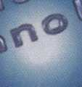

**Auditcon**

LOCK SERIES

TM

Mas-Hami Lton Introduces an affordable lock family featuring genesis technology11

|  |  |  |  |  |
| --- | --- | --- | --- | --- |
| o c» o o o  o o o  0 0 | <9 | a 0 o o o  O 0^0 | &  %' | a 0  0 o o  MASfJ Q  0 0 0  fsa ® |
| AUDITCON LOCK 100R | AUDITCON LOCK 200V | AUDITCON LOCK 200R | AUDITCON LOCK 400V | AUDITCON LOCK 400R |

**AUDITCON LOCK 100R Easy Retrofit: Has the same footprint as most mechanical locks,  
so it's easy to install. Audit Trail: Records last 8 entries in sequential order. Numerical  
Keypad: Offers quick entry. Wrong Try Entry: Will not allow access to any user for a period  
of 30 seconds after 3 incorrect combinations are entered. Multiple Users: Up to 6 users with  
no costly combination changes.**

**AUDITCON LOCK 200V & 200R Offers all the features of the 100 plus: Audit Trail: Provides  
a complete listing of the user's ID, plus the type of entry/activity for up to 100 events,  
in sequential order. Alarm Interface: (optional) Activates the lock's duress condition, when  
connected to an existing alarm system. Windows Compatible PC Software: Print, display or  
file the lock audit reports. Users: Up to 20 users.**

**AUDITCON LOCK 400V & 400R Offers all the features of the**

**100 and 200 plus: Users: Up to 100 users Audit Trail: Number of  
entries is increased to 200 records and stamps the date and  
time of entry or activity.**

**Now all your customers, large or small,  
can afford Mas-Hamilton technology.**

MAS-HAi^LTdl ^

*Defining the future..*

800.950.4744 • [www.mas-hamilton.com](http://www.mas-hamilton.com)  
805-D Newtown Circle, Lexington, Kentucky 40511-1240 Phone 606 253.4744 Fax 606.253.4748

Free Information - Reader Service Card #11

**A. J. Hoffman, CML**

**Yale Collectors’ Edition**

**The subject of this article is the Yale 5-pin codes. I cannot write my first arti­cle about Yale without acknowledging the techni­cal assistance I’ve had from Gordon Morris, Helen Ennis and Louis Threatt over the past 18 years.**

**Yale has not used these codes for about 20 years but we still find them stamped on the bottom of old padlocks brought in by our customers. Since lock collecting started me in the business over 30 years ago, I know how handy these codes can be.**

Code Books Have Errors

Aside from some automobile and cabinet lock companies, most manufacturers do not furnish codes for their own locks. It has long been the custom for locksmiths and distribu­tors to decode locks and keys on the job to create the code books we use in the field.

Field compiled code books are subject to errors, especially when they are for very large and very old code series. All published books I have used for the Yale 5-pin codes, includ­ing HPC and Reed, have nearly 1,000 errors in this particular code series.

These codes were originally handwritten over 100 years ago for the first U.S. post office box locks. The bitting list was soon put into general use for all Yale five-, six- and seven-pin work in all keyways. It was later typed up into large books that the fac­tory worked from. All this work by hand allowed errors to creep into the codes at Yale.

Making and Breaking the Code

The key records people at Yale in the 1890s had to write this massive bitting list with some logic in order to make it as nearly complete and accurate as possible, but they tried to camouflage the progression for secu­rity purposes. They made a progression list of the bittings they wanted to use, based on their MACS (maximum adjacent cut specifi­cation) of four in use at that time with the 113 degree cutter. They broke the bittings up into groups and then assigned the blind codes, jumping first by 189 numbers, then 188, then 187 and 186.

The early code pioneers, such as E. D. Reed, measured enough keys in the field to discover the camouflaged pattern and break the code. Then they followed the pattern to fill in the blanks. However, there were some things the early code breakers didn’t know.

1. Yale used two different lists. One is like a standard code book, in order of code number. The other is in numerical order by bitting. We will refer to these as the “decode” list and the “encode” list, respec­tively. There are a few disagreements between those two lists. Also, since the

original lists were done by hand, some bittings and code numbers were skipped entirely.

1. A few errors were introduced when the handwritten list was typed at the factory.
2. Some large blocks of blind codes were never used by Yale, such as the range 27000 to 27119- Reed and others contin­ued the logic they had discovered and filled in bittings for these skipped num­bers. Some code books even go beyond Yale’s stopping point of 28380.
3. Yale ‘s first handwritten list stopped at 26999- They deliberately “seeded” this list with anomalous blind codes thrown in out of order at the end of each original block of bittings.
4. Codes above 26999 were generated long after the original list to cover bittings omitted in the first list. The original pat­tern of camouflage was not used in this group.
5. Codes higher than 28000 were generated even later, often duplicating bittings already contained in the earlier lists, and adding a few bittings with a MACS of five. (Remember, this list’s MACS is four.) Most of this shows up when the computer sorts the codes by bitting rather than the way they appear in code books. Items 4, 5 and 6 explain why the largest concentra­tion of locksmith code book errors is in the highest code numbers.

The excerpt on page 22 covers the end of one block of bittings and the beginning of the next. You can see the skipping of 186 or 189, the anomalous code assigned to bitting 00334, the irregularity above 26999 and a human error where bitting 00355 was used with one blind code in the “decode” list and a different one in the “encode” list.

Without access to factory records, there is no way to determine all this in the field unless you have a key of every code number to gauge! Therefore, the code publishers should still be commended for their detec­tive work. A few hundred errors in a bitting list of 28,000 codes is not grounds to burn your code books! Asterisks are added to the

201 Keynotes

June 1997

1.190'

Yale

Large Pin  
Standard

|  |  |  |
| --- | --- | --- |
| Direct Bitting Prefixes Since 1976 | | |
| Prefix | Keyway | Keying |
| A | E1R | Non-master Keyed |
| J | E1R | Master Keyed |
| E | All Other | All Keying |

1.025"

**MACS:{**

increment: .019" progression: 2 step depth tolerance: ±.002" spacing tolerance: ±.003"

Applies to all keyways.

Code Card

C57

for HPC 1200CM Code Machine

1. with 95° cutter
2. with 86° cutter  
   4 with 110° cutter

Factory

Depths

1. .320"
2. .301"
3. .282"
4. .263"
5. .244"
6. .225"
7. .206"
8. .187"
9. .168" 9 .149"

Reed

Codes

1 2 3 4 5 6 7

Cuts are read and written bow to tip.

1.190"

|  |  |  |
| --- | --- | --- |
| Direct Bitting Prefixes Since 1976 | | |
| Prefix | Keyway | Keying |
| L | E1R | All Keying |
| F | All Other | All Keying |

**MACS:{**

Yale

Large Pin  
Special

Applies to all keyways.

increment: .025" progression: single step depth tolerance: ±.002" spacing tolerance: ±.003"

Code Card

CX9

for HPC 1200CM Code Machine

1. with 95° cutter
2. with 86° cutter  
   3 with 110° cutter

Reed

Codes

1 2 3 4 5 6 7

Cuts are read and written bow to tip.

Yale

Small Pin  
Standard

|  |  |  |
| --- | --- | --- |
| Direct Bitting Prefixes Since 1976 | | |
| Prefix | Keyway | Keying |
| B | E3R | Non-master Keying |
| S | E3R | Master Keyed |
| H | All Other | All Keying |

.990"

.710"

**MACS:{**

5 with 95° cutter  
4 with 110° cutter

.570"

increment: .018" progression: 2 step depth tolerance: ±.002" spacing tolerance: ±.003"

Factory Depths

0 .250" = 1

Applies to all keyways. Code Card

for HPC 1200CM Code Machine

6 .142" = 7

1 2 3 4 5 6

Cuts are read and written bow to tip.

June 1997

***Keynotes***

k-

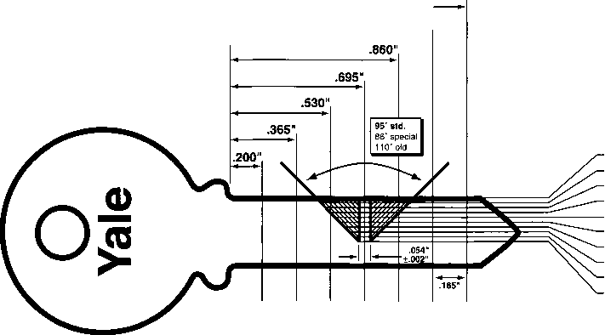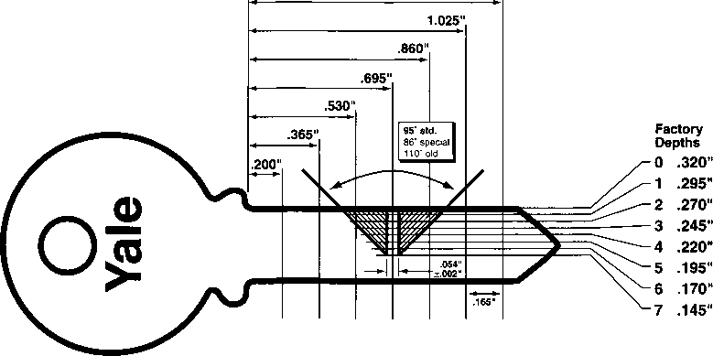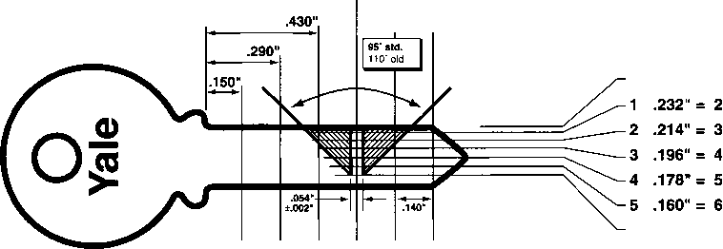

|  |  |
| --- | --- |
| Bitting | Code |
| 00322 | 26095 |
| 00323 | 26281 |
| 00324 | 26467 |
| 00325 | 26653 |
| 00326 | 26839 |
| 00330 | 14091 |
| 00331 | 27209 |
| 00332 | 27389 |
| 00333 | 27567 |
| 00334 | 1001 |
| 00335 | 1190 |
| 00336 | 1379 |
| 00337 | 1568 |
| 00340 | 1757 |
| 00341 | 1946 |
| 00342 | 2134 |
| 00343 | 2322 |
| 00344 | 2510 |
| 00345 | 2698 |
| 00346 | 2886 |
| 00347 | 3074 |
| 00348 | 3262 |
| 00351 | 3450 |
| 00352 | 3638 |
| 00353 | 3826 |
| 00354 | 4014 |
| 00355 | 4202 |
| & error | 4204 |
| 00356 | 4390 |
| codes you can now order from ALOA to help the code publishers identify and correct | |

their errors.

Removing the Errors

I used my trusty Macintosh computer to generate the codes published here. The year was 1994. First I scanned an existing code book and used OmniPage Professional OCR (optical character recognition) software to turn the image into a text file. Then I used the word processor in PageMaker to clean up the text and add tabs between the code number and the bitting.

Next, I imported that text into a Double Helix database that sorted the codes both by bitting and by blind code. It also automati­cally identified all duplicate bittings, as well

22 I ***Keynotes***

June 1997

as duplicate blind codes. Some of these were the result of faulty OCR, which I corrected. The rest were errors in the code book.

Finally, I checked with the factory on all the “suspicious” codes to make the hundreds of necessary corrections. Do you have any idea what it’s like to proofread a list like this? Don’t even ask how many evenings and weekends I spent on it. Just call ALOA for a free copy and enjoy the results!

Locksmiths Beware!

First, check your spacing specifications for Yale. Many machines and published data erroneously show large pin spacing begin­ning at .206-inch and small pin at .146- inch. That means your spacing will be off .004 to .006 of an inch! Yale has never used that spacing. Someone measured keys in the field decades ago and everyone apparently copied those original errors. Contact your distributor or machine manufacturer to pur­chase an update if necessary.

Secondly, most code book and code machine suppliers have consistently diverged from Yale’s standard method of numbering their depths. If you don’t know about these differences, your code key may not work. For this reason, I have included alternate sets of depth labels on the artwork for the key bit­ting specs.

**Order Your Copy From ALOA Now**

label the shallowest cut “1” and the deepest “0” (= 10). If you use Reed codes for this five-pin series, but cut the key on an HPC machine, the key won’t work. You have to subtract one from each Reed depth.

Almost all code books and code machines in use today label the small pin tumbler and disc tumbler depths different from the facto­ry too, but at least they are all consistent with each other. As long as you stick to your code books and never get a bitting directly from Yale, you won’t have any problems. Yale’s shallowest cut is always “0” but the codes and published data call it “1.”

Want More?

I have also computerized an index of nearly 1,000 of Yale’s old cabinet and automobile lock code series. It includes the code prefix, the code range, name of the original OEM customer and year the bitting list was origi­nated. This is probably only good for Trivial Pursuit, but the listing also includes the proper Yale key blank and the proper spac­ing and depth systems to use for each series.

For instance, did you know that many small pin tumbler codes use a .025-inch increment instead of the standard .018-inch? And some Yale disc tumbler locks use a .020-inch while others use a .025-inch incre­ment? And GF is not the only disc tumbler series with first cut spacing at .156-inch from the shoulder. These subtleties can keep your code keys from operating properly, and no existing code books give that information.

**For a limited time, ALOA is taking orders for this 28,000 code series as a free membership benefit. Non- members may order the codes at $10 per copy. A limited number of code books will be printed in approximately 60 days. Call (214) 827-1701.**

The greatest source of annoyance is Reed’s information relevant to the codes featured in this article. Yale’s factory standard is to label the shallowest depth “0” and proceed from there. This bitting list is 0 - 9 where “0” is the shallowest and “9” is the deepest cut. Reed codes and printed key bitting data

About the author: A noted authority

on cylinders and keying system, A.J. is currently  
senior product manager for Kwikset, member-at-  
large to the ALOA Board of Directors and co-  
chairman of the LIST Council. With over 30  
years' experience in locksmithing, he instructs for  
ALOA and regional locksmith associations. He  
was the 1992 recipient of the coveted Philadelphia  
Award and a 1988 inductee into the Locksmith  
Ledger Security Hall of Fame. He has authored  
the Kaba Manual, and the Corbin Russwin  
Cylinder Manual, recognized by ALOA as PRP  
study references.

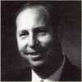

by Sal Dulcamara, CML

"Hello, A-1 Security...! thought you made my house burglar proof."

Thank You, Santa.

When Christmas comes around each year, every good little locksmith hopes that Santa will have placed some absolutely amazing tool in his or her stocking to make life a lit­tle bit easier. We’re a few months too late this year, but if you get this particular tool in your stocking this Christmas, you’ll be saying, “Thank you, Santa.” I suppose though, after I tell you about it, you won’t wait until Christmas.

1 was working on part three of my Impressioning article series, when I received this truly amazing tool for review. Photo one shows the “Foil Key System Lock Opening Tool.”It is the most recent (of many) impres­sive lock opening/decoding tools from John Falle, available from Mark Bates Associates. The timing was coincidental because I was thinking about a Canadian impressioning tool that used the same basic operating prin­ciple. I had wondered why such an effective tool concept managed to fade away, when (I was sure) that locksmiths would want and buy them if they were still available.

After my three part series on impression­ing, my descriptions of the work and my advocacy for practice and dedication in order to become good at impressioning, I was

almost embarrassed to describe a tool that could impression automatically and open a lock with minimal effort. Even though this tool basically operates as an impressioning device, it is primarily an opening tool. You can still take my advice to work hard to improve your impressioning skills, despite the fact that this tool is so quick. You’ll understand more clearly, later.

If you look back at photo one, you will see the assorted components for the first in a series of tools to be available. This first one, most appropriately, is made to open Schlage (or Schlage keyway and spacing compatible) locks. It is designed for both five- and six- pin locks.

Unlike the Canadian impressioning tools, this tools deals with a more complex keyway. Actually, it works with more than one key­way (all Schlage, though). Instead of a modi­fied base key, the foil combs. They are named, presumably, because of their physical resemblance to combs. You can see them labeled “SCHLAGE 5” AND “SCHLAGE

1. ” If you look at the foil combs, you will see one has five tumbler spaces and the other has six. The “L” shaped tools are the angled extraction tools. They also come in two

lengths to work with five or six pin Schlage type locks. These tools are necessary to move the pin tumblers to the top of the keyway for inserting or removing the foil combs.

**Preparing the Foil Comb**

A length of adhesive backed foil comes with the tools. Proper placement of the foil will help to guarantee success. Photo two shows the foil stuck to the back surface of the comb. You need to start out with a piece of foil large enough to fold over both sides of the comb. Then fold the foil over the front side. The sticky part of the foil should meet

23

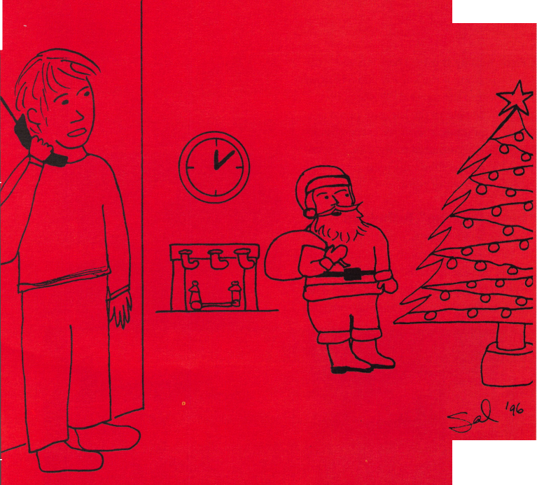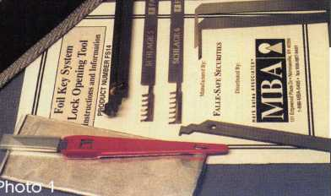

**SCHLAGE5**

Photo 5

**The Tension Tool**

Unlike an impressioning key blank, the foil comb is not designed to apply torque to bind the tumblers. A special tool, palled -the tension tool, takes care of that task. A ten­

Photo 3

result is not an impressioned key.

Figure two shows how the comb operates within the keyway. A fairly light touch is required to impression effectively and avoid damaging the tools. To get the most out of the tool, it is important to read the direc­tions carefully, because the impressioning technique with this tool is slightly different than how you would normally do it with a key blank.

Like a lot of locksmiths, I tried the tool first before fully reading the instructions, and after 15 minutes realized I was doing something wrong. When I removed the comb from the keyway, I first realized that I was a bit careless when applying the foil, because a crease on the surface caused the foil to partially scrape off while inserting the

Only a slight amount of torque is [required. If you see the tension tool starting to bend, you are applying way too much torque. You don’t want to bump the comb up and down the way you might otherwise do with a key. The procedure is as follows:

1. Apply slight torque clockwise, and then

lift the comb slightly upward.

1. Lower the comb to its original position,

I and relax the torque.

You will repeat the action (same direction and rotation) four more times. You will then repeat the action (still with clockwise rota­tion), but with downward movement of the comb, also five times total. Then again coun­terclockwise, five times each both up and down. If you read the instruction sheet care­fully, you will get a few pointers to make the procedure more effective.

After following the directions more close­ly, I got the lock to open in about three min­utes. When I tried it a third time, it opened in less than a minute. I was more than amazed at how quickly and effectively the tool worked. I can’t guarantee how long it will take anybody else, but using the proper procedure seems to speed the process consid­erably.

**Inserting the Comb**

The shape and construction of the comb doesn’t allow direct insertion into the key­way broaching. The proper extraction tool must be inserted first to lift the pihs out of the way, so the slots in the comb clan be placed below the pins. Photo three shows the tool about to be inserted.

With the tool fully inserted, the tumblers are pulled upward to the top of the keyway to clear a path for the comb. While the pins are held, the comb is inserted in the space to the side of the extraction (in this cjase, inser­tion) tool. I inserted the comb to die right of the tool, but the instructions indicate that for certain keyways it may be easier to insert the comb to the left.

In photo four, you can see the rear stop (not unlike a key shoulder) is not dll the way to the face of the plug. The instructions indicate a 5 mm gap. That translates to about 3/16 of an inch. After using the tool a few times, you will almost be able to feel when it is positioned far enough.

just by turning it over. There is a wider tip for the bottom of the keyway and a narrower tip to fit into the top of the keyway. It is preset to be held to the left as in photo six. By switching pieces with the extra tension bar, it can be converted to right side opera- 11 tion. Figure one shows the tension tool posi­tioned to the left or right.

**“Impressioning” Technique**

The gap between the face of the plug and  
the back stop of the comb is designed so the  
tension tool can fit in the keyway while the  
■ process of “impressioning” takes place. The  
basic motion is impressioning, but the end

in the tumbler slot positions. You should  
avoid creases or bubbles on the surface of the  
foil, because it could cause the foil to peel off  
during insertion or removal of the comb.

You should use a hobby knife to trim the  
excess foil extending beyond the tbol sur-  
faces.

Keynotes

sion tool and an extra tension bar are shown in photo five. The assembled tension tool has two contact points, and it is not reversible

comb into the lock. I proceeded to apply the foil again (more carefully, this time), and started all over.

**Extracting the Tool**

Because the bottom pins of the lock get

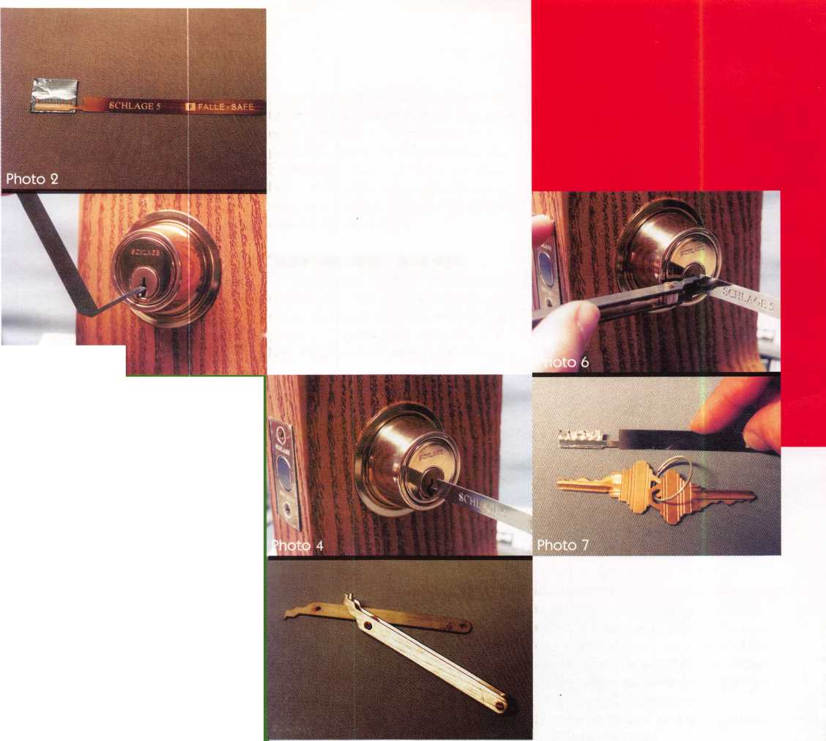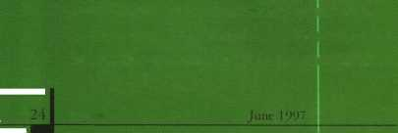

h

|  |  |  |  |  |  |  |  |  |
| --- | --- | --- | --- | --- | --- | --- | --- | --- |
|  | | l |  |  |  |  |  | ANGLE OF TOOL WHEN LIFTED |
|  |  | u |  |  |  | w |  | ANGLE OF TOOL WHEN DHOPPED |
| ~ . L | | | | | | | |  |

D

Figure 1

TEHSIOU TOOL TO LEFT OF LOCK,

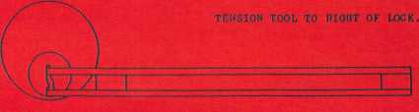

Figure2



caught between the teeth of the comb, the extraction tool must be  
reinserted before the tool can be removed from the lock. I found it  
just a bit awkward finding the 12:00 key removal position for the  
plug because the tool almost became one with the lock. The plug  
rotated freely both clockwise and counterclockwise. The extraction  
tool must be inserted next to the comb and the pins lifted to the top  
of the keyway, so the comb will pull out. If you don’t properly disen-  
gage the tumblers from the comb, you could damage it if you force  
it out of the keyway.

**Don’t Throw Away Your Impressioning File**

Although the basic process of using this tool is nearly identical to  
impressioning, it is not a replacement for impressioning. Photo  
seven shows the pattern remaining in the foil, compared to the actu-  
al key that operates the lock. It is hard to determine depths in the  
foil, because some of the pins in the lock apparently just moved the  
foil sideways in the teeth of the comb rather than actually pushing  
the foil down into the teeth. Some deep cuts on the key have a corre-  
sponding shallow spot in the foil. It’s difficult to tell where on the  
foil individual pins were resting.

I see the tool more as a substitute for picking rather than impres-  
sioning, because it is incredibly fast and effective. And after all, the  
tool is called a lock “opening tool,” not an impressioning tool. It  
seems ideal for those tough-to-pick locks with great depth variations  
between adjacent cut positions. For additional information on this  
and other specialty tools, contact: mark bates Associates, 101  
Edgewood Plaza Drive, Nicholasville, KY 40356. Phone: 1-888-  
MBA-5495. FAX: 606-887-9491.

51

v Cl* 'TAbout the Author: Sal Dulcamaro, CML, has been in the lock­

smith business for over 22 years. He is the president of All Pro Security, Inc. in Michigan and has been an AL0A member for 15 years. A past president of the Locksmith Security Association of Michigan, Sal currently serves as editor of the association newsletter. He was named “Keynotes Author of the YeaP’ for 1996.

STOCK THE PATIO DOOR  
LOCK THAT SURPASSES  
ALL OTHERS IN

DURABILITY

AND



COMBINATION HOOK LATCH & DEADBOLT

n

**EASY INSTALLATION. A,**

* **SMOOTH OPERATION.**
* **MADE OF STEEL AND ALUMINUM.**
* **ALUMINUM, ANTIQUE BRONZE AND WHITE FINISHES.**
* **NON-HANDED.**

ALSO USED FOR:

Camper Tops, Pocket Doors,

Storm Doors, Cabinets, French Doors,

Mobil Homes and Recreational Vehicles.

l I

4*

m

i

♦ «

**Call Today For A Distributor Near You**

**1-800-397-4631**

A Division Of

MIWA Lock USA, Las Vegas, NV

Reader Service #12  
**June 1997**

Keynotes

k~

Opening for a Living

Cars



*If you're gearing up to buy new car opening tools for your business, there's more to consider than you might think. In order to do car openings professionally, safely and profitably, you need the right information on the vehicle and the correct tools. That's why our*

*choice is to use genuine Sully tools.*

Goodbye to Slim Jims

Back in the late 70s, car opening tools took a turn from  
the familiar “Slim Jim” to more sophisticated tools  
designed for specific locking applications. Automotive  
companies like General Motors changed the production  
methods and the modular design that made the old tools  
impractical. About that time, All-Lock hired Dr. Patrick  
H. Sullivan to present seminars to teach locksmiths how  
to open cars professionally. The new tools he provided  
looked like something out of Star Wars—thin rods of

steel with odd bends in strategic locations to fit  
into the deep, dark crevices of the car door. As  
auto security increased with fixed pawls and cov-  
ered linkages, new tools were developed by  
Sullivan to handle the opening process. Sullivan  
was the first to publish detailed car entry manuals,  
the first to establish a modern standardized car  
entry service methodology using plastic wedges,  
light probes, simplified modem lockout tool  
designs and clearly documented instruction for-  
mats—totally eliminating the need for guesswork.

Now, the real secret to opening cars lies in the  
knowledge of what’s inside the door. Unless you  
work in a new and used car lot with unlimited time

to remove door panels and photograph the linkage, you  
may want to get the Automotive Lock Institute Car  
Entry Manual. Each manual, as you expect, includes a  
listing of the vehicles and the procedure to open with the  
appropriate Sully Tool. Also included are various cau-  
tions, notices and warnings to avoid methods that may

damage the vehicle or render it unsafe. Each page con­tains important photographs to help you understand the opening instructions. Because often there are many ways to open a vehicle, alternative methods are provided. These manuals also provide some excellent information in the appendixes showing how to use each tool and special applications.

Prior year car entry information is summarized back through the ’90s. The A.L.I. Car Entry Manual includes a glossary for those terms you may not recognize. The manual is comprehensive and is a “must have’ for any serious car opening locksmith.

The Tools

Now, let s take a look at the actual tools. Sully provides two sets: the 12-piece Quality Convincer Kit and the 22-piece Magnum Quality Convincer Kit. Nothing beats the T-l Sully Handlewedge for wedging open the windows. They are made of hard plastic and the handles make them very convenient for insertion and removal— especially around Ford’s guard piece rail. I find the mold­ed plastic handles on all of the tools a very important feature. They allow easy gripping when manipulating the tool and have clear identification on the handle, which identifies the tool with the correct procedure in the manual. I have a strong preference for the metal por­tion of the tools as well. The plating not only looks good, but protects the tools from corrosion and allows them to move easily through the window gap. The shafts have to be strong enough to pull up through that tough weatherstrip in the interior when manipulating the electric locks, such as Cadillacs and other General Motors products. Yet, with that strength, the Sully tools are malleable enough to make the necessary bends need­ed in some applications.

***SuwrToois***

I want to feature a couple of special tools I appreciate when opening vehicles. The T-l 1 J Sully is perfect for those very deep horizontal lock control rods found in the Buick Skylark; Park Avenue and LeSabre; Oldsmobile Achieva, ’88 and ’98; the Pontiac Bonneville and Grand Am and the Cadillac DeVille.

-A

Keynotes

June 1997

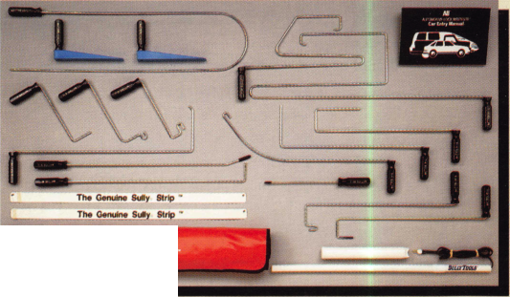

**by Steve Engel, CIVIL. CPP**

I find myself using the T-14 Dipper Sully on most vertical lock control rods to lift up the door button—especially the older vehi­cles. I also like the T-18 Sully Pop, a fork­like tool that can lift a vertical control rod or bell crank through gaps found behind door handles.

There is a T-0 genuine Sully Strip. I remem­ber when we were taught to make these from plastic milk cartons and dental floss. I find more uses for this versatile tool. Although the manual shows a lot of uses on imported vehicles, I even like it on some Ford vans, which have very tight window gaps.

Inside Counts

As I mentioned earlier, knowing what is inside the door is very important. Pointing a flashlight is very impractical when looking for lock control rods, bell cranks and link­ages. You need a good quality flexible light probe. I’ve found that during daylight hours, you need a high intensity bulb in order to see anything—due to the sun’s reflection.

Sully provides two choices: the SL-1, a three C-cell battery version, and the SL-2, a three AA-cell battery version. Skipping visual inspections could waste time and perhaps cause damage.

Safety cannot be overlooked when open­ing vehicles. Sully also has a safety line of clothing: Sully Wear protective wear for opening vehicles in unpleasant weather con­ditions and for visibility at night.

You may also want to attend a Sully semi­nar to learn the latest information, tech­niques and tools.

Every effort has been made to make the Automotive Tool Lock Institute Car Entry Manual and Sully tool program as useful as possible. If your company is looking for quality tools, Sully tools are your choice. Sully tools can be located on the internet at [www.sullytools.com](http://www.sullytools.com) or call them at (703) 689-3416, or fax them at (703) 787-0869.

CML, CPP owns and operates Sage Lock and Safe. He is also an ALOA board member.

AL.I Car Entry Manual Usability ★★★★★

Technology ★★★★ Verdict ★★★★★

Pro: An excellent reference tool, complete with photos and opening instructions and useful tips and cautions. Easy to use with Sully tools.

Con: Does not include picking directions for easily picked vehicles.

$29.95 Retail

Sully Tools Usabiity ★★★★★

Technology ★★★★★ Verdict ★★★★★

Pro: Quality made variety of tools for virtually every opening situation. Plastic handles provide identification and good grip.

Con: Does not include vent opening tools.

Kits from $69.95

IT’S COMING

SEPT. 24-28

Grenelefe Golf & Tennis Resort

Haines City, FI

$ 1

SHOPPING SPREE TO BE GIVEN AWAY ONE EVERY HR.

Over \CfO Booths * New Products * Many Door Prizes * Antique Lock Display

Golf Tournament Sunday Morning. Trophies & Prizes

/^EDUCATION - 2 & 1 -DAY CLASSES

y --||& BASIC LOCKSMITH ME DECO CERTIFICATION AUTO OPENING

y tafii A t rrr, t mr>. a -i~r= w * r> t~ o o ^ ^ . .

BASIC LOCKSMITH AUTO UPDATE COMPUTER MARKETING

MEDECO CERTIFICATION IMPRESSIONING GM SAFE MANIPULATION BASIC SAFE SERVICING

AUTO OPENING BASIC IM P RES SI ON IN G ADA

ACCESS CONTROL

EVENING SEMINARS ALOA PRP -SUNDAY

SOUTHERN HOSPITALITY

[BANQUET SATURDAY NlOHT

Great Food Live Entertainment Awards over $5000.00 In Prizes

SOt/TJT£AST£RiV REGTG1WAT

TocKstviT'T'iTs alssoctzatto/vs cowvEisr'riojv

FOR REGISTRATION INFORMATION 1-800 845-5294

Reader Service #13

June 1997

Keynotes

k~

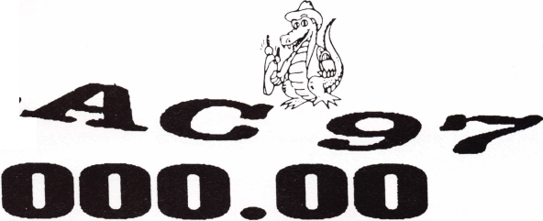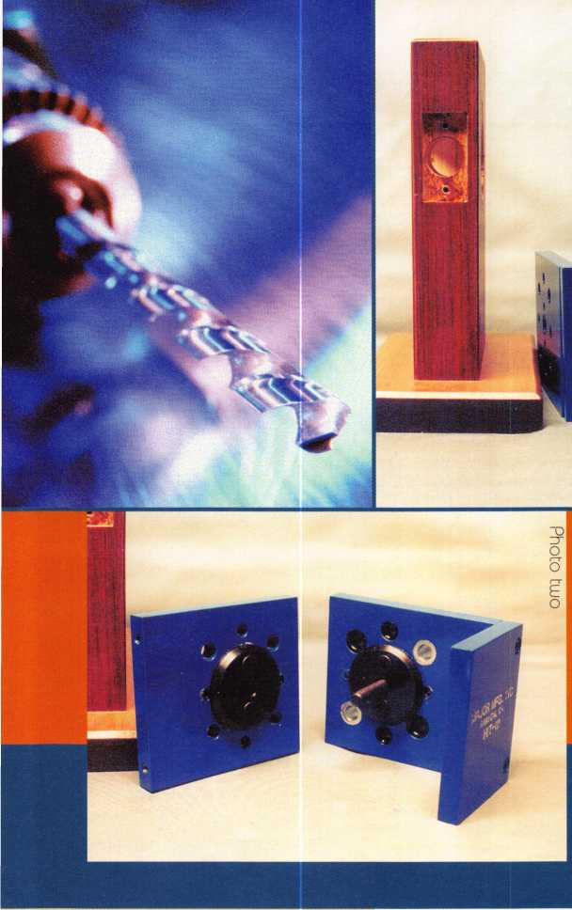

**i/lAJOR MFG.. INC**

anahEim. ca.

HIT-111

R Major

**plates reveal the large aligning washers,  
which fit into the 2 1/8-inch diameter cross  
bore hole on each side of the door. They fit  
into the existing installation hole for posi-  
tioning so that the additional holes will be  
properly aligned. The plate with the hex  
head bolt sticking through has all the bush-  
ings to guide the drill bits through the  
holes. The other plate has follow-through  
holes. This hardware installation tool is  
designed for the drilling to be done from the  
bushing side all the way through the door—  
not drilled from both sides. If drilled from  
the side without the bushings, the drill bit  
would tend to enlarge the holes and eventu-  
ally reduce the accuracy of drilling.**

**Photo three shows the HIT-111 being  
attached. The aligning washers keep every-  
thing centered. The hex head bolt extends  
from the plate with the bushings to the  
plate on the opposite side. An Allen  
wrench (included with the tool) is used to  
tighten the bolt to hold the device securely  
to the door.**

by Sol Dulcomoro, CMl When replacing a key-in-knob lock with a

key-in-lever lock, it will usually be necessary  
to drill additional installation holes beyond  
the standard 2 1/8-inch diameter cross bore  
hole. These (two) additional mounting holes  
are normally located opposite from each  
other—either top and bottom or diagonally  
across from each other.

Major Manufacturing, Inc. makes a large  
assortment of tools for the lock industry,  
including quite a number of installation jigs  
and drill guides. One such tool is the HIT-  
111 (HIT stands for Hardware Installation  
Tool). Shown to the right of a portable lock  
mount in photo one, the HIT-111 is a versa-  
tile drill guide to help with the installation  
of a variety of different brand lever handle  
locksets that require different mounting hole  
locations.

In photo two, the inside surfaces of the

The locations of all the guide bushings is apparent in photo four. They go as sets across from each other. One set of bushings (5/16- inch diameter holes) is at six and 12 o’clock, and another set (3/8-inch diameter holes) at approximately two and eight o’clock. The silver bushings (2 5/64-inch diameter holes) are set at approximately 10 and four o’clock. There are two more bushings, which are much smaller (and not as apparent) at three and nine o’clock. The other side of the plate has matching bushings in the same places (the only bushings on the other side). Those holes use a 5/32-inch bit and are used when installing some locks that are supplied with anchor plate lugs. Those holes are drilled from both sides, but not all the way through. The 5/32-inch diameter holes are drilled about 3/16-inch deep into both sides of the door.



Keynotes

June 1997

D

~o -r O O

**HIT-111**

0

0



Photo five shows how the drill bit goes in from the bushing side, and photo six shows it coming out the other side. The additional mounting holes are apparent at six and 12 o’clock in photo seven. Some locks that require the mounting holes at six and 12 o’clock are: LORI 2100 Series Retro Kit, LORI 2200 Series Retro Kit, LORI 2250 Series Retro Kit, Marks 170 Series Grade 2, Marks 195/295 Series Grade 1, Medeco Embassy 17 Series, NT Falcon T Series, PDQ Spirit ALL Series, Schlage Rhodes Grade 1, Schlage AL Series Grade 2, and Yale AU5400LN. Locks that use the two and eight o’clock bushing positions include: Arrow Sierra, ASSA Brooklyn, and Sargent 10 Line Grade 1. Corbin/Russwin 800/3400 Series and Corbin/Russwin 3600 Series use the 10 and four o’clock bushings. There are additional locks that could use the various bushing combinations to simplify installation.

As lock designs change, so do mounting hole locations. Newer versions of some of the above locks may require different hole pat-

other hardware installation tools for locks that have slight variations to the patterns available in the HIT-111. The HIT-10 can be used for installing Alarm Lock Trilogy and Simplex Unican. The HIT-12 is useful for drilling mounting holes for Best 9K Grade 1, Cal-Royal Grade 1, LSDA LX Series, S. Parker Hardware XL Series, TACO Grade 1 Lever and US Lock Grade 1 Lever. The HIT-13 is for the Marks Hardware 170 Series, Marks Hardware 190/195 Series, Medeco Embassy 19 Series, Sargent 6500 Series Grade 2 and US Lock Grade 2 Lever. The HIT-14 is designed for use with the NT Falcon Re-Lever Kit, which is for converting mortise locksets to accept lever handles.

Just as for the HIT-111, changes in lock design may change whether or not specific installation tools will work with certain locks. Again, verify the information before drilling. For additional information on these and other tools, contact: Major Manufacturing, Inc., 1825 Via Burton, Anaheim, CA 92806. Phone: 714/772- 5202. FAX: 714/772-2302.

“O

zr

O

O

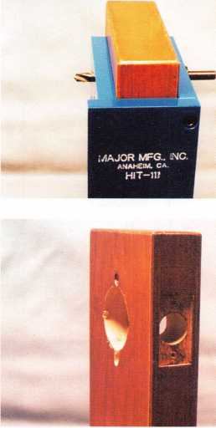

T)

O terns, so verify the information on the lock’s ^ installation instructions before drilling.

Even with the same relative position, not all brands of locks have interchangeable hole locations. Just because the holes are located at six and 12 o’clock (top and bottom of cross bore hole) doesn’t mean they are exactly the same. Some locks require holes that are at six and 12 o’clock, but the distance from the center of the cross bore hole will some- ~o times vary.

O The installation tool can often be especial­ly ly valuable when trying to install one brand < of lever lock to replace another. If the extra § mounting holes are in nearly the same loca­tion, trying to drill free hand will often cause the drill bit to wander back into the original hole. The bushing in the installation tool will help keep your holes straight.

Major Manufacturing, Inc. also makes

^ About the Author: Sal Dulcamaro,

CML, has been in the locksmith business for over  
22 years. He is the president of All Pro Security,  
Inc. in Michigan and has been an ALOA member  
for 15 years. A past president of the Locksmith  
Security Association of Michigan, Sal currently  
serves as editor of the association newsletter. He was  
named “Keynotes Author of the Year” for 1996.

June 1997

Keynotes

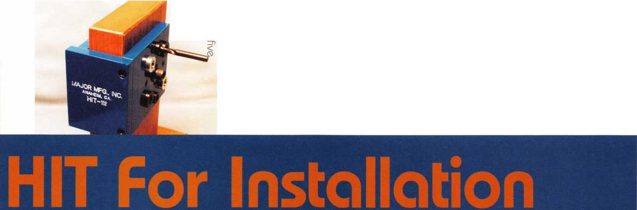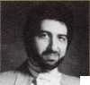

**BY PAU LA L. HALL, CPL**



**Victims**

Lonny Burgau got out with a suitcase full of clothes, some family photographs, his wife, Londa, and two small children. His home and all of its contents are a total loss. Lonny and his wife said, “Now we know what it is like to be homeless.”

Lonny is a 1993 graduate of the lock- smithing program at Pine Technical College in northern Minnesota. In May of 1995, Lonny bought Pex Locksmith in Grand Forks, ND, and moved his family there. With only two years under his belt as owner, Lonny has a rough road ahead of him.

Jim Bisson has been a locksmith since 1976. He bought out his father, Keith Bisson, when Keith retired in 1993. Jim has made some smart decisions since he took over in ’93. In four years, Jim has managed to almost triple business. Now, this second generation locksmith busi­ness is seriously threatened.

Early on a Friday morning in April, two of our colleagues were caught off guard. They were forced from their homes and businesses to witness the worst disaster the upper midwest has ever seen.

I am talking of course about the level five disaster that happened in Grand Forks, ND, and East Grand Forks, MN. They are sister cities located in the northern quad­rant of each state. There is only a bridge separating the two. On April 18, 1997, this entire area was ravaged by floods when the Red River overflowed—in a big way.

Two ALOA members were seriously affected by the dis­aster: Jim Bisson, CRL, owner of Keiths Lock & Key, and Lonny Burgau, CRL, owner of Pex Locksmith. Both are from Grand Forks cities, or, more accurately said, what is left of the Grand Forks cities.

In the wee hours that early morning, the people of Grand Forks were startled by sirens blaring. Many people were extremely tired because they had been up for the past several weeks sandbagging around the city. The National Guard trucks were going up and down the street with bullhorns warning everyone to evacuate immediate­ly. Mother Nature can be very caiel at times.

30 | **Keynotes** **June 1997**



*Ml*

c §^T' V- ci o c

The fight to save the city from the river was intense. For several weeks, people had

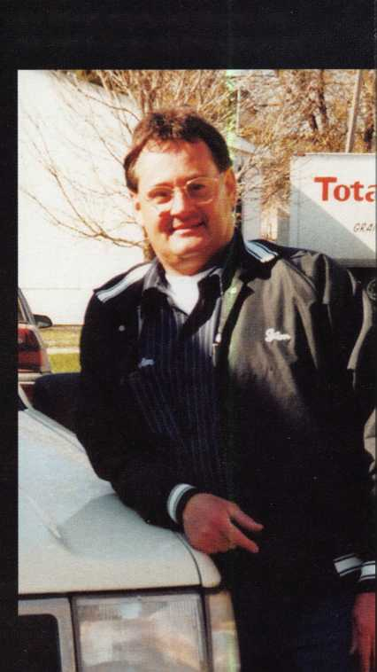

TVttiKI 11

both had substantial damage to their shops. It was several more days before water service was even restored. Lonny and Jim are com­municating through their cell phones. The phone company said it would be a while before all service is restored. The mail finally came in mid May—the first time in more than three weeks. Lonny and Jim’s losses will be hundreds of thousands of dollars. It will be some time before they know for sure what the totals are.

There are other locksmiths in Grand Forks and the Greater Red River Valley who were affected as well. Jim Bisson has four employees and Lonny has one. The institutional locksmith out at the University of North Dakota had sub­stantial damage to his home. Fargo,

ND, and Breckenridge, MN, were also hit hard. There are at least two lock­smiths from these areas that had devas­tating damage. All of these locksmiths need our help just as fast as we can get it to them.

There has been a disaster relief fund established to help sustain our colleagues through this most difficult time. Your contributions are tax deductible and there are no administrative costs involved so every penny will go directly to locksmiths who were devastated by this disaster.

Please give generously.

Jim Bisson

*About the Author: Paula L Hall, CPL has been a locksmith for 1*7 *years and an AI DA member since 1986. She has worked in various positions throughout the trade*, *including service coordinator, service technician and wholesale supply owner of mobile locksmith unit. Currently she is an inde­pendent manufacturer representative in St. Paul,* AIN. *Paula has sewed on the Board of Directors of the M inneapolis chapter' and as chairperson in 1994-93.*

out there helping where they thought they were needed most.

NATIONS TO

***Locksmith Flood Relief Fund c/o Western Bank 7035 Tenth Street North Oakdale, MN 55128***

It has been several weeks since the Red River engulfed the city. Jim and Lonny are just now getting back into their businesses—

been sandbagging, but the city fell behind in their efforts when a major winter storm came through the region and dumped over a half of a foot of snow. The city was with­out power for five days. Then the news came that the Red River would be rising past the predictions. Jim Bisson had been sandbagging for 48 hours straight—with no food or sleep. Workers were frantically building dikes down the middle of major streets. Others were sandbagging as fast as they could. Jim and Lonny were helping to sandbag all over the city. Little did they know then that this flood would overtake their homes and businesses. If only they would have guessed that the predictions were wrong—that the river would rise much higher than expected—then they could have been sandbagging their own homes and businesses. Instead, they were

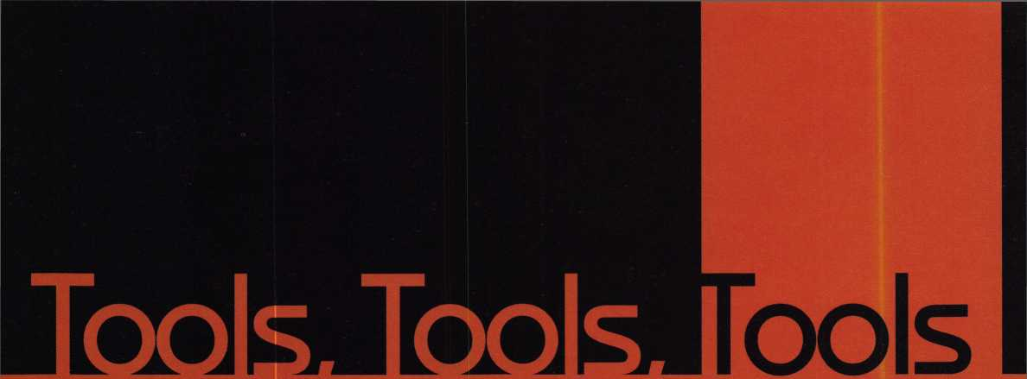

I love tools. The first childhood possession I can remember being fascinated by was a jackknife. Not only could I intimidate the other neighborhood kids with it, but I could use the sharp blade to make things out of wood. So what if the neatest thing I ever made was a crude wooden horse—it was using the tool that appealed to me, not the finished product.

You are probably the same way. Your choice of profession practically dictates that you are a tool junkie. If you’re like me, you have numerous tools with uses so special­ized that they may have seen action only once or twice. Still, you wouldn’t part with them. Such is our relationship with tools.

So much for introductory ramblings. Let’s get to the tool!

The Spin-Cut® Spindle Cut-Off Tool

The Spin-Cut® Spindle Cut-Off Tool is, as the name implies, a device that accurately gages the length to which a combination lock spindle should be cut to accommodate a particular safe and lock. I’ve lost track of how many spindles I’ve come across in the field that were either long or, more com­monly, too short. If the lock is designed for its spline key to be inserted crossing over the end of the spindle (LaGard, Ilco), a spindle that is too long will effectively decrease the amount of spline key surface that can engage drive cam. It can also cause the spline key to rub on the underside of the lock’s cover. That can result in anything from an annoying bind in the dial to much more serious prob­lems. If the lock’s spline key is installed with its flag running out over the surface of the drive cam (S&G), a slightly long spindle poses no problems until the excess length is so great that the end of the spindle rubs against the cover. This would require the spindle to be more than 3/16-inch too long in a typical 6730.

KeynotesJune 1997



CMS



the heavy-handed hammer adjustment did­n’t damage the lock case. It wouldn’t have been unreasonable to expect the wheel post to fracture at its base or at the retaining ring groove.

Spindle Cut Too Short

More dangerous that a spindle left too long is one cut too short. Years ago, I ran across a government specification for security con­tainers. It stated that the spindle of the lock could not have the spindle cut short enough to allow more than four internal drive cam threads to be visible when the lock was installed and splined. You can calculate the shortfall for a typical 40 thread-per-inch spindle to be 1/10 inch with four threads showing. If you’re having trouble visualizing all this, it simply means the spindle isn’t threaded all the way through the drive cam. It lacks 1/10-inch of being flush with the top surface of the cam. That makes four

I can’t think about over-length spindles without recalling a name brand safe that came into my shop many years ago from a prominent manufacturer. My practice was always to do a partial disassembly of the door to ensure the boltwork and locking mechanism were in perfect condition. Although time consuming, it assured the purchaser a trouble-free container and allowed me to sleep better at night. This particular safe contained a dial spindle that was obviously too long for the door thick­ness. The factory assembler had corrected the problem by inserting the spline key and then mushrooming over the key and the end of the spindle with what must have been a fairly hefty hammer. The end of the spindle had to be ground flush with the top of the drive cam so that it could be removed. Then a new dial, drive cam, and spline key were needed to repair the damage. Fortunately,

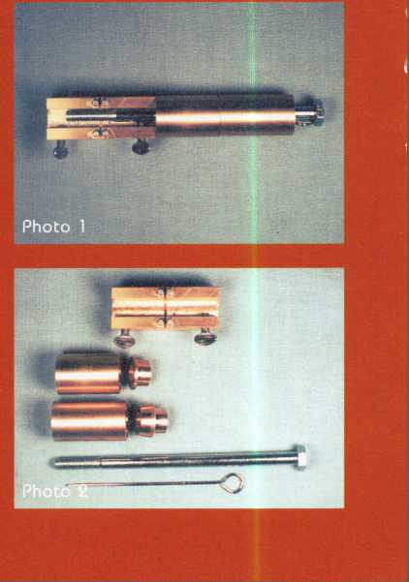

it was

using the tool

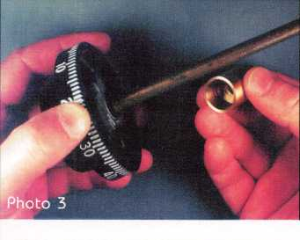

that oppeoled to me, not the finished product.

yiiSiliiiiiM

internal threads in the drive cam visible. A 30 thread-per-inch spindle takes a length of approximately 1/8” for four threads.

I personally think the “no more than four threads short” philosophy is sound. Although this still decreases the area available to bind the spline key in place, it isn’t enough of a shortfall to cause problems. Just remember that the four thread shortage is a maximum deficiency. A spline key that engages too lit­

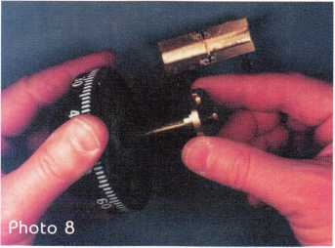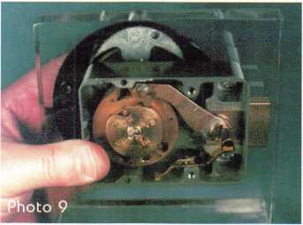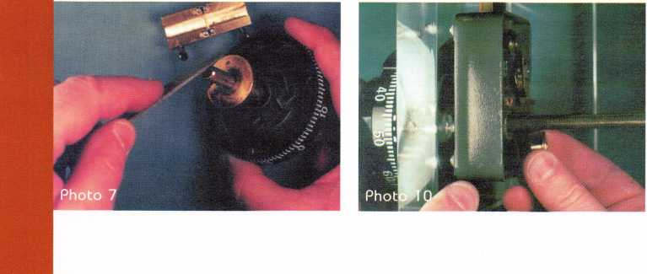

tle drive cam is prone to loosen over time.

The spline key is a friction fit part. To ensure it stays in place, it should engage the maxi­mum surface area of both the drive cam and the dial spindle. Anything less results in increased odds for a malfunction.

There’s More!

Even though the main purpose of the Spin- Cut® Spindle Cut-Off Tool is to help you achieve optimum spindle length, the tool’s utility doesn’t stop there. “But wait,” as the late night television commercial says, “Here’s more!” The Spin-Cut® doesn’t slice or dice, but it does incorporate a retaining ring removal pin and a retainer insertion tool.

I think the best way to describe the fea­tures and functions of this simple and very functional tool set is to work through a set of illustrated, step-by-step instructions. We’ll be using a Sargent & Greenleaf 6730 lock for this demonstration, but the tool set works equally well for LaGard, Ilco, and other combination safe locks that use S&G’s standard “magic module” case size and foot­print.

Photo One The Spin-Cut® Tool comes assembled as shown. It’s a good idea to take note of what goes where, as this is the best way to store the various components when the tool is not in use.

Photo Two Components from top to bottom and left to right: cut-off block with two thumbscrews and four steel guide pins; three-wheel spacing bushing and wheel post bushing; four-wheel spacing bushing and Spirolox insert slide; fixation bolt (its only purpose is to hold all the components together for storage); Spiro-tek Pin®.

First, we’ll use it to mark and cut off a combination lock spindle. In this example, no lock components have been installed on the plexiglass mount that serves as our safe door.

Photo Three Since this is a three-wheel

June 1997 Keynotes k

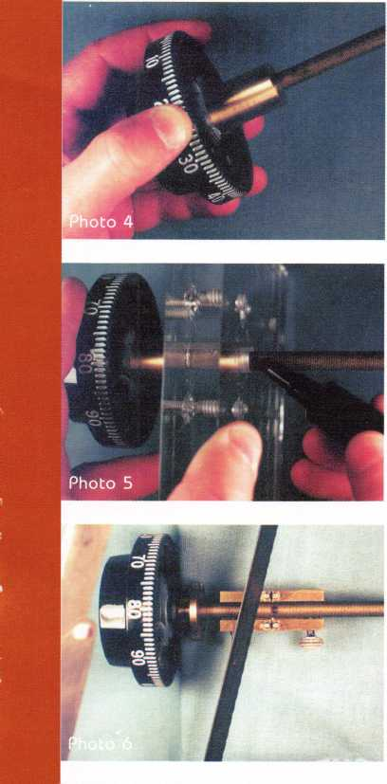

lock, we place the three-wheel spacing bushing over the dial spindle, orienting the hollow end of the bushing toward the dial. Photo Four Slide the hollow end of the bushing over the dial hub.

Photo Five Place the spindle through the spindle hole in the safe door and use the dial to push the spacing bushing up against the dial ring mounting surface of the door. The dial ring is NOT in place on the door. Mark the spindle even with the lock’s mounting surface inside the door.

Photo Six Remove the dial and spindle from the door, and slide the spacing bush­ing off of the spindle. I like to thread an old drive cam onto the spindle and position it between the cut mark and the dial. Then place the spindle in the cut-off block so the mark we just made is in line with the guide pins and cutting slot. It’s helpful to align the spindle’s spline keyway with the thumb screws so that they will get a solid bite when tightened. It’s okay if the threads are deformed at the thumb screw locations. The damaged threads will not be threaded into the lock’s drive cam. When the thumb screws are tight, use a 32 tooth-per-inch (or finer) metal saw between the guide pins (in

the cutoff slot) to make a straight cut through the spindle. Stop as soon as the spindle is cut You won’t be happy if you absent mindedly sever your cut-off block.

Note that the hacksaw blade is not yet posi­tioned in the cut-off slot in this picture.

Photo Seven Loosen the thumb screws and remove the spindle from the cut-off block.

Use a fine metal file to bevel the end of the freshly cut spindle.

Photo Eight Run the drive cam off of the spindle. This will reform any threads that were deformed in the cutting process.

Photo Nine Install the lock body, dial ring, dial, drive cam and spline key. Since this is an S&G lock, the flag of the spline key faces away from the spindle center. As you can see,! the spindle length is perfect. It won’t be nec­essary to re-cut or try to find the mythical “spindle stretcher.”

Let’s back up a few steps and change the circumstances. This time, the dial ring is mounted on the safe door, and the lock body I is also installed.

Photo 10 Run the spindle through the dial ring and on through the lock’s wheel post. Press the dial into position against the ring and hold it there. Now slide on the small wheel post bushing.

Photo 11 With the turned down end of the bushing seated completely into the wheel post, mark the spindle where it first emerges I from the bushing. Now you can proceed with the process of cutting the spindle.

Photo 12 Every toolbox should have at least one Spiro-tek Pin®. Although I don’t get to | carry around a toolbox much anymore, I always have one of these pins on my desk, and there is even one in my boat. Although you will find many uses for this glorified upholsterer’s pin, it’s an especially helpful device for removing Spirolox-type retainer washers from combination lock wheel posts.

Run the point of the pin around the top of the retainer washer to find the end. If you look closely at any of these washers, you will notice that the ends are undercut. This gives I you a place to gently pry the end of the retainer out of the wheel post’s retaining ring groove.

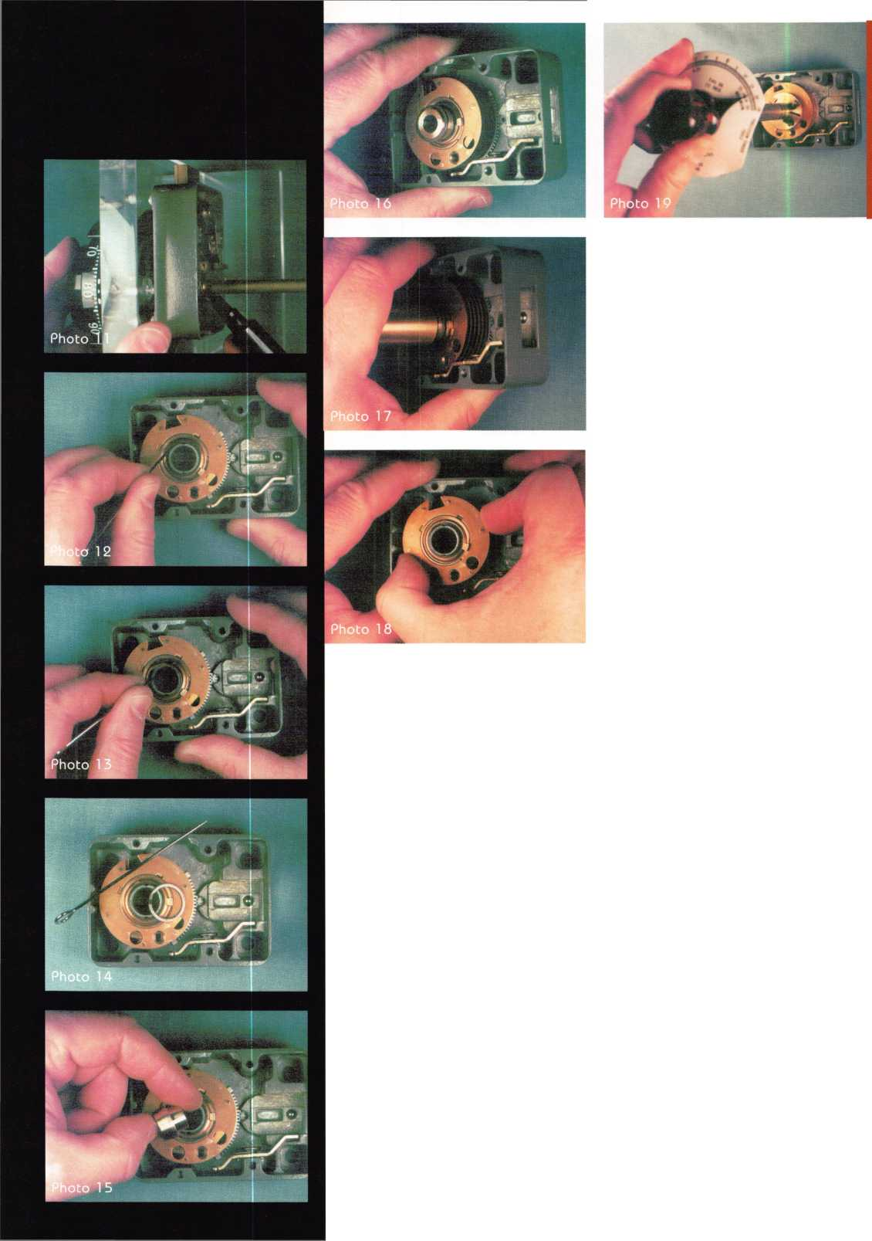

Photo 13 After you ease the end of the retainer out of the groove,

bring it up over the top of the wheel post. Some coordinated techni-  
cians can do this with the pin. I usually resort to using a fingernail  
under the freed end of the washer to lift it up. After the end of the  
retainer is out of the groove, you can work the pin or your fingernail  
all the way around the circumference to “peel” the retainer out of the  
wheel post groove. Take care not to deform the retainer.

Photo 14 The end result is a cleanly removed Spirolox retaining  
washer.

Photo 15 Here’s the part you’ll really love. To re-install the retainer  
washer, place the turned down end of the Spirolox insert slide into  
the wheel post.

Photo 16 Place the retainer over the tapered end of the Spirolox  
insert slide.

Photo 17 Push the retainer down onto the wheel post using the end  
of either the three- or four-wheel spacing bushing. The retainer  
washer will expand as it is forced downward on the Spirolox insert  
slide. It will then continue down the wheel post until it snaps into  
the retaining ring groove. Presto! The retainer is installed.

Photo 18 Here’s a minor, yet important point: Our installation of  
the retainer has left it at the extreme bottom of the wheel post’s  
retaining ring groove. Admittedly, there is not a lot of room for the  
washer to move up and down in the groove, but any travel can  
change the amount or torque—or force required to move the  
wheels—in the lock. Over time, the retainer will have a tendency to  
move to the extreme upward limit of travel in the groove, due to the  
weak, yet constant pressure of the wheel pack assembly. Leap into  
the future by pulling the top wheel up against the retainer. You will  
not feel any retainer movement, but you can be assured that you  
have moved it to its topmost limit of travel in the wheel post  
groove.

Photo 19 Any time you service a lock, you should reset the wheel  
pack torque. A Sargent & Greenleaf 6730 should require between  
12- and 20- inch-ounces of force to rotate all wheels in the same  
direction. It’s a good idea to set the torque near the higher end of the  
range, as torque tends to decrease over the life of the lock. Don’t set  
the torque adjuster to suit the dialing preferences of your customer!  
Torque ranges are specified and set by the lock manufacturer to  
attain the optimum balance between a high level of security and  
longevity.

Although the Spin-Cut® Spindle Cut-Off Tool will work in up  
to 100 meters of water, I do not recommend lock servicing under  
these conditions. Follow proper service procedures well above pre-  
vailing water levels, in a well lighted area.

Seriously, you will find this new tool set a worthwhile addition to  
your toolbox. It’s available direct from the manufacturer, Locks  
Unlimited, in Alexandria Virginia (phone 703-960-6413). You’ll  
also find it in the latest sales flyer from Timemaster, of Topeka,  
Kansas (913-232-8705, or on the internet at [www.time-master.com](http://www.time-master.com).



I About the Author: Brian Costley is Director of Customer Service

for Sargent & Greenleaf He is an AL0A Lifetime Achievement Award  
recepient, a certified master locksmith, a certified safe technician and an AL0A  
certified instructor. And he’s a pretty decent fisherman, too.

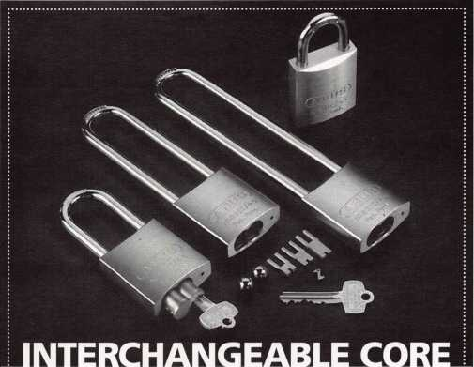

PADLOCK WITH -BAR

The ABUS 83IC/45 convertible  
interchangeable core brass padlock  
is a very flexible locking system. It's  
available with a 1" 2" 4" or 6" hard-  
ened Boron-steel shackle. You can use  
it for any application where you need  
interchangeable core key control.

The 83IC/45 uses stainless steel  
locking balls for greater strength and  
corrosion resistance. Each lock comes  
with three fork drivers, which provide  
compatibility with 5-, 6-, and 7-pin  
cores - and emergency security lock-  
out. The Z-Bar lets you configure each

lock as either key-retaining or non­key retaining. While the cores aren't included, the 83IC/45 accepts cores from Bestf Arrow? Falconf KSPf Medecof and Peaks?

Call us today at 800-225-5348 to reduce your lock inventory. Our low prices, precision-made German quality, and rugged reliability make the 83IC/45 system a great value!

<gH|)

ABUS Lock, USA 3555 Holly Lane North Plymouth, MN 55447-0507

Reader Service #14

Serving the Security

Industry Since 1946.

HPC has the tools you rely on daily as  
a locksmith professional. HPC **-The  
Symbol of Quality.**

HPC leads the security industry producing  
innovative tools, publishing easy-to-read |

code books and informative textbooks.

You want the tools. They’ re an indispensable  
part of your business. Now you need a source.

How about a distributor with a capable sales  
force and the resources to guide you through  
your purchase? One with a vast inventory  
offering same day shipping, order accuracy,  
and call backs. You expect and deserve these  
things, so lets add personal, friendly service.

**|** Now You're Talking!

From price quote to timely delivery, the  
Southern Lock Sales Department is second  
to none; we are your partners in the security  
business!

Experience our Expertise**,** Call  
Southern Lock Today!

P0. Box 1980, Pinellas Park, FL 33780-1980,  
(813) 541-5536. Warehouses in Largo, FL;

Miami, FL; Oakland Park, FL; Charlotte, NC;

& Atlanta, GA. j *

\

Reader Service #15

June 1997

Keynotes



A & B

A & B Safe Corp. is proud to announce a new addi­tion to its depository line of safes. The new front load unit will be available in three sizes, one of which will be equipped with a reversible door to allow the unit to be also used as a rear load unit. Phone (800) 253-1267; Booth #907

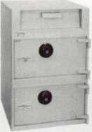

ii

Acme Security Systems

Acme Security Wholesale is feature the newly released  
Adams Rite electric latch retraction panic devices. You  
can see these new prod-

ucts at booth #904 at  
ALOA ’97, or call us at  
(800) 348-2263 for addi-  
tional information.

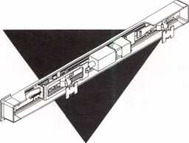

ABUS Lock Company

ABUS Lock Company introduces the new Monoblock series of brass body padlocks that feature a unique design for special applications. The precision crafted, solid brass padlocks feature five-pin tumbler paracen­tric keyways that are specially designed from anti-cor­rosive materials. Thousands of key differs are available. Keyed alike versions are also available. The Monoblock

comes in three sizes: The #82/63 (2 1/2 inches), the #82/70 (2 3/4 inches) and the #82/90 (3 5/8 inches.) Phone (800) 225-5348; Booth #605.

**Adams Rite**

*The new trio of entry trim from Adams Rite features break-away handles and interchangeable components for strength, security and flexiblity. All models fit all previous Adams Rite trim installations and are field-rehandable. Available in three handle styles and eight finishes. Meets ADA and California Title 19 and 24 guidelines. ANSI/BHMA Grade 1. Phone (562) 699-0511; Booth #432.*

Adesco Safe

Welcome the newest addition to the Adesco family! The “BF” line offers the best of burglar and fire protection. This “beefy” unit boasts a two inch thick composite door, three inch thick body and two hour fire label. Its massive locking bolts, tri-spoke handle and glass relocker give this beauty the appearance of a “TL- 15.” Now you can have the best of both worlds—fire and security—in one safe. With five models to choose from, your customer is certain to find the perfect size to fit their needs. Phone (714) 761-2666; Booth #521.

***Keynotes***

June 1997

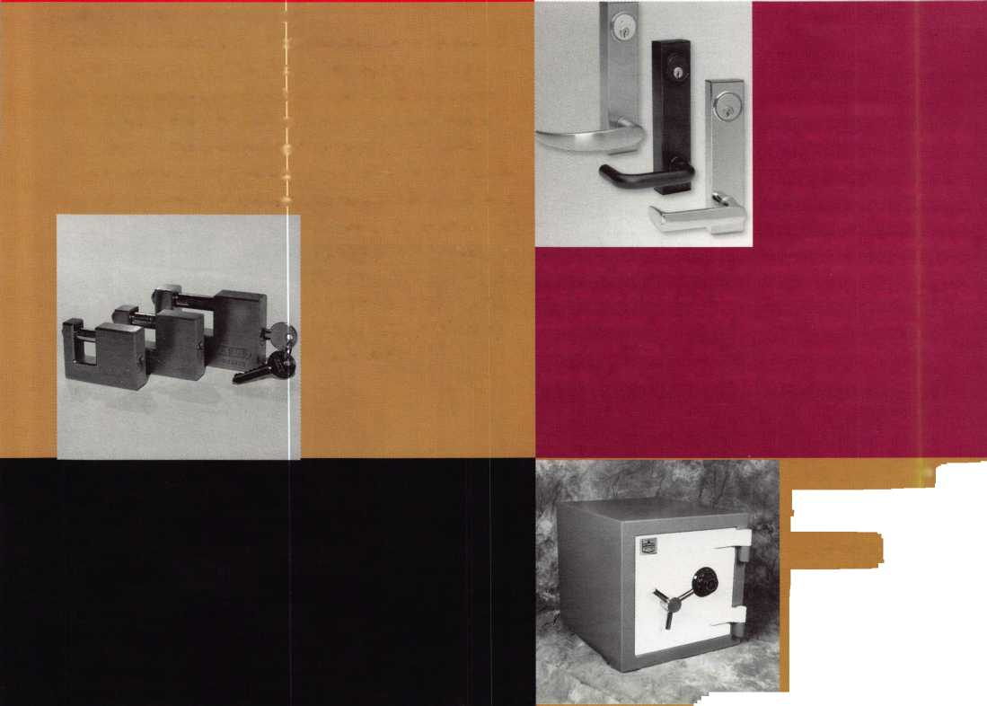

Stop wasting your time trying to get a Look at Haley Bopp streaking across the 1997 sky. Right here in Keynotes magazine (and at the ALOA '97 Security Expo) are some of the most stellar performers in the locksmithing universe. So buckle your seat belts- it's going to be a heck of

. W; - -

- ; : :

US

*, r* *paggfr|* ^ ^ %j

SECURITY



(For information about all the stellar manufacturers and distributors participating in ALOA *97, see pp. 40-41 for a complete list of exhibitors along with a map of where to find them on the Reno trade show floor. See you at the ribbon cutting July 31!)



June 1997

Keynotes

37

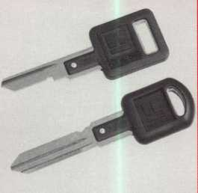

**Adrian Steel Co.** f

*Adrian Steel Company*

*and accessories that are  
b 9 t I/* £

*and match interior components for almost any job*

*requirement. Adrian Steel also offers a key machine*

*base that slopes the machine towards the operator. Key  
machine bases available in 18- and 36-inch lengths for  
one or two machines. Phone (517) 265-6194; Booth  
#626.*

Lock

Complete your line of VATS service equipment with All-

Lock’s new VATS replacement keys. Available in single  
and double sided versions, the All-Lock VATS replace-  
ment key meets or exceeds GM specifications for VATS  
keys, and are the only ones to include a limited lifetime

warranty. Also, take a look  
at All-Lock’s complete line  
of VATS diagnostic tools  
and equipment—all guar-  
anteed! Phone (334) 874-  
9001; Booth #211.

Alarm Lock Systems, Inc.

The T2 Trilogy is comprised of a heavy duty lockset with  
clutch lever mechanism and is completely keypad program-  
mable. Features include an extended 12-button metal key-  
pad; programmable passage function; one-time emergency  
access/service code; individual, group or total user code  
lockouts; master and management codes that can set entry  
allowance from five to 20 seconds; and more. This model is

a grade 1 lockset, which  
exceeds BHMA specifica-  
tion requirements, and is  
available in knob or lever-  
set, both with standard or  
interchangeable cores.

Phone (516) 842-9400, ext.

169; Booth #814.

**KM** 1

A-1 Security Manufacturing

The #PAK-SSB includes Pak-A-Punch model 3, plus  
accessories for punching most domestic automotive  
applications. It includes a large carrying case. Enjoy A-  
1 ’s superior quality, reliable factory service and  
unequaled precision. Phone (804) 359-9003; Booth  
#247

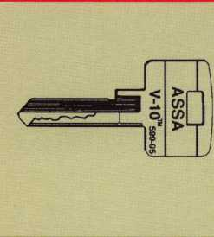

ASSA Inc.

The Twin V-10 is the next  
step in high security cylin-  
ders. It features: new 17  
year patents, exclusive  
keyways, extensive retrofit  
capabilities and 5-way  
customer guarantee.  
Phone (718) 927-2772;  
Booth #800

Keynotes

June 1997

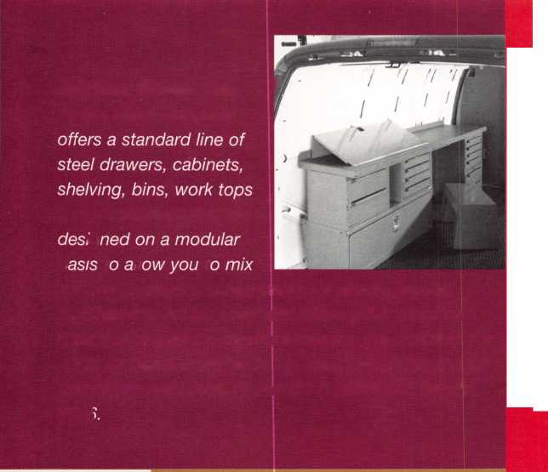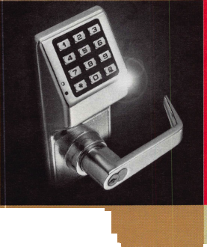

DoorKing, Inc.

f

DoorKing’s Intelligent RF

jdflkl ** * * Access Control products offer lliallm the user the convenience of a m I** ' £Q|I i remote transmitter, but with

n L #!&** *——the* security of a fully pro-

Hi grammable card reader sys-

tern. Each of the MicroClik transmitters are uniquely

coded to one of over 1,000,000 available codes, allowing the flexibility of deleting lost or stolen transmitters easily. By interfac­ing the receiver with a DoorKing access control system, all pro­gramming can be accomplished remotely on a PC using the DoorKing Remote Account Manager software for Windows. This software allows for complete transaction reports from the access system with a simple click of the mouse button. Phone (800) 826-7493; Booth #929.

Display Clear Printer

DRK Specialties

Unlock a Cool One with these keys to beverage plea­sure from DRK Specialties. No more stubborn tops and no more broken nails when using this handy can and bottle openers. Great impulse items! Sharkey—assorted colors, 30/rack; domed bottle opener—assorted novel­ty, 12/card; key popper—assorted colors, 24/display

box; eagle popper— ^ assorted colors, mm ty] 24/card. Phone (800)

m. jk (o) JflPm 654-1850; Booth  
jLJ IJ1' #839.

***Keynotes***

Top: T **7** 2 5 8 T

Build: - 2 2 2 2 -

Master: 2 2 - - 4 a

Bottom: **230324**

|  |  |  |
| --- | --- | --- |
| Door Controls |  |  |
| International | f\^ | 1 |
| Door Controls |  |  |
| International announces |  |  |
| our new champion lever |  |  |
| trim. UL certified |  |  |

ANSI/BHMA 156.3—

1994, grade 1. The 08L lever trim is to work in conjunc­tion with our fire rated security alarmed rim exit device, Pannex. The vandal resistant lever is available for stan­dard or narrow stile doors, and can also be supplied with electric release. Phone (313) 426-0400; Booth #338.

Blackhawk Products

Pin: Pin It Now! software tells you which pins to drop into a cylinder. It stores the control and master bittings for each job. Select the job, type in a change combina­tion and it displays or prints the pinning chart. It covers standard cylinders, master rings, l-cores, OEM pins, universal pins, cross-keying and more, on 31 different keying applications. Phone (970) 882-7191; Booth #334.

Don-Jo Mfg.

The classic wrap around series from Don-Jo Mfg. offers the locksmith the widest assortment of wrap around plates avail­able today. All versions feature stainless steel threaded inserts to help prevent the latch screws from loosening, even when there is extensive damage to the door. All sizes are available in five different architectural finishes. Phone (508) 422-3377; Booth # 738.

Setup Clear Printer jjlotes

Pin it Now!

from

Copyright

Input: 430324

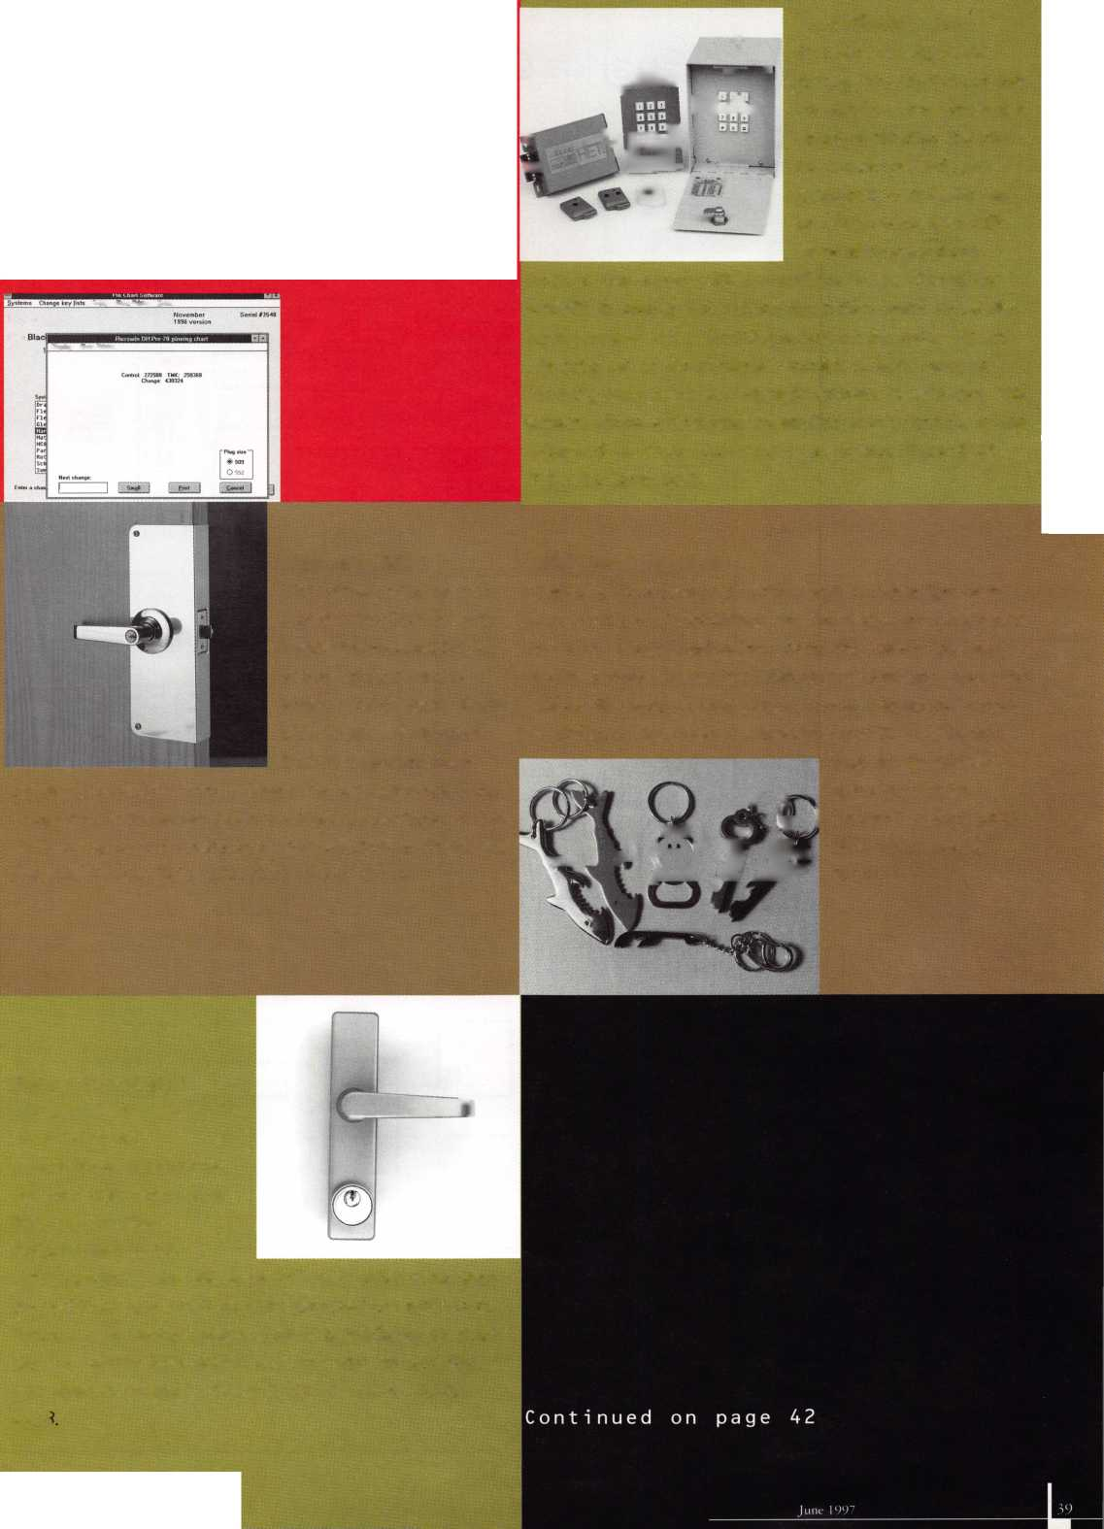

Ln

**160**

**158**

Silent

Auction

**260**

Reno-Sparks Convention Center

Layout as of 04.15.97

Restaurant Area

**2 59**

|  |  |  |  |  |  |
| --- | --- | --- | --- | --- | --- |
| 156 |  |  |  | 457 | 564 |
| 154 | 254 | 1 d | 363 | 455 | 554 |
| 152 | | |  | 453 | 552 |

□

|  |  |  |
| --- | --- | --- |
|  |  | 240 |
| 140 | 141 |  |
| 136 | 137 | 236 |
| 134 | 135 | 234 |
|  | 232 | |

|  |  |  |
| --- | --- | --- |
| 128 |  |  |
| 126 | 127 | 226 |
| UL | 121 |  |
| 122 | 123 | 222 |
| 118 | 119 | 218 |

|  |  |
| --- | --- |
| 112 | 210 |
| 108 |  |
| 106 |  |
| 104 |  |
| 100 | 200 |

|  |  |
| --- | --- |
| 241 | 340 |
| 239 | 338 |
| 237 | 336 |
| 235 | 334 |
| 332 | |

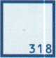

**314**

211

**312**

**310**

**300**

|  |  |  |  |
| --- | --- | --- | --- |
| § 151 | 251 | 350 353 | 450 |
| 148 149 | 248 149 | 349 | 448 |
| 146 147 | 246 247 | 346 446 | |

**546**

|  |  |
| --- | --- |
| 658 | |
| 557 | 654 |
|  | 652 |
| 551 | 650 |
| 549 | 648 |
| 547 | 646 |

**665 756**

|  |  |
| --- | --- |
| 651 | 752  750 |
| 649 | 748 |
| 746 | |

|  |  |
| --- | --- |
| 757 | 856 |
| 755 | 854 |
| 852 | |

**846**

**857**

**855**

**853**

**851**

**849**

**847**

□

□

Offices & Service

□

Desk

*III*

**319**

ill

**418**

**518**

|  |  |
| --- | --- |
|  | 622 |
| 521 | 620 |

**722**

**619718**

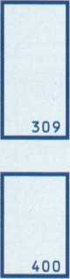

Ld

**500**

**818**

**918**

**703 802**

**800**

|  |  |  |  |  |
| --- | --- | --- | --- | --- |
| 741 | 840 | 841 | 940 | 941 |
| 739 | 838 | 839 | 938 | 939 |
| 737 | 836 |  | | 937 |
|  | 834 |  |  | 935 |
| 733 | 832 | 833 | | 933 |

**931**

|  |  |  |  |  |  |  |  |
| --- | --- | --- | --- | --- | --- | --- | --- |
| 229 | 329 |  |  | | 729 | 828 829 | 928 929 |
|  | 327 |  |  |  | 726 | 827 | 926 927 |
| 225 | 324 325 | 424 | 524 | 1 d 825 | | | 924 925 |

**923**

**921**

**919**

**917**

|  |  |  |  |  |
| --- | --- | --- | --- | --- |
| ^3 | | 914| | |  |
| 713 |  |  |  | 913 |
| 71 1 | 810 | ?11 | 910 | 911 |
|  |  |  | M | 909 |
| 707 | 806 | 807 | 906 | 907 |

**9041 905**

**900 901**

Wvv^t

J=L

JZL

Entrance

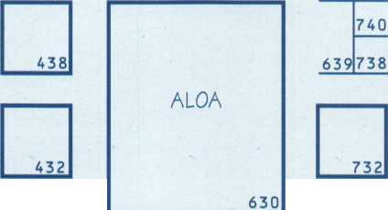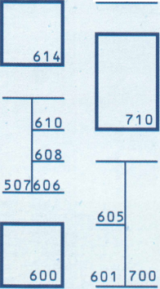

I

I

I

I

I

I

I

I

A & B Safe Corporation.  
A-1 Security Mfg Corp..

Aable Locksmiths

Abus Lock Company

Acme Security Systems

Adams Rite Mfg Company,

Adesco Safe Company

ADI Inc.

Adrian Steel Company

AdvanSec—Adv. Sec. Concepts,  
Aero Lock

Aiphone Intercom Systems  
Alarm Lock Systems Inc. _  
Alarm Monitoring Services

All-Lock Company, Inc.

Allstate Insurance Company  
ALOA

American Lock Company

[

American Security Products _  
American Security Distribution

Architectural Control Systems

ASP Inc.

ASSA Inc.

B-E Industries Inc.

BiLock North America Inc.

Blackhawk Products

Buddy Products/ Locksmith Division.

Capricorn Electronics Inc.

CCLyPRESTOLOCK

Chicago Lock Company

Clark Security Products

Commercial Van Interiors

Corbin Russwin Arch Hdwr

Corby Industries Inc.

Curtis Industries

Detex Corporation

Direct Security Supply, Inc.  
Don-Jo Manufacturing, Inc.  
Door Controls International  
Doorking

The Dorma Group.  
DRK Specialties

Dugmore and Duncan, Inc.

Emergency Road Service, Inc.  
Enhance

Escalera, Incorporated ESP Lock Products Inc. _ ESSEX Industries, Inc. Eurasia Pacific

Folger Adam Security, lnc._  
Fort Lock Corporation

Framon Manufacturing Company

Gardall Safe Corporation

Global Door Controls Inc.

Glynn Johnson

Guardian Personal Security

H.B. Ives

H.E.S., Inc.

Handi Disc / Handi Bits .

_907 _24 7 _825 _605 _904 _432 _521 _810 _626 _750 _126 _122 _814 _911 _211 _450 _630 _418 _627 _818 _807 _222 _800 _141 _665 _334 _241 _748 _737 _340 _319 _255 _446 _852 _746 _840 _703 _738 _338

929

836

839

824

234

_910

_756

314

651

353

254

601

100

_108

802

608

564

248

551

940

|  |  |
| --- | --- |
| Highland Glen Products, Inc. Homeowner’s Marketing Services HPC, Inc. | 546  924  600 |
| Hurd Corporation | 648 |
| IDN Incorporated | 733 |
| llco Unican, Corp. | 500 |
| Intermountain Lock & Supply | 726 |
| Jet Hardware Mfg., Co. | 639 |
| JLM Wholesale, Inc. | 106 |
| KABA High Security Locks | 833 |
| Keedex Manufacturing | 847 |
| Keri Systems, Inc. | 127 |
| Key Feeder Systems, Int’l | 622 |
| KEY-BAK/West Coast Chain Mfg. | 722 |
| Knaack Manufacturing Co. | 900 |
| Knight Safe Manufacturing | 928 |
| KSP | 235 |
| Kwikset Corporation | 232 |
| LAB Security | 718 |
| Labor Saving Devices | 147 |
| LCN Closers/Div of Ingersoll | 606 |
| Liberty Safe & Security | 455 |
| Linear Corporation | 908 |
| Lockmasters, Inc. | 614 |
| Lockmasters, Inc. | 905 |
| Locksmith Publishing Corp. | 619 |
| Lori Lock/Delta | 806 |
| Low Tech Products | 146 |
| Lucky Line Products, Inc. | 547 |
| M.A.G. Engineering & Mfg. | 424 |
| Major Manufacturing, Inc. | 239 |
| Markar Products Inc. | 838 |
| MARKS, U.S.A. | 741 |
| Marray Enterprises | 906 |
| Mas-Hamilton Group | 210 |
| Master Lock Company | 707 |
| Maxis Security Locks | 124 |
| mba Speciality Tools | 259 |
| MDS Incorporated | 310 |
| Medeco Security Locks | 200 |
| Meilink Safe Company | 400 |
| Midwest Safe Distributors Inc. | 832 |
| Midwest Wholesale Hardware | 448 |
| Morse Watchmans Inc. | 136 |
| MUL-T-LOCK USA, Inc. | 309 |
| Nanotechnology, Inc. | 125 |
| National Cabinet Lock | 514 |
| National Security Safe Co. | 729 |
| New England Lock & Hardware | 325 |
| Newman Tonks | 700 |
| Ningbo Light Industrial Product | 811 |
| NKL Industries Inc. | 557 |
| Olympus Lock Company | 829 |
| Omaha Wholesale Hardware | 739 |
| Papaiz USA Ltd | 236 |
| PDQ Industries | 350 |
| Perry Blackburne, Inc. . | 346 |
| Prime-Line Products Company | 240 |
| Pro-Lok | 218 |

ALOA '97 Security Expo

Exhibitor

**List**

R. Q. Associates828 RA-Lock Co. 834 ROFU International Corp. 225 Rutherford Controls Inc. 713

S. Parker Hardware Mfg. 552 SAFTLOK363 Sargent & Greenleaf, Inc. 318

Safe & Vault Technicians Association 148

Schlage Lock Company-Primus710 Schwab Corp518 Secura Key246 Securitron Magnalock Corp.914 Securitron Magnalock Corp.918 Security Door Controls112 Security Equipment Corp.349

Security Industry Association 849

Security Lock Distributors332 Select Products Limited123 Sentry Group229 Silca Keys USA, Inc.300 Stone & Berg Wholesale 251 STRATTEC Security Corp.226 Strong Arm Security, Inc.901 Supra Products, Inc.941 Taymor Industries, Inc.740 Tech-Train Productions128 TESA Access Control140 The National Locksmith524 Top Notch Distributors119 Trans Atlantic Co. 938 Trine Products Company 327 Turn 10 Wholesale846 U-Change Lock Industries336 U.S. Lock Corp.507 USCAN Lock Distribution 324 Von Duprin, Inc.610 VSR Lock Inc. 620 Weiser Lock Company 732 Weston Key Systems711 Wilco Supply857 Winfield Architectural Lock 658 Yale Security, Inc.438

June 1997

Keynotes



AUTOMOTIVE KEYS ,1

**Eurasia Pacific**

*High quality heavy-duty padlocks available in stainless steel, brass or alloy. “Brass satin" is also available. Padlocks have hardened or stainless steel shackles, and long shackles can be made to order. Locksmith*

; | *series can also be made*

*^ 3296; Booth #353.*

**GT-85 International**

*GT-85 lubricant with Teflon is a space-age lubricant. The high quality ingredients, not found in most maintenance sprays, are electronically fused and will not separate. Unlike other products that contain graphite, petroleum and/or paraffin, GT-85 dries dry! It will not freeze or build up after application. It does not attract dirt, sand, lint or other debris. Phone (800) 525-4885; Booth #650.*

Framon Manu

Framon’s new KX-

quickly and accurately

and space cams are availabi

ers, such as: KABA, ASSA,

Corbin, etc,. For locksmiths doin

master keying or high  
security work, the KX-1  
makes key cutting a  
breeze. Phone (517) 354-  
5623; Booth  
*#100.*

■ of

|  |  |
| --- | --- |
| Sit keys | • AUTOMOTIVE ,  ! KEYS |
| gj |  |
| i -4j| |  |
|  |  |
| Jfjl •.w’f::: |  |
|  |  |
|  |  |

llco Unican

The llco Unican RACK-IT  
pegboard system has  
been designed to provide  
great organization and  
flexibility. Spacing and  
layout of the hooks and  
racks allow you to cate-

gorize your key blanks for easy identification. You can  
customize your own or build your system using our  
plan-o-gram. Phone (919) 446-3321; Booth #500.

llco Unican Group

Mechanical pushbutton  
combination lock with  
heavy duty latch mecha-  
nism, outside pull paddle,  
inside push paddle, inside  
latch holdback, outside  
reset/clear button, out-

side combination change without removing lock,  
prepped for 31/32-inch and 1 1/8-inch backsets. Phone  
(910) 725-1331; Booth #500.



Keynotes

June 1997

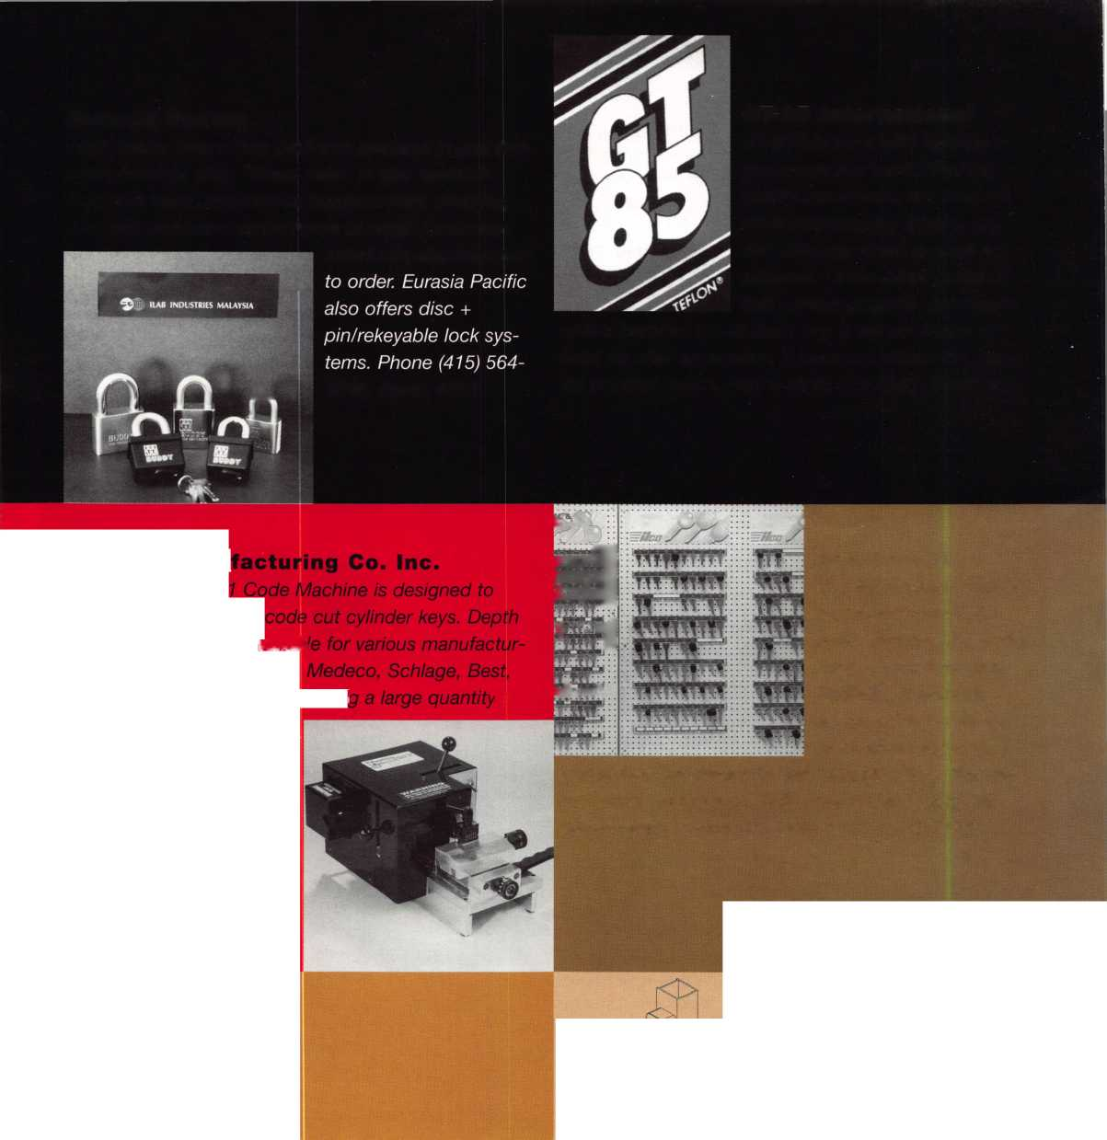

**Knaack Mfg.**

*WeatherGuard has put together a variety of prepackaged interiors for full size and mini vans. They have several pack­ages tailored to the needs of specific trades, such as contractors, plumbers, electricians and locksmiths. Modules have been designed so that a module from one prepackaged interior may be interchanged with the same area of another package. Phone (815) 459-6020; Booth #900.*

JLM Wholesale

JLM Wholesale is pleased to announce that we are now stocking the 8000 Series by Abloy Security Group. These electric locks for narrow stile doors have a special patented latch bolt. The locks are always auto­matically deadlocked when the door closes. Lock cases are equipped with an integral microswitch to indicate the position of the bolt. These locks are intended main­ly for storefront type aluminum/glass doors. Dimensions are according to Adams Rite mechanical lock cases (BHMA type E8231). Phone (810) 628-6440; Booth #106.

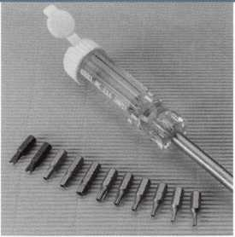

**Locksmith Publishing Corp.**

*LPC’s Reed General Code Books were the first code books developed as a reference system for locksmiths. Today, our code system contains the most up-to-date code information available in the security industry, pro­viding more domestic and foreign codes than any other system in existence. Check out our newest additions to the LPC Code Library, Vol. 13 and 14. Phone (847) 692- 5940; Booth #619.*

June 1997

Keynotes

Keedex, Inc.

The Keedex Tamper  
Resistant Screwdriver,  
part# TAMPER, comes  
with 11 interchangeable  
tips. Includes the follow-  
ing tips: six tamper resis-  
tant torx tips (T10, T15,

T20, T25, T27 and T30), three tamper resistant hex tips  
(5/32-inch, 3/16-inch and 7/32-inch) and two spanner  
tips (#6 and #8). All the tips fit into the screwdriver’s  
storage handle. Phone (714) 636-5657; email:  
[info@keedex.com](mailto:info@keedex.com); <http://www.keedex.com>; Booth  
#847.

Keri Systems, Inc.

The Intelliprox 1000 is a single door keyless entry proximity access system.

The mini controller has 500 users, relay output and operates on 12 volts.

As a stand-alone system, programming is accomplished with a remote hand-held programmer. A 26 bit Wiegand output allows connec­tion to any manufacturer’s controller. Phone (800) 260- 5265; Booth #127.

43

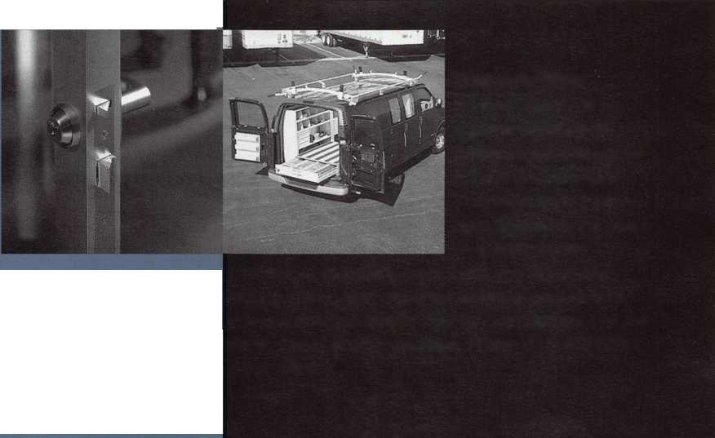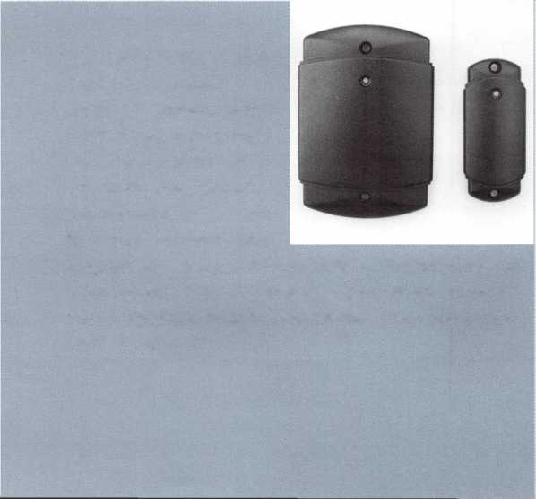

MBA

Hawkeye borescopes  
provide a crisp, bright  
view at an affordable  
price using a unique light  
source—a Mag-lite flash-  
lite! These scopes, avail-

able in three lengths— 7-, 12- and 17-inches, have a

standard straight ahead vi

adapter is also available,  
aluminum carrying case.

ALOA, or contact MBA toll

(606) 887-9491; Booth #259.

w. An optional 90 degree

is the handsome, sturdy

e see the great view at

free (888) MBA-5495; fax

Olympus Lock

We have introduced a product designed to make your  
life easier by saving you time and money. The Olympus  
DON Cam Lock has combined quality, dependability  
and style. The ease of rekeyability is due to the patent-  
ed retaining clip. It is supplied with reversible straight  
and offset cams, and a new hex nut retaining stabilizer  
plate. The DON Cam Lock features the new one-inch

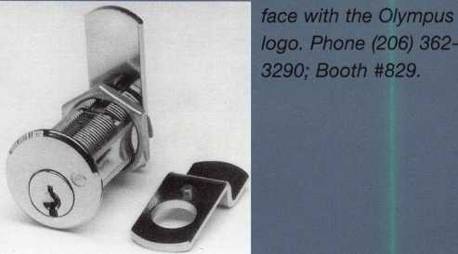

PDQ Industries

i In, . The extra heavy duty

l- ;|T grade 1 MR series mor-

1 | tise lock from PDO

fffMN ' Manufacturing is the

' lIPL • newest addition to the

company’s 100% Made in the USA SPIRIT Series locks. Featuring field reversible handling and function changes, the MR Series offers 16 different ANSI func­tions in two stock cases. Phone (717) 656-4281; Booth

**Prime-Line Products**

Meilink Safe Co.

The Meilink Safe Co. has a

popular “RSC. ” In addition

added vertical bolts now to

These new safes are availa

Value. For further informati

saler or Judd Penske at Meh

Booth #400.

idded three new sizes to its

to the new sizes, Meilink has

taling five working bolts,

ible in Graphite and Gray

ion, contact your local whole-

fink. Phone (800) MEILINK;

*For nearly 20 years, Prime-Line Products has been  
“The Source” of over 8,000 replacement parts. From  
sliding glass door handles and locks, to security items  
such as our Guard-A-Lock line of door and jamb rein-  
forcing products, Prime-Line has those hard-to-find  
products. We have put our most popular security items  
into our Security Specialist Catalog, and have set up a*

*nationwide drop-ship  
program that is available  
through your current dis-  
tributor. Call for your copy  
of this invaluable tool.  
Phone (800) 255-3505;  
Booth #240.*

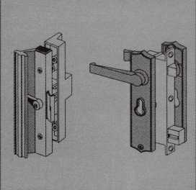

44

June 1997

***Keynotes***

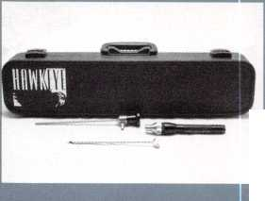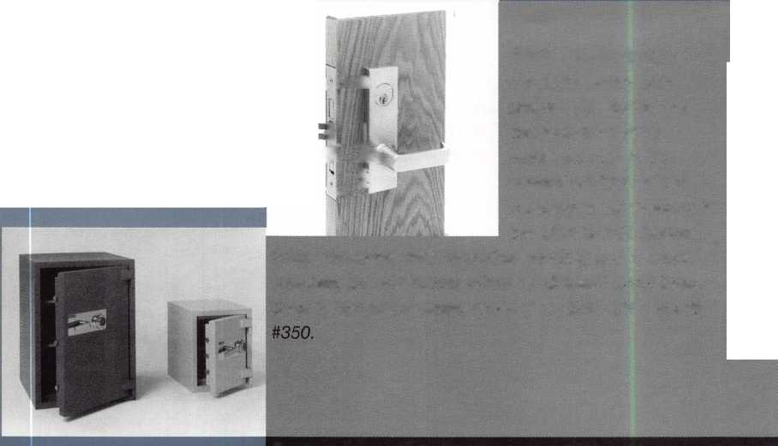

Secura Key

Radio Key 600 is one of the lowest priced single door proximity systems in the access control industry, with a retail price of only $330. The surface mounted access control unit features a built-in antenna, a programming keypad and a capacity for 600 users. No hand-held programmers, PCs or separate control panels are required. An auxiliary reader is available for higher

security applications. Phone . .. f (818) 882-0020; Booth

| ’ H #246.

Padlock

Drill Jig™ Drill Guide

Pro-Lok

Pro-Lok is aggres­sively introducing new products: The new car opening update and vol­ume; new opening tools; tool carrying

case; gun lock; key decoders; master pin follower and  
four-piece follower set. Also, two padlock drilling fix-  
tures—one for disk locks and one for rekeyable locks

that saves the body and cylinder for reuse. Call Pro-Lok  
fora list of distributors. (714) 633-0681; Booth #218.

**Sargent and Greenleaf, Inc.**

*The 6120 series, UL Type 2, motor driven electronic  
safe locks allow for single or multiple users. Time delay  
is available on all models. Programming is quickly done  
using the easy-to-read alpha numeric keypad, which is  
available in eight different finishes. Security options  
include: spy-proof keypad cover, TD status indicator,  
bolt position indicator and remote enable/disable of  
lock access. Phone (606) 885-9411; Booth #318*

Disk Pro-Lok  
Buster™ „ , . u ^ ^

Pro-Lok has developed new

machined aluminum padlock

service tools for professional  
locksmiths. The green anodized  
LT605 Diskbuster is a fixture  
that automatically lines up your  
drill bit to penetrate the shear-  
line on disk-type padlocks,  
allowing safe, simple openings.

The gold anodized LT612

Padlock Drill Jig lets you drill most rekeyable padlocks open while  
saving the lock body and cylinder. The black anodized LT612DG  
Drill Guide is an optional attachment that centers the oval retain-  
ing nut on the bottom of many rekeyable padlocks, allowing you  
to drill it out, sen/ice the cylinder and reuse the padlock. For  
more information, contact Pro-Lok. Phone (714) 633-0681; Booth  
#218.

Saf-T-Lok, Inc.

The magazine lock is a  
precision, miniaturized, all  
mechanical, combination  
lock that is contained in  
the bottom of a fully  
functional magazine. The  
lock is installed simply by  
inserting the magazine  
into the handgun. When

the lock is engaged, it prevents the gun from firing and  
prevents the magazine from being removed unless one  
of 10,000 possible combinations is entered. Expected  
availability is the summer of 1997. Phone (561) 743-  
5625; Booth #455.

***Keynotes*** I 45

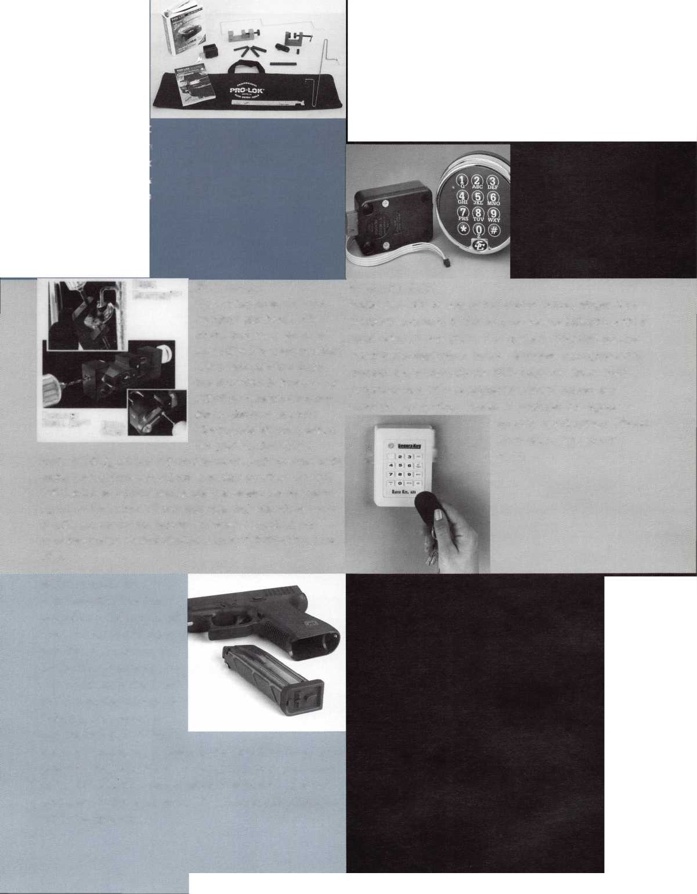

STRATTEC Security Corporation

vice bulletins, the Professional’s Choice catalog J and annual Lock and Key cat- I alogs. Contact your local STRATTEC distributor for more information about STRATTEC parts and support.

/f's your reputation. Trust the .**4^ original. Phone *(414) 24*7- " ^

3332; Sootf? #226.

STRATTEC is the leading manufacturer of automotive locks and  
keys for North America’s largest automotive companies like GM,  
Ford, Chrysler and Mitsubishi. Developing and manufacturing  
automotive lock technologies, such as Pass-Key, Passlock and  
PATS, STRATTEC quality sets the aftermarket industry standard.  
With extensive aftermarket service and support, STRATTEC leads  
the industry with quality parts, training, information and support  
materials for locksmiths. Support includes local, regional and

national training, ongoing ser-

Taymor Industries, Inc.

This grade 1 closer meets or exceeds BHMA/ANSI  
156.4 grade 1 standards and is UL listed. It is  
adjustable from 2-6 power with separate adjustment  
screws for latch, closing speed and back check. Tri-

packaging includes top  
jamb, standard and paral-  
lel arms, as well as a dec-  
orative cover. An ADA  
version is available with  
1-4 power adjustment  
#13-1900BFDA. Phone

(800) 388-9887; Booth

#740.

Taymor Industries

This grade 1 cylindrical leverset is available in passage, privacy, entry, storage room and classroom configura­tions. It is through-bolted, has a 2 3/4-inch backset standard with ASA strike pad and T-strike standard. It meets or exceeds all BHMA/ANSI 156.2 series 4000 grade 1 requirements. Additionally, the lock is provided with a clutch mechanism allowing the exterior lever to freely pivot 90 degrees in either direction when locked, reducing abuse and wear. Phone (800)

388-9887; Booth #740.

**TESA Access Control**

*Winner of the 1997 Security Industry Association Product Achievement Award for Access Control, the TESA ML500 Stand-Alone Electronic Lock brings to market the best that technology has to offer. For more information on the full line of TESA’s access control products, call TESA Access Control. Phone (800) 472- 8372; Booth #140.*

Weston Key Systems

Mark Fuller, CRL, introduces KILOKS patented multi­point security for cylindrical locks. Scheduled for avail­ability later this year, an entire product line is in the

works, including versions in standard and full mor­tise cases (shown) and two or three point auto­matic deadbolting capa­bility. Phone (713) 862- 7674; Booth #711.

Keynotes

June 1997

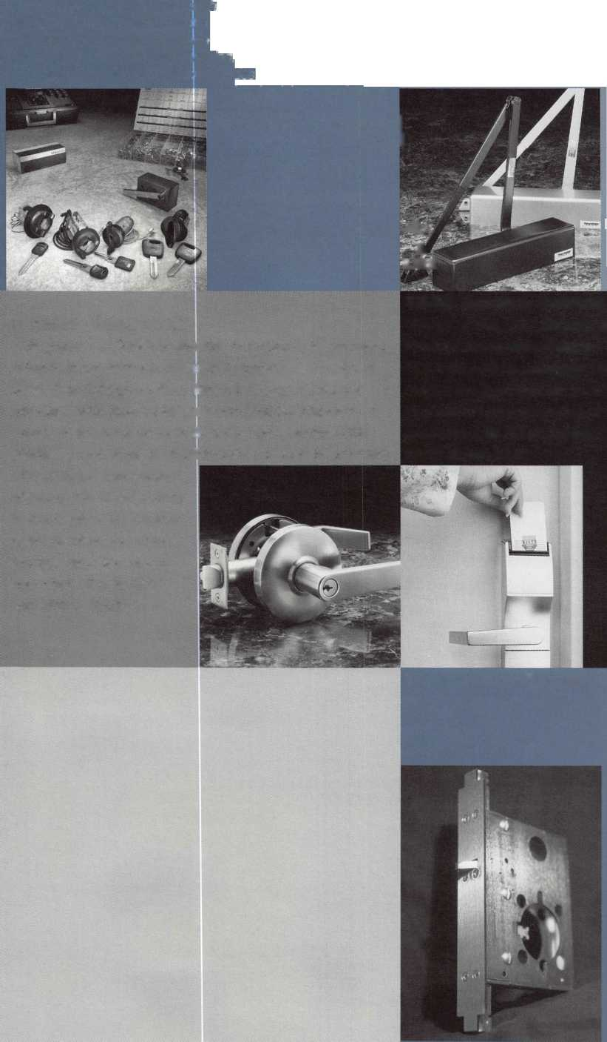

Buyer’s

Guide

Sectorater GM

After removing the ignition lock from a GM auto with VATS to find the numbers stamped on the lock is not a code, the lock must be disassembled to make a key, rekey or repair. The Sectorater GM is a GM igni­tion lock disassembly tool that saves time and money. It works on standard GM plus any lock with a sector gear.

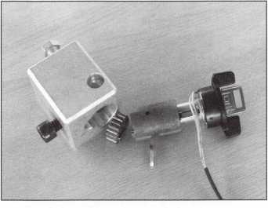

The Sectorater GM holds the lock so the steel wedge can be punched out with a 3/32 pin punch, and then it presses the sector gear off in just seconds. A vice is not needed.

The milled space on one side allows the attachment of a lock casing to the tool with a 1/4 20 bolt. Simply align the VATS wire with this notch, insert the tool in place of the ignition lock and use the tool. VATS lock and wire does not have to be disconnected from column. Simple and fast. Now avail­able. Contact A1 Bullard, (502) 790-2290.

Reader Service #16

SPEEDYPIK®

The automatic key ID system. This com­pact unit fits inside your IBM compatible computer in a 51/4 bay the same as a disk drive. The latest addition is a 5,000 key pre-programmed database. Now you can

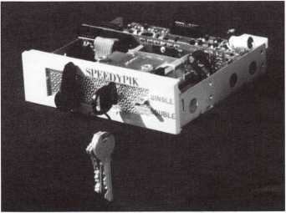

leave the key cutting in the care of an  
apprentice without a long training period.  
This will free the locksmith up to do other  
work. (617) 567-1111; FAX (617) 277-  
7777; e-mail: [SPEEDYPIK@juno.com](mailto:SPEEDYPIK@juno.com).

Reader Service #17

Allstate Locksmith Insurance Program

As a retail or mobile locksmith, you under-

stand how important  
it is to rely on a solid,  
reputable company to  
help you with your  
business insurance  
needs. If you have any  
questions about your  
insurance needs in  
general, an Allstate  
Agent can provide  
you with additional  
information. To be  
referred to an Allstate  
Agent, please call 1-  
800-669-6711.

New Tools from Pro-Lok

Pro-Lok introduces three new service tools for  
professional locksmiths. The LT370 MP  
Removal/Follower is a machined aluminum

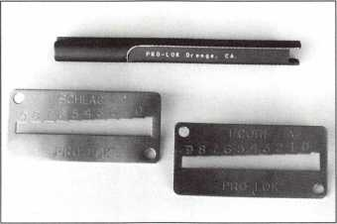

follower tool that allows removal of upper chamber master pins with a quick twist.

New key decoders fashioned from high-grade stainless steel are the KDSC (fits all Schlage keys) and the KDIC for Best/Falcon style IC/A2 interchangeable core keys. Both utilize a “Sure-Step” design and use factory specifica­tions and tolerances. For more information, contact: Pro-Lok at (714) 633-0681.

Reader Service #19

Solutions for Auto Lockouts

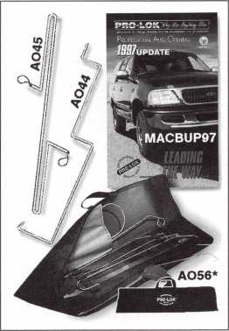

Pro-Lok offers a new 1997 Car Opening  
Update. The MACBUP97 Update “All-On-  
1 ” format concentrates on specific opening  
details and related technical data—devoting  
one page to each new vehicle. The company  
also announces the AO 5 6 Deluxe Zippered  
Case and two new entry tools—A044  
Camry/LexusTool for ’97 models and A045  
Loop-D-Loop for late model Mercedes,

Volvo and BMW sedans. For more informa-  
tion, contact: Pro-Lok at (714) 633-0681.

Reader Service #20

Pewter Keychains

Order pewter keychains direct from the fac-  
tory at our fabulously low wholesale price of  
$2.45 each. We are so confident in our  
product that they are guaranteed. Our high

quality unique  
products are  
what your cus-  
tomers are  
looking for and  
are available at  
a price every-  
one can afford.

Remember,  
time is money,

so send in your order today to: Milman  
Manufacturing; Champlain Mall Rd., P.O.  
Box 1641 ;Champlain, NY 12919; (514)  
425-5794 or fax (514) 425-5793.

Reader Service #21

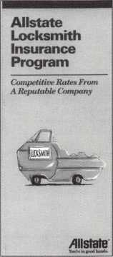

Reader Service #18

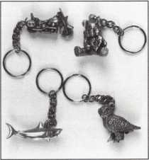

June 1997

***Keynotes \ 47***

Associate

Members

|  |  |
| --- | --- |
| Manufacturers | Alarm Lock Systems, Inc.  345 Bayview Ave.  Amityville, NY 11701 (800) ALA-LOCK; (516) 789-3383  © |
| A & B Safe Corp.  171 S. Delsea Dr.  Glassboro, NJ 08028 (800) 253-1267; FAX (609) 863-1208  @ © & | All-Lock Company  900 Ravenwood Dr.  Selma, AL 36701  (334) 874-9001; FAX (334) 874-6011  (jj) |
| Access Protection Mfg.  216 Plaisto Rd.  Plaisto, NH 03865  (603) 382-0822; FAX (603) 382-0833  © | Allied -Gary Safe Company  West 425 2nd Ave.  Spokane, WA 99204 (509) 458-2633; FAX (509) 458-2633  (g |
| Adesco Safe Manufacturing Co.  16720 S. Garfield Ave.  Paramount, CA 90723 (800) 821-6803; FAX (310) 408-6427 | American Lock Co.  3400 West Exchange Road  Crete, IL 60417-2099 (708) 534-2000; FAX (708) 534-0531  © © |
| ASSA Inc.  10300 Foster Ave.  Brooklyn, NY 11236 (718) 927-2772; FAX (718) 257-2772  © | American Security Products  11925 Pacific Ave.  Fontana, CA 92337-6963 (909) 685-9680; FAX (909)685-9685  @ |
| Abloy Security, Inc.  6015 Commerce Drive Ste. #450  Irving, TX 75063  (972) 753-1127; FAX (972) 753-0792  © | Arrow Lock Company  10300 Foster Avenue  Brooklyn, NY 11236 (718) 257-4700; FAX (718) 649-9097  @ l|J) (g (g |
| Abus Lock Company  P.O. Box 47507  Plymouth, MN 55447-0507 (800) 225-5348  © | Auto Security Products (A. S. P.)  P.O. Box 10  Redmond, WA 98073-0010 (206) 556-1900; FAX (206) 558-1205  g |g |
| Adams Rite Manufacturing Co.  4040 S. Capital Ave.  City of Industry, CA 91749 (310) 699-0511; FAX (310) 699-5094  (gl (J») | Baton Locks & Hardware Co.  14275 Commerce Dr.  Garden Grove, CA 92643 (714) 265-3636; FAX (714) 265-3630  |g (g |
| Adrian Steel Company  906 James St.  Adrian, Ml 49221  (517) 265-6194; FAX (517) 265-5834  © | Chicago Lock Company  P.O. Box 69  Pleasant Prairie, Wl 53158-0069 (800) 445-3204; FAX (414) 947-7178  © |
| Aiphone Intercom Systems  1700-130th Avenue, NE  Bellevue, WA 98005 (206) 455-0510; FAX (206) 455-0071  @ @ (|J | Corbin Russwin Architectural Hardware  P.O. Box 25288  Charlotte, NC 28229 (704) 283-2101  (g (g g g |
|  |  |



Associate members of the Associated Locksmiths of America (ALOA) manu­facture or distribute materials or equip­ment, or provide services, for the securi­ty industry. Many have donated money, services and equipment to ALOA in addition to their annual dues. Their sup­port of ALOA projects enhances overall membership benefits and we encourage our members to patronize these firms. If you know of a potential candidate for associate membership, please contact the ALOA Sales staff at (214) 827-1701. Associate member dues are $500 per year and entitle the payor to use the ALOA logo, and selected discounts on ALOA products and services.

Legend

® Alarms: Personal, vehicle, electronic, fire, burglar, and exit

@ Bank security equipment

® Automotive: Lockout equipment, key chains/rings

© Builders Hardware: Door closers, furniture/decorative hardware, viewers, emergency exit devices

® Business/Technical & Educational:

Books, reference guides, publications, computer software

® CCTV/Photo Imaging: Cameras, monitors, photo ID equipment, cables

® Electric/Electronic Security: Card access control and readers, surveil­lance, electric/magnetic locks and strikes, keypads

® Lock Devices: Auto locks, cylinders, emergency exit/entrance control, locks (various types), strikes

® Tools & Supplies: Key blanks, cutters, picks, rings/hooks, custom van/truck supplies

® Safes/Vaults

® Other

Keynotes

June 1997

Associate

Members

|  |  |  |
| --- | --- | --- |
| Curtis Industries  6140 Parkland Blvd. Ste. 300  Mayfield Heights, OH 44124-4103 (800) 555-5397 | Glenncraft Corporation  205 Fortin Dr.  Woonsocket, Rl 02895-6116 (401) 769-0101; (401) 766-1170 | Jet Hardware Mfg. Co.  800 Hinsdale Street  Brooklyn, NY 11207 (718) 257-9600; FAX(718) 257-0973 |
| • ® |  | • |
| DETEX  302 Detex Dr.  New Braunfels, TX 78130 (800) 729-3839; FAX (210) 620-6711 | Grobet File Co. of America  750 Wasahington Ave.  Carlstadt, NJ 07072 (800) 962-7242; FAX (800) 243-2432 | KABA High Security Locks  P.O. Box 490  Southington, CT 06489 (860) 621-3601; FAX(860) 621-9727 |
| • • • • | • | 9 |
| DOM Security Locks North America  100 Central Ave,  Brockville, Ontario, Canada K6V 5W6 (800) 363-4803; FAX (613) 498-5820 | GT-85 International, Inc.  P. 0. Box 21185  St. Petersburg, FL 33742-1185 (800) 525-4885; FAX (813) 526-1234 | Kenstan Lock Company  101 Commercial St.  Plainveiw, NY 11803-2412 (516) 271-2700; FAX(516) 271-2759 |
| o | • | • • |
| Don-Jo Manufacturing, Inc.  P.O. Box 929  Sterling, MA 01564 (508)422-3377; FAX (508) 422-3467 | H.E.S., Inc.  2040 W. Quail Ave.  Phoenix, AZ 85027 (602) 582-4626; FAX (602) 582-4641 | KEY-BAK; Div. of W. Coast Chain Mfg. Co.  1460 S. Balboa Ave.  Ontario, CA 91762 (909) 923-7800; FAX(909) 923-0024 |
| 9 9 | • • • | • • • • |
| Door Controls International  2362 Bishop Circle East  Dexter, Ml 48130  (800) 742-3634; FAX (800) 742-0410 | Highland Glen Products, Inc.  218 Parkdale Ave.; P.O. Box 924  Buffalo, NY 14213 (716) 883-1110; (800) 248-KEYS | Knaack Manufacturing Co.  420 E. Terra Cotta Ave.  Crystal Lake, IL 60014 (800) 456-7865; FAX(815) 459-9097 |
| • • • • | • • | • |
| Emtek Products, Inc.  15250 E. Stafford St.  City of Industry, CA 91744 (800) 356-2741; FAX (800) 577-5771 | Hill Security Products  711 East Walton Avenue  Spokane, WA 99207 (509) 487-1142; (800) 722-1142 | Kwikset Corp.  One Park Plaza, Suite 1000  Irvine, CA 90638  (714) 474-8818; FAX (714) 474-8879 |
| • 9 | • | • • |
| ESP Lock Products, Inc.  375 Harvard Street  Leominster, MA 01453 (508) 537-6121; FAX (508) 537-1699 | HPC, Inc.  3999 N. 25th Avenue  Schiller Park, IL 60176 (847) 671-6280; FAX(847) 671-6343 | LCN Closers (Division of Ingersol)  121 W. Railroad Ave.  Princeton, IL 61356 (815) 875-3311; FAX (815) 875-3222 |
| • | • • • | • |
| Federal Lock Company  14247 E. Don Julian Rd.  City of Industry, CA 91746 (800) 682-9851; FAX (708) 378-4767 | Hurd Corporation  Box 1450  Greeneville, TN 37744-1450 (423) 787-8800; (423) 787-8817 | LAB Security  700 Emmett St.  Bristol, CT 06010  (800) 243-8242; FAX (203) 583-7838 |
| • | ^ | • |
| Folger Adam Security, Inc.  16300 W. 103rd Street  Lemont, IL 60439  (630) 739-3900; FAX (630) 739-6138 | llco Unican  400 Jeffreys Road  Rocky Mount, NC 27804 (919) 446-3321; FAX (919) 446-4702 | La Gard, Inc.  3330 Kashiwa Street  Torrance, CA 90505 (310) 325-5670; FAX (310) 325-5615 |
| • • | ••••••• | • |
| Fort Lock Corp.  3000 N. River Rd.  River Grove, IL 60171 (708) 456-1100; FAX (708) 456-9476 | Industries, C.L. Inc.  9730 Gouin Blvd. West  Pierrefonds (PQ) H8Y 1R5 (514) 683-6282; FAX(514) 683-9015 | Locksmith Publishing Corp.  850 Busse Hwy.  Park Ridge, IL 60068 (847) 692-5940; FAX (847)692-4604 |
| •••••• | • # | 9 |
| Gardall Safe Corporation  P.O. Box 30  Syracuse, NY 13206 (315) 432-9115; FAX (315) 434-9442 | International Electronics, Inc. (LE.I.)  427 Turnpike St.  Canton, MA 02021 (800) 343-9502; FAX(617) 821-4443 | Lockmasters, Inc.  5085 Danville Rd.  Nicholasville, KY 40356 (606) 885-6041; FAX (606) 885-7093 |
| • | • | • • • • • |
| © Alarms  ® Sank security equip.  :® Automotive © Builders Hardware | © Business/Tech A Id.  ♦ CCTV/Photo Imaging © Electric/Electronic Sec.  © Lock Devices | © Tools & Supplies © Safes/Vaults © Other |

June 1997

***Keynotes \*** 49

Associate

Members

|  |  |  |
| --- | --- | --- |
| Lori Lock/Delta  P.0. Box 1040  Southington, CT 06489 (203) 621-3605; FAX (203) 621-5972 | The National Locksmith Magazine  1533 Burgundy Parkway  Streamwood, IL 60107 (630) 837-2044; FAX (630) 837-1210 | Schwab Corporation  PO Box 5088  Lafayette, IN 47903-5088 (317) 447-9470; FAX (317) 447-8278 |
| © • | © | © |
| Lucky Line Products  7890 Dunbrook Rd.  San Diego, CA 92126 (619) 549-6699; FAX (619) 549-0949 | Newman Tonks  P.O. Box 548  Shepardsville, KY 40165 (502) 543-2281; FAX (800) 777-8229 | Securitron Magnalock Corp.  550 Vista Blvd.  Sparks, NV 89434  (800) 624-5625; FAX (702) 355-5636 |
| • | © © | © © |
| Lund Equipment Co.f Inc.  P.O. Box 213  Bath, OH 44210  (216) 659-4800: FAX (216) 659-9347 | NT Falcon Lock  2650 Orbitor Street  BreaCA, 92621-6265 (800) 266-4456; FAX (800)777-8229 | Security Door Controls  P. 0. Box 6219  Westlake Village, CA 91359-6219 (805)494-0622; FAX (800) 959-4732 |
| • • • | © © | © |
| M.A.G. Engineering & Mfg. Inc.  15261 Transistor Lane  Huntington Beach, CA 92649 (714) 891-5100; FAX (714) 892-6845 | Pach & Company  941 Calle Negro  San Clemente, CA 92672 (714) 498-2951; FAX (714) 498-6879 | Sentry Group  900 Linden Ave.  Rochester, NY 14625-2784 (716) 381-4900; FAX (716) 381-8559 |
| • • • | © • | © |
| MARKS USA  5300 New Horizons Blvd.  Amityville, NY 11701 (516) 225-5400; FAX (516) 225-6136 | Prime-Line Products Company  5405 Industrial Pkwy.  San Bernadino, CA 92407 (909) 887-8118; FAX (909) 880-8968 | Silca Key U.S.A. Inc.  5633 Hudson Industrial Pkwy.  Hudson, OH 44236 (216) 656-5613 |
| • | © © | © • |
| Master Lock Company  2600 North 32nd Street  Milwaukee, Wl 53210 (414) 444-2800; FAX (414) 449-3114 | Pro-Lok  655 North Hariton Street  Orange, CA 92668-1311 (714) 633-0681; FAX (714) 633-0470 | Star Key Industries,Inc.  145 Brite Ave.  Scarsdale, NV 10583-1426 (914) 235-1700 |
| © © | • © | © |
| Medeco Security Locks  P.O. Box 3075  Salem, VA 24153  (540) 380-1684; FAX (540) 380-5010 | Rainbow Technology  261 Cahaba Valley Pkwy.  Pelham, AL 35124-1146 (800) 637-6047; FAX (800) 521-6896 | STRATTEC Security Corp.  3333 W. Good Hope Rd.  Milwaukee, Wl 53209 (414) 247-3333; FAX (414) 247-3329 |
| • • • | • | © © © |
| Meilink Safe Company  111 Security Parkway  New Albany, IN 47150 (800) 634-5465; FAX (800) 896-6606 | Rofu International Corp.  2004-B 48th Ave.; Court E  Tacoma, WA 98424 (800) 255-7638; FAX (206) 922-1728 | Sully Tools Inc.  3515 Nodding Pine Ct.  Fairfax, VA 22033  (703) 689-3416; FAX (703) 787-0869 |
| • | • | © © © |
| Metalurgica Odis S.A.  Porto Seguro 4395 Quinta Norma  P.O. Box 107-2; Santiago, Chile (562) 776-6511 | Rutherford Controls Inc.  2697 Internal Pkwy, Bid 5 #100  Virginia Beach, VA 23452 (757) 427-1230; FAX (804) 427-9549 | Treskat USA  725 Adriane Park Circle  Kissimmee, FL 34744 (800) 645-5657; FAX (407) 870-9696 |
| © | © | © |
| MUL-T-LOCK USA, Inc.  300-1 Route 17 South Suite A  Lodi, NJ 07644  (800) 562-3511; FAX (201) 778-4007 | Sargent & Greenleaf, Inc.  P.O. Box 930  Nicholasville, KY 40340-0930 (606) 885-9411; FAX (606) 887-2057 | Trine Products Corporation  1430 Ferris Place  Bronx, NY 10461  (718) 829-4796; FAX (718) 792-9127 |
| ® ® ® | (0| (0 (0 0 | © © © |
| National Cabinet Lock  200 Old Mill Road, P. 0. Box 200  Mauldin, SC 29662 (864) 297-6655; FAX (864) 297-9987 | Schlage Lock Co.-PRIMUS  3899 Hancock Expy.  Security, CO 80911 (719) 390-5071 | U-Change Lock Industries  1640 W. Hwy. 152  Mustang, OK 73064 (405) 376-1600; FAX (405) 376-6870 |
| • | © © | (0 (0 0 |
| , Alarms ■■, . -  © Bank security equip.  ©■Autouiqthw @ • BuildersHardware - | ® Business/Tech & Ed.  ® CCTWPhoto lmaging ® Electric/Efectronic Sec.  ® Lode Devices | ® Tools & Supplies ® Safes/V/aults ® Other |

50

***Keynotes***

June 1997

|  |  |  |  |  |  |
| --- | --- | --- | --- | --- | --- |
|  | i | 21 | 41 | 61 | 81 |
|  | 2 | 22 | 42 | 62 | 82 |
|  | 3 | 23 | 43 | 63 | 83 |
|  | 4 | 24 | 44 | 64 | 84 |
|  | 5 | 25 | 45 | 65 | 85 |
| Use this card to | 6 | 26 | 46 | 66 | 86 |
| obtain more | 7 | 27 | 47 | 67 | 87 |
| information about |  |  |  |  |  |
| the products and | 8 | 28 | 48 | 68 | 88 |
| services | 9 | 29 | 49 | 69 | 89 |
| advertised or | 10 | 30 | 50 | 70 | 90 |
| described in this | 11 | 31 | 51 | 71 | 91 |
| issue. | 12 | 32 | 52 | 72 | 92 |
| Card valid until | 13 | 33 | 53 | 73 | 93 |
| October 1,1997. | 14 | 34 | 54 | 74 | 94 |
|  | 15 | 35 | 55 | 75 | 95 |
|  | 16 | 36 | 56 | 76 | 96 |
|  | 17 | 37 | 57 | 77 | 97 |
|  | 18 | 38 | 58 | 78 | 98 |
|  | 19 | 39 | 59 | 79 | 99 |
|  | 20 | 40 | 60 | 80 | 100 |
|  |  |  | ■ —i _ |  |  |
|  | 1 | 21 | 41 | 61 | 81 |
|  | 2 | 22 | 42 | 62 | 82 |
|  | 3 | 23 | 43 | 63 | 83 |
|  | 4 | 24 | 44 | 64 | 84 |
|  | 5 | 25 | 45 | 65 | 85 |
| Use this card to | 6 | 26 | 46 | 66 | 86 |
| obtain more | 7 | 27 | 47 | 67 | 87 |
| information about | 8 | 28 | 48 | 68 | 88 |
| the products and  c o r\/i r* oc | 9 | 29 | 49 | 69 | 89 |
| berviceb  advertised or | 10 | 30 | 50 | 70 | 90 |
| described in this | 11 | 31 | 51 | 71 | 91 |
| issue. | 12 | 32 | 52 | 72 | 92 |
| Card valid until | 13 | 33 | 53 | 73 | 93 |
| October 1,1997. | 14 | 34 | 54 | 74 | 94 |
|  | 15 | 35 | 55 | 75 | 95 |
|  | 16 | 36 | 56 | 76 | 96 |
|  | 17 | 37 | 57 | 77 | 97 |
|  | 18 | 38 | 58 | 78 | 98 |
|  | 19 | 39 | 59 | 79 | 99 |
|  | 20 | 40 | 60 | 80  ■ mm ■ | 100  ■ mm |

ALQA Mentor

I number for information on each item.

Reader Service

‘June 1997

Name _

_Title

Company

Street Address _ City

_State

Phone_

_Country

FAX

_ZIP_

Please help us assist you by answering the following questions:

1. What is your type of company? aLocksmithing bMobile locksmithing cMultiple shops dSecurity/Maintenance

©Corporate /Industrial fGovernment/Military gPolice hConsultant iManufacturer jOther

1. What is your job description? aOwner/Partner/President bManager/Officer eBuyer/Specifier/Purchasing dEmployee eOther
2. Do you pass Keynotes along to others, and how many? aYes bNo #

f Wow many employees does your company have? al-5 b6—10 cl 1-20 d21ormore

* How many service trucks does your company have? al b2-3 C4-10 dl 1 or more

1. What is your Company's annual sales? (Voluntary) a$10-50 b$50—100 c$100-250 d$250-500 e$500-1,000 f Over $1,000,000
2. What is your reason for inquiry? aCurrent need bFuture need
3. What is your purchasing authority? aBuy bApprove cRecommend

Inumber for ’ information on each item.

Reader Service

‘June 1997

Name _

_Title

Company

Street Address _ City

_State

Phone_

_Country

FAX

_ZIP_

Please help us assist you by answering the following questions:

1. What is your type of company? aLocksmithing bMobile locksmithing cMultiple shops dSecurity/Maintenance

eCorporate/Industrial fGovernment/Military gPolice hConsultant iManufacturer jOther

1. What is your job description? aOwner/Partner/President bManager/Officer eBuyer/Specifier/Purchasing dEmployee eOther
2. Do you pass Keynotes along to others, and how many? aYes bNo #
3. How many employees does your company have? al-5 b6—10 cl 1-20 d21ormore
4. How many service trucks does your company have? al b2-3 C4-10 dl 1 or more
5. What is your Company's annual sales? (Voluntary) a$10-50 b$50—100 c$100-250 d$250-500 e$500-1,000 f Over $1,000,000
6. What is your reason for inquiry? aCurrent need bFuture need
7. What is your purchasing authority? aBuy bApprove cRecommend

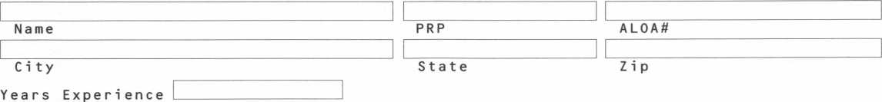

Areas of Locksmi thing that y_o u are profic i_e_n t i_m_

Domestic Auto Commercial Master Keying

Foreign Auto Residential Access Control

Auto Opening Safe Servicing Safe Opening

CCTV Computers Business

Other

A v a i lable f.o_r calls:

Phone numbers.

Weekdays

Saturday

Sunday

**am to**

**AM tO AM tO**

**PM**

**PM**

**PM**

Days

Nights

Pager



PO BOX 11602 RIVERTON NJ 08076-1602

Place

Stamp

Here

llliiiliililliiiliiililliiiiillilliilliiiii

l.lllml

Place

Stamp

Here

PO BOX 11602 RIVERTON NJ 08076-1602

Place

Stamp

Here

Robert DeWeese, CPL Bear Lock & Security, Inc. 205 Cleveland Ave. Baltimore, MD 21222-4237

Associate

Members

|  |  |  |
| --- | --- | --- |
| Vindicator Corp.  3001 Bee Caves Rd.  Austin, IX 78746-5561 [512) 314-1200; FAX (512) 314-1270 | Boyle & Chase Inc.  P. 0. Box 74  Accord, MA 02018-0074 (800) 325-2530; FAX (617) 335-5342 | HS&S Wholesale Distributors  12915 West 8 Mile Road  Detroit, Ml 48235 (800) 521-2202 |
| • • • • | ess | 0 0 0 0 0 0 0 |
| Weiser Lock Company  6700 Weiser Lock Blvd.  Tucson, AZ 85746  (520) 741-6231; FAX (520) 741-6363 | Clark Security Products, Inc.  4775 Viewridge Ave.  San Diego, CA 92123-1641 (800) 854-2088 | Hans Johnsen Company  8901 Chancellor Row  Dallas, TX 75247  (214) 879-1550; FAX (214) 879-1530 |
| • • | • ® ® 9® ® | •••••••• |
| Wilson Safe Company  3031 Island Avenue/P.O. Box 5310 Philadelphia, PA 19153 (215) 492-7100; (800)345-8053 | Cook’s Building Specialties  2441 Menaul Blvd. NE; P.O. Box 37320 Albuquerque, NM 87176-7320 (505) 883-5701; FAX (505) 883-5704 | Hardware Agencies, Ltd.  1220 Dundas Street East  Toronto, ON M4M 1 S3 (416) 462-1921 |
| • | •••••• | 0 0 000000 |
| Yale Security Inc.  P.O. Box 25288  Charlotte, NC 28229-8010 (704) 283-2101 | DiMark International  3117 Liberator St., Unit A  Santa Maria, CA 93455 (800) 235-2435; FAX (805) 928-8034 | Hardware Suppliers of America  P.O. Box 2208  Winterville, NC 28590 (800) 334-5625 |
| • • • • | s • | • • |
| Distributors | Dire’s Lock & Key Co.  2201 Broadway  Denver, CO 80205 (303) 294-0176 | IDN, Inc.  1000 S. Main, Suite 280  Grapevine, TX 76051 (817)421-5470; FAX (817) 421-5468 |
|  | 00000000000 | 000 0000000 |
| Accredited Lock Supply Co.  P.O. Box 1442  Secaucus, NJ 07096-1442 (800) 652-2835; FAX (201) 865-5031 | Doyle Lock Supply  2211 W. River Road N.  Minneapolis, MN 55411 (800) 333-6953; FAX (612) 521-0166 | IDN—Armstrong’s, Inc.  1440 Dutch Valley Place NE  Atlanta, GA 30324 (800) 726-3332 |
| 0 0 0 0 0 0 0 | 00000000000 | 0000000000 |
| Ace Lock & Security Supply Co.  565 Rahway Ave.  Union, NJ 07083-6631 (908) 688-7666; (800) ACE-FAX4 | Dugmore & Duncan Inc.  30 Pond Park Rd.  Hingham, MA 02043 (800) 225-1595; FAX (617) 740-4043 | Intermountain Lock & Supply Co  2300 W. 2nd Ave., Unit B  Denver, CO 80223  (800) 323-8046; FAX (303) 698-2094 |
| 00000000 | 0 0 0 0 0 0 | 000 0000000 |
| Akron Hardware Consultants, Inc.  2579 South Arlington Road  Akron, OH 44319  (800) 321-9602; FAX (800) 328-6070 | Ewert Wholesale Hardware  4709 W 120th St  Alsip II 60658 (800) 451-0200 | Jo-Van Distributors Inc.  929 Warden Ave.  Scarborough, Ontario MIL 4C6 (416) 752-7249; FAX (416) 752-3845 |
| • • • | 0 0 0 0 0 | ••••••••••• |
| American Security Distribution  4411 E. La Palma  Anaheim, CA 92807 (714)996-0791; FAX (714) 579-3508 | Fairway Supply, Inc.  2631 Lombardy Lane  Dallas, TX 75220  (214) 350-0021; FAX (214) 352-4299 | JLM Wholesale, Inc.  3095 Mullins Ct  Oxford, Ml 48371-1643 (800) 522-2940; FAX (800) 782-1160 |
| ••••••• | 0 0 0 0 0 0 0 | • • • |
| Andrews Wholesale Lock Supply  544 S. 9th St.  Lebanon, PA 17042-6608 (717) 272-7422 | Foley-Belsaw Company  6301 Equitable Road  Kansas City, MO 64120 (800) 821-3452; FAX (816) 483-5010 | Key Sales & Supply Co., Inc.  9950 Freeland Ave.  Detroit, Ml 48227 (313) 931-7720; (313) 931-7758 |
| • | • • • • | 000000000 |
| Armstrong’s Lock & Supply, Inc.  1440 Dutch Valley Place NE  Atlanta, GA 30324  (800) 726-3332; FAX (404) 888-0834 | Fried Brothers, Inc.  467 N. 7th St.  Philadelphia, PA 19123 (800) 523-2924; FAX (800) 541-3489 | Lockmasters, Inc.  5085 Danville Road  Nicholasville KY, 40356 (606) 885-6041 |
| 0000000000 | 0000000000 | • • • • |
| 9 Alarms  9 Bank security equip.  9 Automotive • Builders Hardware | 9 Business/Teclt A Ed.  9 CCTV/Photo Imaging  9 Electric/Electronic Sec.  ♦ Lock Devices | 9 Tools & Supplies  9 Safes/Vaults  9 Other |

June 1997

Keynotes

51

Associate

Members

|  |  |  |
| --- | --- | --- |
| Locks Company  2050 N.E. 151 St.  N. Miami, FL 33162 (8003 288-0801; FAX (3053 949-3619 | Southern Lock and Supply Co.  Box 1980, 10910 Endeavor Way  Pinellas Park, FL 34664 (8003 237-2875; FAX: (8003 447-2299 | Gil-Ray Tools, Inc.  P.O. Box 801, 1306 McGraw St.  Bay City, Ml 48707 (5173 892-6870; FAX (5173 892-6870 |
| 0 0 0 0 0 0 0 | 000000000 |  |
| Locksmith Store Inc.  1229 E Algonquin Rd. Suite E  Arlington Heights, IL 60005 (8473 364-5111; FAX (8473 364-5125 | Stone & Berg Wholesale  99 Stafford Street  Worcester, MA 01603 (8003 225-7405; FAX (8003 535-5625 | National Key & Road Service  124 Stratford Dr.  Louisburg, NC 27549 (9193 497-0474; FAX (9193 497-5555 |
| 0 0 0 0 | 0000000000 |  |
| M. Zion Company  17 Murray Street  New York, NY 10007 (2123 349-8677 | Strauss Safe & Lock Company  1801 Second Avenue  Des Moines, IA 50314 (5153 288-9571; FAX: (5153 288-9752 | Pine Technical College  1000 4th Street  Pine City, MN 55063 (8003 521-7463; FAX (6123 629-7603 |
| 0 0 0 0 0 ® | 0 0 0 0 0 0 |  |
| McDonald-DASH Locksmith Supply  5767 E. Shelby Dr.  Memphis, TN 38141 (8003 238-7541; FAX (9013 366-0005 | Top Notch Distributors, Inc.  P.O. Box 189  Honesdale, PA 18431 (8003 233-4210 |  |
| 00000000 | 0 0 0 |  |
| McManus Locksmith Supply, Inc.  P.O. Box 9231, 1309 Central Ave.  Charlotte, NC 28299 (7023 333-9112 | Turn 10 Wholesale  P.O. Box 746  Marietta, OH 45740 (8003 848-9790; FAX (8003 391-4553 |  |
| 0 0 0 | 0 |  |
| McMaster-Carr Supply Company  600 County Line Rd,  Elmhurst, IL 60126-2081 (6303 833-0300; FAX (6303 834-9427 | U.S. Lock Corporation  77 Rodeo Drive  Brentwood, NY 11717 (8 003 9 25-50 00; FAX (8003 338-5625 |  |
| 0 0 0 0 (0 | 0 0 0 0 0 |  |
| Monaco Lock Co.  339-345 Newark Ave.  Jersey City, NJ 07302 (8003 526-6094; FAX (8003 8 45-LOCK | Webster Safe & Lock Company, Inc.  3020 Millbranch  Memphis, TN 38116 (9013 332-2911; FAX (9013 332-2878 |  |
| (0) (g 0 | 0 0 0 0 0 0 0 |  |
| Omaha Wholesale Hardware  1201 Pacific Street, PO Box 3628  Omaha, NE 68108 (8003 238-4566 | Service |  |
| (0 (0 g |  |  |
| E. L. Reinhardt Co., Inc.  3250 Fanum Road  Vadnais Heights, MN 55110 (8003 328-1311; FAX (61 23 481-0 1 66 | Alarm Monitoring Service, Inc.  5021 Fairfield St.  Metairie, CA 70006 (5043 454-2163; (5043 456-8737 |  |
| ® 0) (g g <0 0) |  |  |
| Security Lock Distributors  40 A Street  Needham Heights, MA 02194 (8003 847-5625; FAX (8003 878-6400 | Allstate Insurance Company  2775 Sanders Road, Suite A5  Northbrook, IL 60062 (8473 402-8196; FAX(8473 326-7509 |  |
| 0 0 g | © |  |
| Sentry Security Fasteners  8109 N. University  Peoria, IL 61615  (3093 693-2800; FAX (3093 693-2872 | GE Capital Fleet Services  Three Capital Drive  Eden Prairie, MN 55347 (612 828-2928; FAX (6123 828-1766 |  |
| © ® | $ |  |
| ® Alarms  © Bank security equip.  ® Automotive © Builders Hardware | © Business/Tech & Ed.  © CCTV/Photo Imaging © Electric/Electronic Sec.  ® Lock Devices | ® Tools & Supplies © Safes/Vaults ® Other |

52

Keynotes

June 1997

**Keynotes**

Classified



Dept

■Employment Opportunities Experienced Technician

If you are good at locksmithing and/or access control, consider this. A well-established compa­ny in suburban Arlington, VA is looking for motivated individu­als. You will earn the best salary and bonuses. We have an excel- lant company-funded retirement plan. We offer paid medical and dental plans, paid personal days, as well as paid vacations and holidays. All of your tools, uni­forms and your truck are fur­nished by the company. Education is big with us: “you must learn to earn.” We ensure that you will go to seminars, classes, and conventions to learn the latest in security technology in our fast-moving business. No on-call. You should be a team player, hard-working with a pos­itive attitude, and well-versed in locksmith skills. Access control and safes a plus. Call:

Federal hock and Safe, Inc. at (703) 525-1436 or FAX (703) 525-1637.

Help Wanted

Growing, established company seeking professional locksmiths with at least three years of well- rounded experience. We offer full benefits, fully equipped vans, modern shop and pleasant working conditions in a beauti­ful seaside area. Must possess clean drivig record, neat work habits and be will to continue learning. Send or fax resumes to: Rackliffe Lock & Safe 785 Boston Post Rd.

Old Saybrook, CT 06475 (860) 388-1810 (860) 388-5143 (Fax)

Locksmith Wanted

Experienced locksmith wanted: minimum five years expereince in all facets of commercial and industrial locksmithing. Safe, alarm and access control experi­ence a plus. Must have clean driving record, good communi­cation skills, be hard working and neat in appearance. Salary and benefits commensurate with

experience and training. Smoke, drug and alcohol free environ­ment. Fax or mail resume and references to:

R. Haskett

1613 Wade Hampton Blvd. Greenville, SC 29609 (864) 322-7314 (Fax)

Locksmith Wanted

Experienced in service work. Must have communication skills and clean driving record. Paid vacation-holidays and sick leave. Insurance is also available. Salary negotiable according to experience. We are a 20-year company with two shops and five vans in a growing commu­nity. Contact:

Bill

Bill’s Lock & Safe No. Little, AR (800) 374-4604 (501) 376-0046

Locksmiths Wanted

Experienced locksmiths wanted to work in New Jersey, Delaware, and Philadelphia metropolitian area. Must have vehicle and tools.

(800) 627-1300

Help Wanted

Locksmith apprentice. US Dept, of Labor Certificate program. Experience and/or a desire to learn, and a penchant for prob­lem-solving a plus. Residence in Boulder, CO desired. Resume by e-mail to: [locks1234@aol.com](mailto:locks1234@aol.com) or

City Lock

2900-C Valmont Road Boulder, CO 80301

Manager

Able Lock has a management position available for an individ­ual with 5 + years experience in the locksmith or related indus­try who is willing to relocate to Las Vegas. Must have the proven ability to supervise employees and manage business operations, including sales and marketing, purchasing, invento­ry control and payroll.

Commitment to quality cus­tomer service required. We offer competitive salery and excellent benefit package, including med­ical/dental, matching 401K and employee stock purchase plan.

Please send resume to:

1911 E. Charleston Blvd.

Las Vegas, NV 89104 ATTN: M. Joseph

Help Wanted

Prominent manufacturer of elec­tronic locks in Atlanta, GA, seeks VP Operations and Logistics. Position requires degree in mechanical engineer­ing and a minimum of 4+ years of experience in industrial project managment in the electronic locks field. 115K. Fax resume to: Keynotes Classified (214)827-1810 (Be sure to reference this ad on cover sheet)

Locksmith Wanted

Locksmith wanted for fast growing company in north western Montana. Prefer CRL, but will train right person. Needed for counter and outside service person. Salary with pos­sible advancement. Person should have good phone and sales skills. Organized, friendly and clean cut. Fax resume to: (406)543-1175

or call number after 7:00 p.m. Missoula Valley Locksmith ATTN: Peter

Locksmith Wanted

Locksmith wanted for large growing company in Richmond, VA. Must have experience and neat appearance. Earn 35K-40K, paid health insurance, vacation, sick pay and profit sharing. Call or write: Richmond Lock and Safe 711 Johnston Willis Dr.

Richmond, VA 23236 (804) 378-1010

Technician Wanted

Do you enjoy being challenged? We are a fast growing company looking for good technicians to join our progressive company.

Must be clean cut and bondable. Electronics and safe experience helpful. Send resume to:

ABC Locksmith Service 4063 Seneca St.

Buffalo, NY 14224

Experienced Locksmith

Experienced locksmith good with hands, excellent with peo­ple. Room to grow with expanding company in Texas. Five-day week, health and life insurance, paid vacation and holidays, profit sharing plan and uniforms. If you want a profes­sional work place with multiple locations, send resume with ref­erences and earning record to: Darvid Inc.

4021 Belt Line Road Suite 104

Dallas, TX 75244-2322

Locksmith Wanted

An established locksmith com­pany in Maine needs a lock­smith experienced in all phases, including masterkeying, safes, access control and high security. This is a growth opportunity for the right person. Competitive wage plus comprehensive bene­fit package. Send resume to: General Manager Lock, Stock & Barrell, Inc.

P.0. Box 939 Portland, ME 04104

Eager & Willing?

Work? Plenty of it! Looking for the right, three years plus expe­rienced locksmith who is hard working and willing to work night calls and weekends. Must have good personality, well groomed and a people person. Customer service is number one in this company. Must work well under pressure. Positive attitude a must. Must have per­sonal vehicle and tools. Auto, residential, commercial and safe background a plus. Most impor­tant-need somone who is trust­worthy and honest. Please send resume and photo to:

Lockbusters, Inc.

P.O. Box 720475 Houston, TX 77272-0475

June 1997

Keynotes

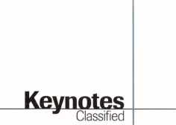

Experienced Technicians

If you are good at locksmithing and/or access control, consider this: A well established compa­ny in suburban Arlington, VA, is looking for motivated indi­viduals. You will earn the best salary and bonuses, excellent retirement plan, paid medical and dental, paid vacations and holidays, all tools, truck and uniforms and paid classes. No on-call. You should be a team player, hard-working with a positive attitude, and well versed in locksmith skills. Safe work a plus. Call:

Federal hock and Safe, Inc.

(703) 523-1436 (703) 525-1637 (FAX)

Unlock Your Potential

Virginia Safe and Lock Service is experiencing continued business growth. To keep pace with this growth, we are looking for ener­getic, neat, dependable, profes­sional secuity technicians who can perform a multitude of safe and locksmithing duties. Ideal candidate must have excellent driving record and dedication to safety. Minimum three years of commercial related experience and a high school diploma required. Salary commensurate with experience. Benefits include: relocation allowance, company-provided vehicle, free uniforms with weekly cleaning, overtime commission, tuition reimbursement, medical, paid vacations, holidays and sick leave provisions, congenial work environment and employee pen­sion/IRA.

The Washington D.C. and northern Virginia area boasts some of the finest hospitals, aca­demic institutions, shopping centers and weather. Cost of liv­ing is affordable. Great reloca­tion opportunity.

Qualified applicants contact: Harry Werner (800) 551-2236

Security Technicians Needed

Get lucky and work in booming Las Vegas. Great work environ-

54 | Keynotes June 1997

ment, great weather, great income potential for experi­enced, motivated, hardworking technicians. Paid holidays, vaca­tion, medical, 401K plan, and in-house training. Don’t delay. Fax your resume today.

Liberty Lock & Safe (702) 871-5397 (702) 876-5470 (FAX)

Position Desired

CRL wishes position in lock­smith shop as inside/outside field technician. Twenty five years in own business closed due to economy of area. Desires warm/fair weather area.

Salary/benefits package equal to experience. Have own equip­ment, but will need van if mobility is required. Contact: Chris

P.O. Box #225

Great Fall, SC 29055-0225

■Business for Sale Move to Utah

The Salt Lake City area was rated the number one entrepre­neurial “hot spot”in the United States by Kiplinger’s, and Forbes recognized Salt Lake as one of the top US cities for business and job growth. The Employement Review also rec­ognized Salt Lake as one of the top 20 places to live and work in the United States. We are offering our successful lock and safe retail shop and mobile busi­ness in a suburb of Salt Lake City (home of the 2002 winter Olymics) for sale. Two fully equipped service vans, invento­ry, equipment, computers, accounts and good reputation. Located on busy street in strip mall. Grossing over $145,000— could be more. Asking $115,000. Owner to stay if nec­essary. Call:

(801) 568-9277

email: [MGMINC@Juno.COM](mailto:MGMINC@Juno.COM)

Locksmith Business For Sale

Sixteen year old successful, well established locksmith buisness for sale in sunny west central Florida. Fully equipped retail

store, two fully equipped vans, 70% commercial accounts. $185,000. Additional informa­tion available to qualified buy­ers. Respond to:

P.O. Box 21631

Saint Petersburg, FL 33742

Business For Sale

Successful locksmith business for sale in Savannah, GA. Well established shop and mobile ser­vice with over 15 years in the same location. Reaonably priced. Serious inquiries only. Call:

(912) 925-4326 Monday through Friday 8:30 am to 5:30 pm est.

Locksmith Business For Sale

Twenty-seven years in business, want to retire. Was asking $50,000—reduced to $30,000. This is a give-away price. Includes inventory, equipment, tools and fully stocked ’88 3/4- ton Chevy van (42,300 miles) with Adrian cabinets. Move all to your location. Contact: Kenneth Bland (304) 525-0574

Business For Sale

Are you ready to run?

Locksmith business, full service, established 23 years. Located in nice Arden area of Sacremento. 90% established commercial accounts. Two service vans, four employees. Highly visible, excellent reputation. Owner’s health at risk. 3 5 OK carry note. (916) 674-3411 after 7p.m. or weekends

Business For Sale

Locksmith company, residential, commercial, 17 years servicing Washington, D.C. metropolit- ian area. Owners relocating. Contact:

Phil Friedman (410) 484-5272

Business For Sale

Excellent opportunity for owner/operator in retail/service locksmith business located in northeastern Connecticut.

$200,000 total price with 50% seller financing, inventory, equipment, trucks and training included. Large no-competition service area. For details call: Michael Rice

Century 21 Elite Associates (860) 456-9288

■Wanted to Buy/Sell Wanted

Used tubular key machine. Call: (301) 627-5876.

For Sale

Reed Code Books 1,2,3,4; Reed padlock code books 1,2,2,5— $30 each or $200/set; Falcon I/C core deadbolts and knobsets —call for list and prices.

All County Lock & Key Call Paul or Jerri (305) 947-7930

For Sale

Redi-line generator—500w con­tinuous. For service van. Automatically turns itself on and off when electrical device (such as HPC 1200) is used. Recently serviced and works perfectly.

Sells for $450 new. Will sell for $225 or trade for decent dupli­cating machine. Call:

Mid-Florida Locksmith (407) 864-9003

Wanted to Buy

Used Ilco KD 87 old style abloy machine and keying kit.

Contact:

Glen Johnson (218) 624-4136

For Sale

A-l Pak-a-Punch, brand new in box, never used. Does not have quick change kits. $195. Arrow six-pin originals precut factory keys $.60 per set. Contact:

EbeVs Lock Service P.O. Box 35973 Las Vegas, NV 89133 (702) 655-7280

For Sale

Silca Club Junior. Like new with assorted keys. Also, cutter for Dom keys—$800. Call:

Dave at (201) 827-5060

NEW ILCO DISTRIBUTOR!!

Keynotes

**Classified**

Monday Security Corporation  
1-800-886-6721

For sale

Open Tidel TACC 11 safes with ease. Sometimes they can be opened without drilling. $19-95 shipping and handling for tips and drill points. Send check, credit card or money order to: **Lonnie McKinney, CML P.O. Box 3691 Salina, KS 67402-3691**

Wanted to Buy

Medeco code machine for 10-11 series commercial keys. Contact: **Leroy**

Donaco Enterprises (505) 526-4106 (phonelfax)

For Sale

Diebold safe and safe deposit locks, cases, time movements, handles, cylinders and related products. Call for fax list. **Safemasters at (301) 565-2100**

■Commercial Classified

Business Oportunities

Owners and Technicians—learn how to create a great second income. For a pre-interview audio, call:

Knight Lock & Key (800) 597-4655 Ask far Parrish

High Security Auto Keys

Aero Lock provides high securi­ty auto keys by code. Shipped via express mail. Cut and out the same day. $22 delivered. Price good in U.S. territory only.

Aero Lock

3675 New GetwellRd. #9 Memphis, TN 38118 (800) 627-9433 [aerolock@ix.netcom.com](mailto:aerolock@ix.netcom.com)

Contact Laura for details  
on dealer discounts

We carry almost every make  
and model of new and  
used safe deposit locks,  
and safe parts, specializing  
in the antique parts.

Have you received our  
catalog?

Reader Service #22



* LCN
* Von Duprin
* ILCO
* Sargent & Greenleaf

(Arm-A-Door)

* Roton
* Detex
* Simplex
* Norton
* Stanley
* Rixson
* Glynn-Johnson
* Adams Rite
* Jackson
* Master Padlock
* Folger Adam
* Locknetics
* Rutherford

(EFF-EFF)

* Telkee

To Order Call Toll Free

**Phone: 800-238-4566 • Fax: 800-538-4566**



Call Or Write for our FREE Full Line Catalog

Omaha Wholesale Hardware  
P.O. Box 3628 • Omaha, Nebraska 68103



Reader Service #23

June 1997

***Keynotes***

PRP

Report

| James Watt, CML Committee Chairman

The PRP evaluation is an excellent tool for determining your current level of knowledge and your standing in the profession.

**/PRP Dates**

July 19

Boston, MA

North Bennet Street School Jack Hobin, CPL (617] 227-0155

July 31 /August 1

Reno, NV

ALOA ‘97 Security Expo Jessica Vasquez (214] 827-1701

August 16

Charlotte, NC

North Carolina Locksmiths Association Granger Marley, CML (919] 859-6060

August 17

Elicott City, MD Clark Securitiy Products Marlene Sealey-Frey (619] 974-5273

September 13

Chicago, IL

Greater Chicago Locksmiths Association Roy Miller (773] 777-2772

September 14

Philadephia, PA

Greater Philidelphia Locksmiths Association Orvis Kline, CPL (610] 891-1594

September 14

Long Beach, CA Clark Securitiy Products Marlene Sealey-Frey (619] 974-5273

September 28

Haines City, FL SERLAC Jim Riley (800] 845-5294

October 5

Scarborough, Ontario, Canada Jo-Van Distributors Joan Daniels (416] 752-7210

30-day application period required

56

Just Getting Started?

From time to time, PRP committee mem­bers and ALOA staff get asked about what kind of expertise in what subjects are required to sit for the PRP For those of you who haven’t ordered your copy of the Resource Guide (see item below) or talked to others who have gone through the program, the ALOA proficiency registration evaluation currently consists of 36 categories, 10 of which are mandatory:

* Codes and Code Equipment
* Cylinder Servicing
* Key Blank Identification
* Key Duplication
* Key Impressioning
* Professional Lock Opening Techniques
* Lockset Functions
* Lockset Servicing
* Basic Master Keying
* Cabinet, Furniture and Mailbox Locks. The remaining 26 categories are electives

that may be selected according to each lock­smith’s field of specialization or expanding knowledge. Each elective contains between 25 and 40 questions, depending on the sub­ject covered. For example, to qualify for the first level of certification—Certified Registered Locksmith—you would need to score 70% on the mandatory subjects listed above as well as any two electives.

If you’ve been taking locksmithing classes, training and working as a professional lock­smith for several years, you just might already know what is necessary to become a CRL. The PRP evaluation is an excellent tool for determining your current level of knowl­edge and your standing in the profession.

**PRP History Requests**

There continues to be requests for PRP his­tory reports. If you need information about your PRP history, contact the chairman at (406) 721-9797 or FAX (406) 549-7067. Please have your current ALOA membership number and/or any old ALOA membership numbers under which you might have taken the PRP evaluation. A history report can be mailed to you upon your written request to ALOA headquarters or the chairman.

**Give the PRP Another Try**

For those of you who may have started the PRP some time ago and found that you could not pass the Mandatory, please consid­er giving it a second chance. If you have not attended a sitting in the last two years, the Mandatory—while still being the compre­hensive test it has always been—is now easi­er to pass as it is better written and, there­fore, easier to understand. Please give it a try this year.

**PRP Resource Guides**

The PRP Resource Guide, although not the last word on the PRP by any means, is an excel­lent beginning source to use to find the infor­mation you need to prepare for your next sit­ting. The guides are available from either the PRC Chairman or the ALOA office for only $18, which includes shipping. Call today to get your copy.

**New Certifications**

CRLs

Russ Barragan, NV Charles Batcke, MI Ronald Norton, CA John Van Adrigham, CA George Way, OH CPLs

James Loftus, VI Stanley Pidcock, NV Floyd J. Reiser, MI

I About the Chairman: James Watt,

CML, CPS, owns and operates Art and Ray’s Lock and Safe in Missoula, MX He has been an ALOA member since 1977 and is also serving as the Northeast Regional Vice President of ALOA.

Keynotes

June 1997

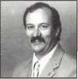

|  |  |
| --- | --- |
| ^ 1 \ 1 , | Tbs |
| Irade | .. _ _ p- — — - -■ — - - • — - - — - — - - - - - - - - -- - — ■ |
|  | jpon^arruinno, CIVIL, CHS  Trade Tips Editor |

Atrium Door Lock Repair

Here is a tip for an atrium door lock that will not open from either side. These locks break often, preventing the door from open­ing. Here is a quick fix to open the door and repair.

You need to imagine you are looking at the edge of the door with it open. With the deadbolt latch at bottom, use the left side of the door for your drill point. Remove all external trim. Measure in from the front side of the faceplate in line with the top of the deadbolt latch 1 5/8 of an inch. Draw the line. Measure down from the tip of the face­plate 4 3/8-inch. Where these lines cross is where you drill a fourth-inch hole. Reach through the hole with an ice pick or similar tool and pry up on the release and, as you hold up on the release, take a small flat blade screwdriver or knife and pull back on the deadbolt to open the door. As you look at the edge of the door, the drill point is always on the left side of the door for the deadbolt if the deadbolt is at the bottom. The drill point will be on the right side of the door if the deadbolt is on top.

If the spring latch is a problem, you mea­sure down 2 9/16 inches from the top of the faceplate (or by using the center of the latch) and draw a straight line 11/2 inches in from the front of the face plate. Drill a fourth inch hole where the two lines cross. Reach through the hole and work the latch back to open the door. The drill point for the spring latch is on the opposite side as the dead latch.

Ben Skeen

VATS Number

GM was so good with providing codes and VATS values for late model vehicles that I saw no need to buy a 10-cut adaptor. Then, one night it happened: GM gave me an incorrect VATS number.

I evaluated my situation: I had one each of the double-sided and two each of the sin­gle-sided VATS keys. I decided to punch out the VATS inserts from the older VATS keys and insert them, one by one, into the num­ber three double-sided key that I already cut

until I located the correct R value. I filed down a give-away screwdriver until the end was blunt (about 1/16 by 3/16 inches). Then I placed the older VATS keys on a partially opened vice and punched out the pellets.

To make it easier to insert the pellets, I enlarged the pellet hole with a small file so I could insert them with thumb pressure. Then, I centered the pellets by pressing them against a small block of wood. After several unsuccessful tries, the engine started when I used a 13 valve. I cut the double-side number 13, and the job was finished. I guess the computer (or a human) had omitted the first digit of the VATS value.

It worked so well that I made a complete set. To simplify insertion of the pellets, I filed the pellet hold at a slight angle. To keep track of the values, I color coded the pellets with white and yellow correction fluid. I used white for ones and fives and yel­low for twos and tens. For example, an eight value would have a white dot at the bottom of the pellet (indicating a five and a white dot on one side and a yellow dot on the other side.) Number 14 would have yellow at the top of the pellet and two yellow dots on the side of the pellet.

It’s a good idea to insert the pellet with the color coded side down so you don’t rub off the markings; however, if you do lose the markings, you can always use an ohmme^er to determine the correct VATS value.

It really works great. I no longer have to fumble around in the dark to line up VATS adaptors.

James Sullivan #021697

*Editors Note: Although this trick may work in a pinch, this should not he considered a permanent key for the customer. The pellet will probably fall out with use. We have seen this happen in VATS keys where the plastic pellet became worn. This is also why it is necessary to keep up with changes in the industry and buy the proper tools to do a pro­fessional job.

Last month’s Trade Tip winner was “No Lockout,” submitted by Larry Wright.

**/How To Become A Trade Tipper**

Each month, the Associated Locksmiths of America (ALOA) holds a “Trade Tips” con­test in Keynotes for ALOA members. In addition to helping other locksmiths by sharing your knowledge, there are three levels of prizes to be awarded:

June 1997

Sargent & Greenleaf 6120 electronic safe lock

Grand Prize: An expense-paid trip to the ALOA ’98 Security Expo

Each year, the ALOA Publications Commit­tee selects one outstanding tip, the author of which receives a seven-day ALOA con­vention package that includes travel and accomodations.

Authors of any Trade Tip published will still receive $20.

Want to Participate?

Mail your best idea (including photos,

illustrations or parts, if necessary) to

Keynotes

Trade Tips Editor

3003 Live Oak St.

Dallas, TX, 75204-6186.

All entries are sent to the Trade Tips editor with the author’s identity deleted. The tips must be submitted exclusively to Keynotes and become the exclusive property of ALOA. Tips are judged on the basis of accuracy, professionalism, ethical stan­dards, originality and usefulness.

June 1997 Keynotes 1

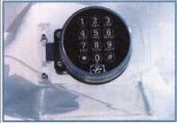

Chapter

Mews

Jana Barnum, CML Chapters Chairman

Our business and our lives reflect our attitude and outlook of the past and the future as we see it.

Greetings chapter members! Spring time 1997 is almost gone and summer is just around the corner! I hope all of you are as excited about your business climate and prospects of summer 1997 as I am. The key to being successful is, simply, to always set your aims and goals high, and then aggres­sively seek to achieve them on a daily basis. Chapter growth can be viewed the same way. If we consistently paint a picture of gloom around us, eventually it will be so. Our busi­ness and our lives reflect our attitude and outlook of the past and the future as we see it. So, let’s all pull in the same direction and build a better future for our association and our business. Can we count on you?

Recently, I attended and represented ALOA at the 1997 MLANJ convention. I do appreciate the opportunity to represent our membership at the ALOA booth and lis­ten to fellow locksmiths express their views and concerns for the future. For those of you who may be interested in numbers, we recmited 21 new members from that show alone. One thing I was certainly amazed at was how many people there were who don’t know that ALOA offers its members a chance to learn the trade through its scholar­ship program. These scholarships are avail­able to those who could not normally afford to attend an ALOA convention or pay full price for training classes. Our scholarship program offers free locksmith training classes at the ALOA convention and at other ACE sponsored events, such as at MLANJ. If you know of someone who could use a scholar­ship, contact your nearest ALOA representa­tive and ask for a scholarship application.

This year again, the cooperation between MLANJ and ALOA’s ACE program has been a tremendous success!

Chapter officers, please note that the next generation of the Association and Chapter Officers’ Training Class has been completed and was presented at this convention. If you have been keeping up with this column, you will remember that I have spoken sever­al times about this class and its benefits, not only for the student taking the class, but for the chapter or association that they will

serve with the knowledge gained. I believe this to be the best hands-on study course for anyone who sincerely cares about organiza­tional protocol, and wants their meetings to be well run and organized. This course will provide the building blocks needed to build membership, build up the quality of meet­ing time and provide a higher level of pro­fessional leadership. If there is any other chapter or association that wishes to have this class, or to see it included with your convention class lineup, please feel free to call me or request more information from the ALOA office.

From The Chapters

Ohio Valley Chapter

The state of Ohio is looking for qualified locksmiths who are interested in employment in state correctional institutions. There is also a need for qualified vendors to provide correc­tional facility locking systems, door hardware and supplies. For more information, contact Bob Shearer at the Lebanon Correctional Institution, (513) 933-0313.

The chapter is also active in reviewing draft legislation that is before the Ohio state legislature. Issues include apprenticeship ver­sus registered employees, licensing fees and the applicability to institutional locksmiths. Bill Mandlebaum, chairman of the Pennsylvania Ohio Locksmiths Association and legislative liason, recently represented locksmithing interests before the Ohio legis­lature along with other regional locksmiths.

On the educational front, chapter members will be boning up on ASS A products in June.

Keystone Chapter

While Ohio is awaits their state legislature’s decision (above story), locksmith legislation has also been introduced in Pennsylvania. Don Decker of the Ohio Chapter has a copy if anyone in that area wants to review it. Contact Don at (937) 879-0087 or fax (937) 879-4000 (call first).

Delaware Contribution

The Delaware Locksmith Association held a free class on locksmithing legislation, con­

ducted by Steve Young this spring. The class was noted in area chapter meetings, and was available to anyone who was interested in learning more about the legislative process. Kudos to the northeast for staying abreast of this vital area of locksmithing’s future.

Wow, What a Class!

Locksmiths throughout the state of Arizona met in Phoenix for a two-day ACE class on safe manipulation. The training was led by Kenneth Lee, CPL, of Norman, OK. Each participant was given the opportunity to manipulate LaGard, S&G and Mosler combo locks by touch. The class also earned partici­pants their certification in Safe Manipulation.

There were participants as far away as Prescott, Kayenta, Tucson, Yuma and Payson. The Grand Canyon Chapter (the host chapter) provided lunch and each lock­smith received a cut-away lock donated by LaGard and James Hawley, CRL.

Much was learned in the two-day session and everyone walked away with a better approach to handling a lost safe combination.

—-John Ilk, CRL

Montana Chapter

The Montana Chapter has recently elected new officers:

Jim Morrissey Chairman

Winston Morrissey... .Vice Chairman Carole Morrissey Secretary/Treasurer

- I About the Chairman: Dana

Barnum, CML, #05444, operates South Penn Lock & Safe Co. in Media, PA. He also serves on the ALOA Education, Membership and Bylaws committees, as well as having been on the board of directors of the Greater Philadelphia Locksmiths Association (GPLA). Dana has also sponsored many new ALOA members. Dana can be reached at FAX (610) 565-9902 or e-mail him at dlbamum@aol. com.

Keynotes

June 1997

|  |  |
| --- | --- |
| ALOA | ( |
| Extra | \ |



Dept)

Goodbye to Friends

ALOA would like to send best wishes to the friends and families of Herman Lowenberg, Harold George Reynolds, Dennis A. Rob­bins, Gary D. Rutherford, Vernon Sumner and Christopher E. Heinz. These six gentle­men have passed away this year, and they will be missed. Their contributions to the industry and ALOA are greatly appreciated.

Libraty Closed

The ALOA Video Library will be closed until August 5 th. Items will be available to members after this date.

it’s Contest Time!

It’s time again for the ALOA Truck and Storefront Signage Contest. It’s easy to join in—simply follow these contest rules:

* Participants should send in a color 3X5 photograph by July 1, 1997.
* Last year’s winners are not eligible.

Entries become the property of ALOA.

* Judging is done by the Keynotes staff. Entrants will be published in Keynotes and

the winners will be announced at the ALOA ’97 Security Expo.

This years prizes have been generously donated by Mike Groover of IDN and John Cannon, CML of Locks Unlimited.

November/December Issue

Just a reminder: The November and December 1997 issues will be combined so that ALOA would have the funds to con­duct the membership survey.

Be A Mentor

For those of you who are interested in being a part of the ALOA Mentor Program, the form you need is on the Reader Service card.

Positive ID Policy

Use the following positive identification policy when servicing lockouts:

Notify Caller. When a call comes in to request lockout services, ask the caller if he/she has identification and authority to open the lock.

Complete Form. Upon arrival at the job

site, the locksmith should complete an Authorization Form that asks for the name, address, phone number, identification num­ber and property description from the cus­tomer. ALOA provides a model form.

Verify I.D. Verify the customer’s photo-iden­tification card and compare it to the infor­mation provided by the customer. If no photo-ID card is available, ask for some other reasonable form of ID.

Verify Authority. The locksmith should inquire as to what authority the customer has to open the lock, and request to see any reasonable and appropriate evidence that could verify the authority. This may be impossible in some cases.

Ask for Signature. Ask the customer to sign the Authorization Form, which should contain a statement that (a) the information given by the customer is correct, (b) the customer has the authority to open the lock, and (c) the customer shall identify and hold harmless the locksmith against liability.

The ALOA model form contains this state­ment.

Optional Last Resort. If you have any sus­picions that the customer is giving false information or does not have authority to open the lock, say that you will be happy to open the lock provided a law enforcement officer is present. If the customer agrees, call the police; if not, leave.

File the Form. Keep the Authorization Form on file for a reasonable period of time.

Correction to Board Report

In addition to the other nominees listed in the Nominating Committee Report on p.

19 of the May 1997 issue of Keynotes, Mark Blum, CML, has been nominated for a three-year term to the ALOA Board of Directors. More information on all nomi­nees will be in the July/August issue.

Rules of the Meeting

The annual membership meeting for ALOA will be held Aug. 2, 1997, in Reno, Neva­da, in conjunction with the ALOA ‘97 Security Expo.

Rules for the annual membership meet­

ing are:

1. Identification will be required for admittance—ALOA membership card pre­ferred.
2. Ballots must be surrendered at the door by any member leaving before the elec­tion is held. The ballot will be returned upon re-entry.
3. Members wishing to speak shall approach a microphone and wait to be rec­ognized. When recognized, the members shall state their names, membership num­ber and city. Discussion will be limited to three minutes per subject per member.
4. Non-members must obtain a guest badge at the door and wear it prominently on their person.
5. Guests may only address the chair at the request of the President.
6. Elections will be by paper ballot.
7. Nominations may be made by any member present. Nominees must be quali­fied by the secretary at least 24 hours prior to the start of the membership meeting.
8. Each nominee is entitled to a nomina­tion and two seconding speeches, limited to three minutes.

9- Candidates nominated by the ALOA Nominating Committee are entitled to two seconding speeches, each limited to three minutes.



14 Abus35

1. Door and Hardware Institute IFC

100 Jet Hardware Mfg, Co. BC

1. LAB Security 8

24 Locksmith Publishing Corp.IBC

1. MIWA Lock USA 25

11 Mas-Hamilton Group19

1. Monday Security Group 55
2. Omaha Wholesale Hardware 55

15 Southern Lock and Supply Co. 35

1. SERLAC 27



June 1997

Keynotes

Back

Page

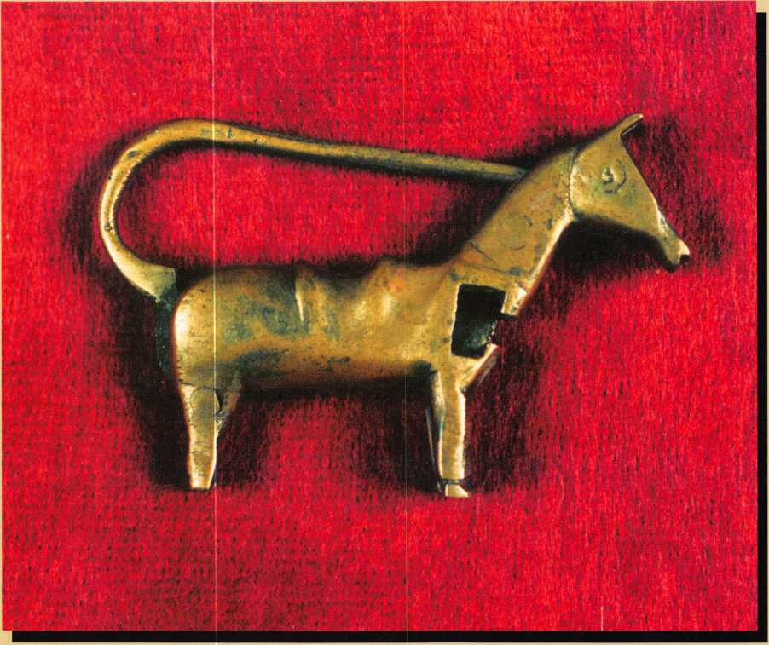

An Interesting Tail

By AJ Hoffman, CML

I’ve been horsing around as a lock collector since about 1964. Mainly as a result of my unbridled enthusiasm for my hobby and profession, Keynotes sad­dled me with the responsibility of whipping up a tale about one of my locks on the spur of the moment. It may stir up some interest in lock collecting.

Hand made animal figure padlocks have been used in the Middle East and, to a lesser extent, in the Far East for centuries. Today, they are mass produced mostly as decorative novelty items, and the mecha­nism is crude and easy to defeat. This sample is one of those cases of “slip shod” construction—probably less than 20 years old. It is made entirely of brass and stamped “INDIA” on the opposite side. It measures 2 7/8-inches long and 1 7/8-inches tall. The horse’s tail curls up over its back to form the shackle.

The mechanism is called “barbed spring locking” and is the same general type used in the more com­mon Chinese padlocks, which are shaped sort of like toolbox and may be more familiar to the reader. The key is pushed in to surround and compress a pair of opposing springs that secure the shackle. As the cor­rect key is pushed in, it unlocks the shackle, pushing it straight out the opposite end.

Well, I guess that concludes my dog and pony show for this issue.

Keynotes

June 1997

**DOOR AND HARDWARE INSTITUTE, 14170 Newbrook Drive, Suite 200, Chantilly, VA 20151-2232;  
Phone 703.222.2010; Fax 703.222.2410; [www.dhi.org](http://www.dhi.org)**

Free Information - Reader Service Card #1

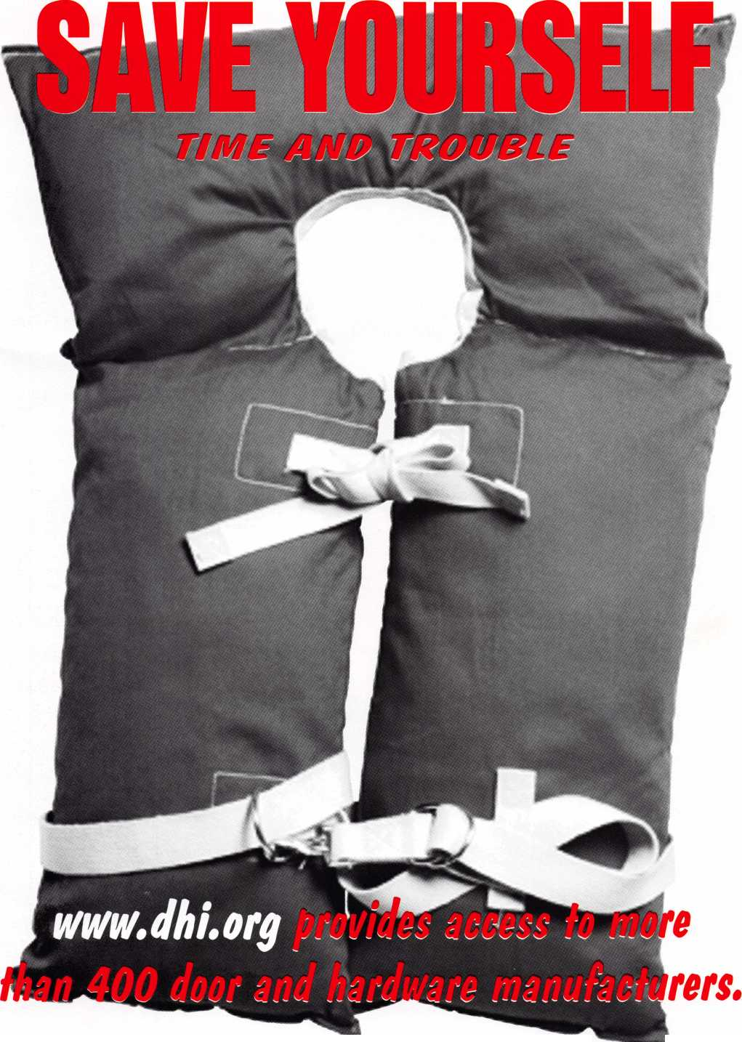

**Jet Soars to a new level of Quality**

**In two short years since its initial introduction by jet, the silver line has become a symbol of quality and a monument to precision in the key manufacturing indus­try. The silver line keys are coined, embossed and designed to look exactly like the originals. Plus the jet pledge guarantees superiority over the originals as well.**

**jet’s silver line offers regular and sectional keys from...**

**ARROW BEST .’ CORBIN RUSSWIN**

**DIEBOLD FALCON HHM**

**KWlKSET LeFEBURE MEDECO**

**MOSLER SARGENT SARGENT & GREENLEAF**

**SCHLAGE YALE YORK**

**New key blanks are constantly added to the silver line to serve Master Keying and Duplication needs. Recent additions include Corbin Russwin D2-6-NS and**

**77-6-NS... Another jet symbol of Quality.**

**!** V1 ».t\ **v , ? Af** ‘ **li'.ViiV"?' r** s'J **\* -YiI**

**JET HARDWARE MANUFACTURING CORP 800 Hinsdale Street, Brooklyn NY 11207**

